Paul Russell

ID: UM3267BPM7972

Market Research Thesis Report
On the Hospitality Industry
In Dubai, UAE.

A Final Thesis Presented to
The Academic Department
Of The School of Business and Economics
In Partial Fulfilment of the Requirements
For The Masters Degree in Project Management

Atlantic International University
June 2008

Foreword

My motivation for this report is driven by my passion for the Hospitality industry and its many facets. In producing this research report I had to rely on a lot of co-operation from many professionals within the industry and numerous tourism reports by the UAE government sectors.

Without the assistance of the numerous hospitality professionals that I have received the completion of this report for my Master’s Degree would not have been possible. I would also like to thank my wife who has to suffer my constant studying and complaining when I am struggling to compile information.

Table of Contents

- Introduction

1.1 The Hospitality Industry in the Middle East
1.2 Construction Costs per Room
1.3 Over Capacity and Resourcing
1.4 Rising Ecological and Environmental Concerns and the
Growing Regional Response

2.0 OVERVIEW OF DUBAI HOTEL PERFORMANCE

2.1 Luxury Hotels Supply and Demand Summary (2007)
2.2 Luxury Hotel Room Occupancy Indicators (2000-2006)
2.3 Luxury Hotel Bed Occupancy Indicators (2000-2006)
2.4 Luxury Hotel Average Room Rate Indicators (2000-2006)
2.5 Luxury Hotel RevPAR Indicators (2000-2006)
2.6 Luxury Hotel Revenue Indicators (2000-2006)

- COMPETITIVE SET ANALYSIS

3.1 Competitive Set Overview
3.2 Competitive Set Room Mix and Sizes
3.3 Competitive Set Key Performance Indicator
3.4 Competitive Set Key Performance Indicators Evolution (2005-2007)
3.5 Competitive Set Seasonality Indicator (2006)
  - Competitive Set Rate Comparison

- SUITE PERFORMANCE

5.0 APPENDIX: DUBAI HOTEL HISTORIC SUPPLY INDICATORS (2005)

  - Luxury Hotel Supply Indicators (2000-2006)
  - Luxury Hotel Room Supply Indicators (2000-2006)
5.3 Luxury Hotel Bed Supply Indicators (2000-2006)

- APPENDIX: COMPETITIVE SET PERFORMANCE INDICATORS (2005)

- APPENDIX: ROOM FEATURES

  - Burj Al Arab
  - Jumeirah Beach Hotel
  - Madinat Jumeirah: Mina A’Salam
  - Madinat Jumeirah: Al Qasr
  - Madinat Jumeirah: Dar Al Masyaf
  - The One and Only Royal Mirage
  - 6.7 Ritz Carlton

General Information

Tables

Table 1-0 New Hotel Guest Rooms Supply by Country (Rooms)
Table 1-1 Dubai Hotels Supply and Demand Summary (Q1 & Q2 2007)
Table 2-1 Competitive Set – Overview
Table 2-2 Competitive Set – Unit Types and Sizes
Table 2-3 Competitive Set – Unit Types Distribution
Table 2-4 Competitive Set – Key Performance Indicators (Jan-April 2007)
Table 2-5 Competitive Set – Key Performance Indicators (2006)
Table 2-6 Competitive Set BAR Comparison
Table 2-7 Competitive Set BAR Variance Analysis
Table 3-1 Competitive Set Suite Performance Summary (2007)
Table 4-1 Dubai Hotels Supply and Demand Summary (2006)

Figures

Figure 1-1 Five Star, Four Star and Other Hotel Room Occupancy (2000-2006)
Figure 1-2 Five Star, Four Star and Other Hotel Bed Occupancy (2000-2006)
Figure 1-3 Five Star, Four Star and Other Hotel ARRs (2000-2006)
Figure 1-4 Five Star, Four Star and Other Hotel RevPAR Indicators (2000-2006)
Figure 1-5 Luxury Hotel Revenues (2000-20006)
Figure 1-6 Five Star Hotel Revenue Indicators (2000-2006)
Figure 1-7 Four Star Hotel Revenue Indicators (2000-2006)
Figure 1-8 Total Revenues per Hotel (2000-2006)
Figure 2-1 Competitive Set – Occupancy Evolution 2005-2007
Figure 2-2 Competitive Set – Average Room Rate Evolution 2005-2007
Figure 2-3 Competitive Set – Seasonality 2006
Figure 4-1 Luxury Hotel Supply (2000-2006)
Figure 4-2 Luxury Hotel Room Supply (20002006)
Figure 4-3 Luxury Hotel Bed Supply (20002006)
Figure 5-1 Competitive Set ARR and OCC (2005)
Figure 5-2 Competitive Set-Select- Seasonality2005

Glossary of Terms

Abbreviation | Description
AED | Dirham
ARR | Average Room Rate
CAGR | Compound Annual Growth Rate
DTCM | Dubai Department of Tourism and Commerce Marketing
DXB | Dubai
F&B | Food & Beverage
GCC | Gulf Co-operation Council
M² | Square Meters
MICE | Meeting, Incentive, Conference and Exhibitions
OCC | Occupancy Levels
RevPAR | Revenue per available Room
U.A.E | United Arab Emirates
USD | United States Dollars

Market Research Report On the Hospitality Industry In Dubai, UAE.

1.0 Introduction

Tourism in the UAE is the economies fastest growing area, and Dubai takes the lead as the fastest growing holiday destination in the history of the travel industry according to the WTO (World Tourism Organisation). Worldwide tourism growth remains at an average 3.7% for the rest of the world whilst the Middle East hit the 10.2% highs in 2006.

Dubai’s hotels also have one of the highest RevPar worldwide therefore attracting numerous hotel investors and developers eager to cash in on the lucrative market.

According to Arthur de Haast, Global CEO of Jones Lang Lesalle, the onslaught of hotel and related leisure projects in the Middle East region is justified by the expectations of sustained growth in demand.

With this as a backdrop the following report has been generated benchmarking key properties and indicators as an investment tool for potential investors in the hospitality industry in Dubai.

This Market Research report has been compiled using a variety of information using traditional research methodology and reports by the UAE tourism board and interviews with a variety of professionals, whom will remain nameless, from a variety of Hotels within the region.

The main function of this report is to provide investment information for any developer in the UAE whom wishes to invest in the Hospitality industry and especially the lucrative five star hotel market in Dubai

Although there is a general lack of transparency within the industry due to its increasingly competitive nature all information present is as accurate as I can possibly achieve and all supplementary methods have been utilized to check the accuracy of the figures.

1.1 The Hospitality Industry in the Middle East

Whilst the current growth in hotel supply in the Middle East is based on future targets of a promise land, the current results in the industry indicate that they are on the right track.

According to HVS’s international research approximately 253 new hotels will be coming on line over the next four years giving an additional 120,000 guest rooms. This is a pure addition to the current amount of rooms available and excludes the enormous Dubailand’s project. Dubailand (Bawadi) alone has a reported sixty thousand hotel room with one hotel ‘Asia Asia’ having a reported 6,000 guest rooms in one hotel (Arif Mubarak, CEO Bawadi).

The vast quantity of these guest rooms are in the UAE, which accounts for almost 60% of all new supply. In Dubai alone the following quantity of guest rooms are reported to be entering the market (Chris Clarke 2008);

- 2008 – 27,000
- 2009 – 18,000
- 2010 – 13,000
- 2011 – 20,000

Figure 1-0 - New Guest Room Supply by Country (Rooms)
Years 2008-2009

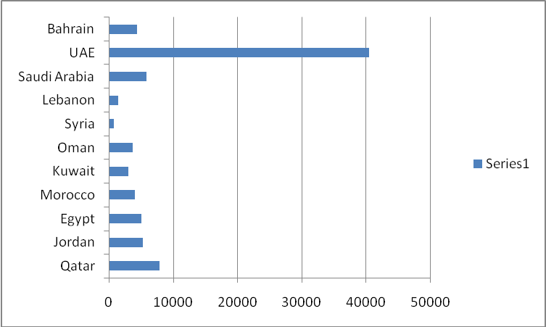
Source: HVS International Research 2007

1.2 Construction Costs per Room

Construction costs in June 2007 were running at approx USD $500-600,000 per room for a high end five star project. With recent inflationary pressure caused by market forces costs in the construction industry have escalated, MEED (Middle East Economic Digest) estimate an average room cost of 1.5 million per room at May 2008. This is an increase tripling of construction costs in a one year period in the UAE.

The table below highlights the wide variation in constructions costs per room for a selection of recently announced projects where the costs and number of rooms were published.

These projects sit in a wide range from US$700,000 to US$20,000,000 and are for developments currently master planned with released figures.

Country /Emirate | Project | Price  USD | No. of Rooms | Price. Per Room
Bahrain | Banyan Tree | $170mil | 156 | $1.08mil
Jordan | Ayla Oasis | $1.4bil | 600 | $2.33mil
Oman | Salalah | $1.4bil | 700+ | $2mil
Saudi Arabia | Red Sea T.P. | $40bil | 557,000 | $0.7mil
Abu Dhabi | Desert Island* | $3bil | 150 | $20mil
Dubai | Bawadi | $54bil | 60,000 | $0.9mil
Fujairah | Mina Al Fayer | $163mil | 200 | $0.81mil
Ras Al Khaimah | Bab Al Bahr | $327mil | 290 | $1.12mil
*Includes for the entire Desert Island development (source: Global Futures & Foresight – Hotel outlook 2020)

1.3 Overcapacity and Resourcing

The sheer scale of the newly announced developments coupled with those already underway raises the issue of whether the region is facing the risk of overcapacity.
With occupancy levels running at over 80% as demonstrated in tables inside the report, and record revenues of US $329 per night in the first quarter of 2007 in Dubai it is easy to see the motivation to construct further properties in the region.

However, a number of external factors could serve to depress
demand - such as a possible recession in the US and Europe (currently happening), concerns over climate change bringing travel restrictions in Europe, security worries and pressure on business costs driving down travel budgets.

Whilst ‘Plan A’ is focused on an assumption of continued growth, the operators need to think clearly about ‘Plan B’ – e.g. what happens if they cannot attract the premium price customers at whom they are targeting the majority of developments? Would they be forced to lower prices and target a broader audience? If so, would they be able to retain the image of luxury and exclusivity so critical in attracting premium rate customers?

Another key challenge is whether the region will be able to attract and develop a sufficiently skilled pool of human resources to service these developments. With China and India’s economies on the rise, where will the human resource come from? WTTC had forecast the need for an additional 1.5million staff in the sector.

The WTTC estimate was created prior too many of the announcements for the large master planned projects. This being said I believe the WTTC estimate may not take full account of the scale and accelerated pace of development now being considered and the true figure could end up being closer to 2 - 2.5 million.

Failure to attract sufficiently qualified staff could lead to service failures which would have a detrimental impact on the brand image of those properties.

1.4 Rising Ecological and Environmental Concerns and the Growing Regional Response

Developers, operators and Local Authorities across the region are beginning to respond to the perception that travellers are becoming more concerned about the impact their vacations and visits are having on the environments they travel to.

Recent environmental issues raised in the region about waste, power, water and sustainability could have a potentially dramatic impact on the success of existing and recently announced hotel projects in the region hence the introduction of LEED accreditation in Dubai.
As travellers become more alert to these issues, they will seek ‘standards’ to rely on as guides to the most sustainable hotels to stay in – such as the Green Globe model – a ‘global
benchmarking, certification and improvement system for sustainable travel and tourism’ - endorsed by 182 Heads of State at the United Nations Rio de Janeiro Earth Summit in 1992.

An April 2007 Trip Advisor survey of over 1,000 travellers worldwide found 40% consider environmentally-friendly tourism when making travel plans. 66% say environment friendly measures in travel are making a difference.

Nearly 25% believe that air travel should be avoided, whenever possible, to help preserve the environment, while 38% said would pay more to take an eco-friendly flight and 26% would pay a 5-10% premium.

To stay at an environmentally-friendly hotel 34% said they would pay more money, while 38% said they had already stayed at an environmentally-friendly property, and 9% would specifically
seek out environmentally-friendly establishments.

When asked to specify how much they extra they would be prepared to pay for 'green' accommodation, 25% said they would pay a 5-10% premium, and 12% would pay a 10-20% premium.

Ian Rumgay, European communications manager for Tripadvisor says "This survey shows that far from being irresponsible, planet polluting energy wastrels that they are often portrayed, many
travellers do care about the environment and are willing to pay for it,". "It is a wake-up call for all sectors of the travel industry to provide more green options".

Increasingly broad assessments will be made of the ‘whole life environmental footprint’ of the sector – for example considering every aspect of a hotel’s construction, resource usage, waste and emissions. A number of encouraging developments are now underway suggesting the region is paying more attention to environmental concerns, for example:

• An eight million tonne capacity construction waste recycling plant has been launched by the Al Rostamani Group to help recover and recycle Dubai’s construction and demolition
waste. Costing around US$18M it will operate at full capacity by September. According to Dubai Municipality, 10.5 million tonnes of construction and demolition waste was handled in 2006 – representing 75% of Dubai’s total annual waste.

• Jordan’s Najwa Wadi Rum ecologically and socially conscious development is expected to reach Green Globe accreditation.

• The Fairmont Dubai has established a number of green initiatives in partnership with the Emirates Environment Group (EEG) – a UAE NGO focused on the environment.

• Masdar – a new 6sq km zero waste, zero carbon energy, science and technology community in Abu Dhabi will open in late 2009. While these and other similar developments are encouraging, significant environmental and resource challenges also exist.

• The UAE Minister of Environment has said that Arab cities will face a water shortage of 100 to 133 billion cubic meters per year by 2030 - presenting “the biggest economic, social and environmental challenge faced by Arab countries”.

• A survey by facilities management company Farnek Avireal found that Dubai's five star hotels consume up to 250% more water and 225% more energy than their European counterparts. Dubai’s Hotels average 650 to 1,250 litres of water per guest and
consume 2,750-3,250 KW of power per square foot. By comparison, hotels in Germany were said to be using 350 litres and 1,000 KW per square foot.

• Kuwait’s electricity and water minister has stated that it needs to spend $27 billion on water and power projects over the next eight years to meet growing demand

Market Research Thesis Report

Investment Tool for Developers
Benchmarking Key Performing Five Star Properties
in Dubai UAE

Report Date May 2008

Author – Paul Russell

- OVERVIEW OF DUBAI LUXURY HOTEL PERFORMANCE

2.1 Luxury Hotels Supply and Demand Summary (2007)

The following section provides an overview of luxury hotels in Dubai based on Q1 and Q2 2007 datasets provided by Dubai Department of Tourism and Commerce Marketing (DTCM).

A detailed historical perspective (years 2000-2006) of demand indicators for luxury hotels in Dubai are presented in the Sections 1.2 – 1.6 while historical supply indicators are provided in the Appendix.

Please note: For the purpose of this report, luxury hotels are defined as five star properties as classified by DTCM. Similarly, other hotels comprise four, three, two one star and listed hotels by DTCM classification.

Within the five star set I have specifically focused on the most up market sub-products such as suites and villas as these form a large part of the new five star product.

The following table presents a summary of supply and demand indicators for Dubai hotels in Q1 and Q2 2007:

Table1-1 Dubai Hotels Supply and Demand Summary
(Q1 & Q2 2007)
Category | 5-star | 4-star | Overall All  Hotels
Supply Indicators
Operating Hotels | 42 | 49 | 317
Total Available Rooms | 12,377 | 7,384 | 32,032
Total Available Beds | 18,745 | 10,731 | 52,086
Demand Indicators
Room Occupancy Rate | 87.4% | 84.3% | 83.6%
Bed Occupancy Rate | 89.2% | 83.1% | 80.9%
ARR (AED) | 1,224 | 554 | 718
ARR (USD) | 335 | 152 | 197
RevPAR(AED) | 1,070 | 467 | 600
RevPAR (USD) | 293 | 128 | 164
Source: DTCM statistics, 2006

In 2007 luxury hotels comprised 13% of Dubai hotel supply (42 hotels). At 12,377 available rooms, luxury hotel rooms comprised 39% of total available rooms’ inventory at all hotels in Dubai.

Similarly in 2007, luxury hotels provided 37% of all available beds in Dubai hotels at an average of 1.51 beds per room. Four star hotels provided marginally less beds per room than five star hotels (1.45 beds per room).
Average room rates (ARRs) across all five star hotel products in Q1 and Q2 2007 stood at AED 1,224 (USD 335) per room compared to AED 554 (USD 152) per room for four star hotels and AED 718 (197 USD) per room for the overall market.

Five star hotels also enjoyed the highest room occupancy (87.4%) out of all categories of hotels (market average 83.6% occupancy for all hotels). As such, RevPARs at five star properties averaged AED 1,070 (USD 293) per available room compared to AED 600 (USD 160) per available room for the market.

2.2 Luxury Hotel Room Occupancy Indicators (2000-2006)

The figure below presents hotel room occupancy indicators for five, four and other hotels over the period 2000-2006:

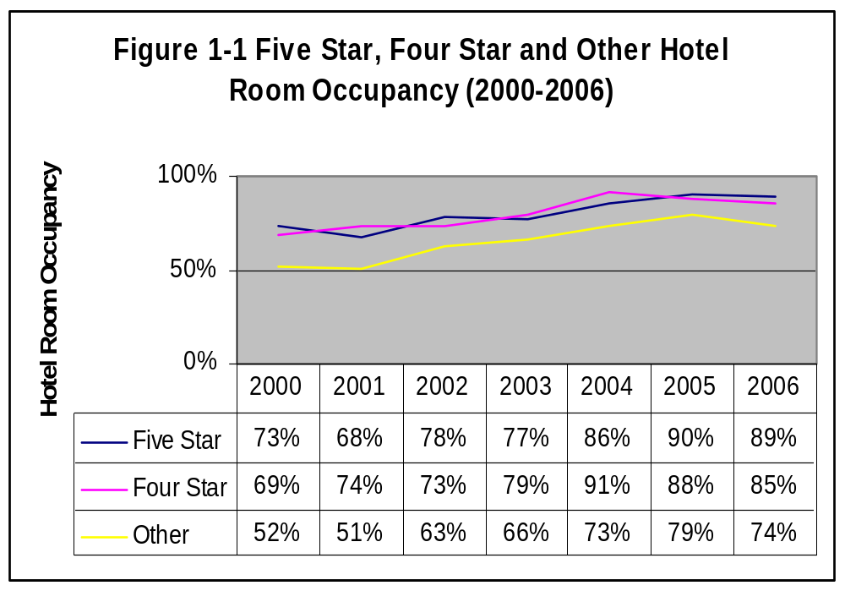
Source: DTCM Statistics, 2006

Room occupancy at five star hotels outperformed all other categories averaging 80.0% between 2000 and 2006 while peaking at 90% in 2005. Four star hotels also achieved high room occupancies averaging 79.8% over the same period while outperforming five star hotel occupancies in 2004.

Since peaking at 91% room occupancy 2004 four star hotel room occupancy has declined to 85% in 2006 as 1,604 four star hotel room were added over this period (37% increase from 4,386 rooms in 2004).

2.3 Luxury Hotel Bed Occupancy Indicators (2000-2006)

Figure 1-2 presents hotels bed occupancy indicators for five, four and other hotels over the period 2000-2006.

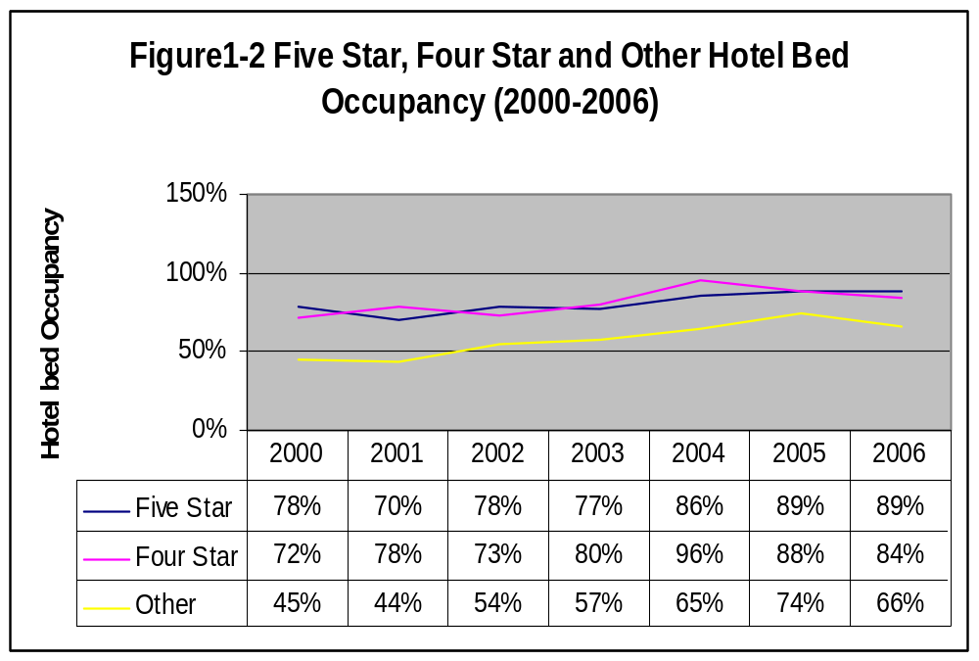
Source: DTCM Statistics, 2006

2.4 Luxury Hotel Average Room Rate Indicator (2000-2006)

The figure below demonstrates Average Room Rate (ARR) evolution in Dubai hotels between 2000 and 2006 for luxury hotels. Growth in overall market ARRs has been driven predominantly by growth in ARRs for 4 and 5 hotels as the following figure presents:

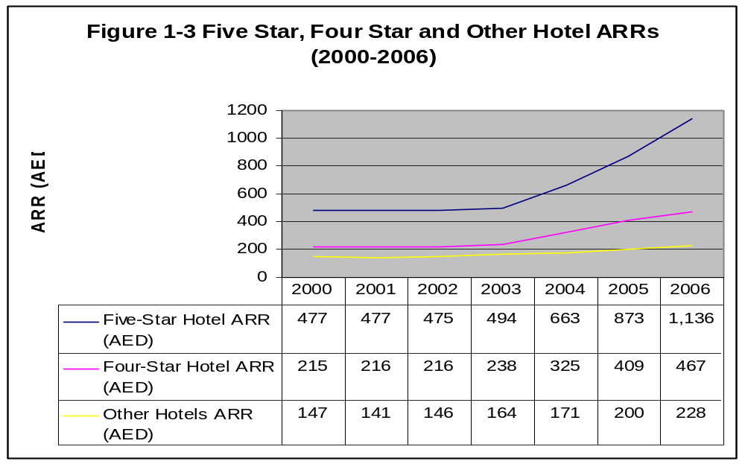
Source: DTCM Statistics, 2006

Growth in ARRs for five star hotels at 138.1% exceeded growth in ARRs for four star hotels (116.7%) over the period 2000-2006. Comparatively, ARRs at other Dubai hotels only grew 55.3% over the same period.

  - Luxury Hotel RevPAR Indicators (2000-2006)

The figure below demonstrates Revenue Per Available Room (RevPAR) evolution in Dubai hotels between 2000 and 2006 for luxury hotels.

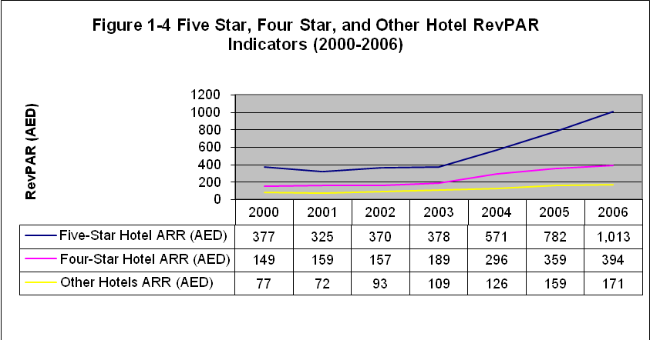
Source: DTCM Statistics, 2006
RevPARs for five star hotels have grown 191.7% from AED 347 per available room in 2000 to AED 1,013 per available room in 2006. RevPARs at four star hotels also exhibited strong growth increasing 164.6% from AED 149 per available room in 2000 to AED 394 per available room 2006. RevPARs for five star hotels were approximately two and a half times RevPARs for four star hotels in 2006. RevPAR for other hotels stood at an average of AED 171 per available room in 2006, less than half RevPARs for four star hotels.

2.6 Luxury Hotel Revenue Indicators (2000-2006)

Figure 1-5 presents total revenues at luxury hotels in Dubai as proportion of total revenues earned at all hotels in Dubai over the period 2000-2006.

0
2,000
4,000
6,000
8,000
10,000
12,000
Hotel Total Revenues (AED
Millions)
Five-Star Hotel ARR (AED)
1,710
1,807
2,308
2,667
3,888
5,636
6,991
Four-Star Hotel ARR (AED)
341
445
429
589
855
1,171
1,374
Other Hotels ARR (AED)
575
541
673
759
854
1,105
1,303
2000
2001
2002
2003
2004
2005
2006
Figure 1-5 Luxury Hotel Total Revenues (2000-2006)
Source: DTCM Statistics, 2006

Note: Total Revenues are comprised of Room Revenues and Other Revenues as reported by DTCM.

Total revenues at five star hotels have increased 309% from 1.71 billion in 2000 to AED 6.99 billion in 2006. Comparatively, four star hotels achieved 14.2% of total 2006 hotel revenues while other hotels achieved 13.5%.

The following figures present a detailed breakdown of five and four star revenue streams and their evolution over time (2000-2006) at hotel category level and on a per hotel basis.

Figure 1-65 Star Hotel Revenue Stream (2000-2006)
0
2,000
4,000
6,000
8,000
Revenue Streams (AED
Millions)
Room Revenue (AED
Millions)
861
926
1,164
1,376
2,139
3,092
4,365
Other Revenue (AED
Millions)
849
881
1,143
1,291
1,750
2,544
2,627
2000
2001
2002
2003
2004
2005
2006
5 Star Hotel Revenue Distribution (2006)
Room
Revenue
(AED Millions)
62%
Other
Revenue
(AED Millions)
38%
Source: DTCM Statistics, 2006

Room revenues at five star hotels grew 407.2% from AED 0.86 billion in 2000 to AED 4.37 billion in 2006. Comparatively, other revenues at five star hotels grew 209.4% over the same period to achieve a total of AED 2.63 billion in 2006.

While room revenues at five star hotels comprised 50% of total revenues in year 2000, proportionately room revenues have increased to 62% of total revenues in 2006.

Figure 1-74 Star Hotel Revenue Streams (2000-2006)
0
200
400
600
800
1000
1200
1400
1600
Revenue Streams (AED Millions)
Room Revenue (AED Millions)
161
205
211
293
473
712
862
Other Revenue (AED Millions)
180
240
218
296
382
459
512
2000
2001
2002
2003
2004
2005
2006

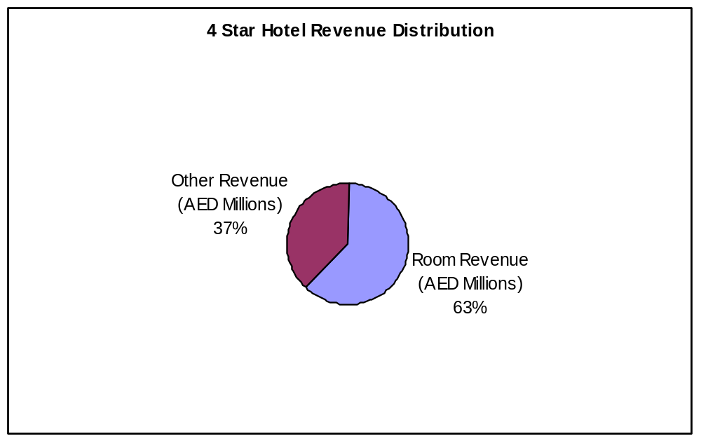
Source: DTCM Statistics, 2006

Room revenues at four star hotels grew 436.6% between 2000 and 2006 from a total of AED 161 million to AED 862 million. In contrast, other revenues at four star hotels grew 183.8% from AED 180 million in 2000 to AED 512 million in 2006.
As with five star hotels, room revenues at four star hotels have increased as a proportion of total revenues between 2000 and 2006. Room revenues comprised 47.1% of total revenues at four star hotels in 2000, notwithstanding, room revenues grew as proportion of total revenues at four star hotels to 63% in 2006.

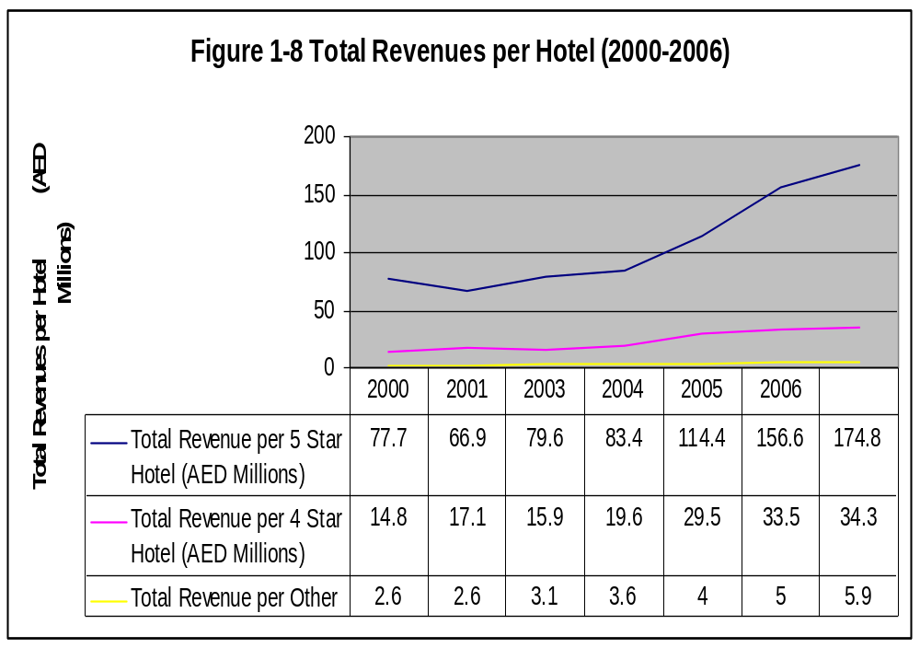
Source DTCM Statistic, 2006

Revenues per hotel vary significantly between five star, four star and other hotel categories. In 2006, on average a five star hotel in Dubai earned AED 174.8 million in revenues while a four star hotel on average earned AED 34.3 million in revenues.

In comparison during 2006, the 222 other hotels in Dubai (three star, two star, one star and listed categories) on average achieved AED 5.9 million in revenues per hotel.

Total revenues per four star and five star hotel grew at similar rates; total revenues at four star hotel grew 131.7% from AED 14.8 million per hotel in 2000 to AED 34.3 million per hotel in 2006; total revenues at five star hotels grew 124.9% from AED 77.7% million per hotel in 2000 to AED 174.8 million per hotel in 2006.

- COMPETITIVE SET ANALYSIS

The following section provides analysis of a select set of up market luxury hotels in Dubai. Five properties have been selected on the basis that they represent premium five star beach properties in Dubai and represent a similar product to the new developments that are up and coming in Dubai on the three new reclaimed Palm and Waterfront Developments.

These new developments have a considerable portion of their entire development strictly set aside for the five star resort leisure market.

3.1 Competitive Set Overview

A competitive set of five of Dubai’s leading hotels were selected on the basis of being competitive to the new developments on the main reclaimed masterplans.

I provided this market research to provide supply (facilities, location, room size) and demand (pricing, ARR, occupancy, market segmentation) indicators for new developers to allow them to understand the current market place and target their prospective market accordingly.

Out of the five hotels in this section, four are operated by the hotel operator Jumeirah, a subsidiary of Dubai Holdings.

The chosen hotels are all located within a 5 km stretch of beach in some of Dubai’s most prestigious communities such as Al Sofouh and Marsa Dubai communities.

The trunk of the Palm Jumeirah approximately bisects the strip of beach on which the competitive properties are located on.

All hotels within the competitive set provide outstanding architecture and service levels and an extensive range of luxury facilities and amenities; all have a fitness centres, business centre’s an executive lounge, recreation areas, spa facilities, and 24 hour room service.

A detailed description of the hotels, room amenities and details is provided in the Appendices. The following table presents on overview of the five properties that form the core competitive set.

Table 2-1 Competitive Set – Overview
Property  Name | Hotel Name | Total No.Units | No. of F&B  Outlets | No. of Meeting  Rooms
Burj Al Arab |  | 202 | 8 |  | 5
Emirates Towers | Emirates Towers | 400 | 15 |  | 18
Madinat  Jumeirah | Mina A’Salam Hotel | 292 | 8 |  | 2*
Madinat  Jumeirah | Al Qasr | 292 | 9 |  | 0*
Madinat  Jumeirah | Dar Al Masyaf | 283 | 2 |  | 0*
 | The Palace | 246 | 4 |  | 1
 | Arabian Court | 172 | 3 |  | 5
 | Residence & Spa | 49 | 0 |  | 0
Ritz-Carlton Dubai | Ritz-Carlton Dubai | 138 | 6 |  | 13
Jumeirah  Beach Hotel | Ocean View | 598 | 22 |  | 14
Jumeirah  Beach Hotel | Beit Al Bahar | 19 | 0 |  | 0

*Madinat Jumeirah has a separate conference centre with over 6,500 m² of meeting space.

3.2 Competitive Set Room Mix and Sizes

The following table presents number of unit type as well as unit sizes for the competitive set:

Table 2-2 Competitive Set – Unit Types and Sizes
Property Name |  | Total No. of Units | Unit Type | No. of Units by Type | Size (m²)
Burj Al Arab |  | 202 | Deluxe Suite | 142 | 170
 |  | 202 | Panoramic Suite | 18 | 225
 |  | 202 | Club Suite | 4 | 330
 |  | 202 | Two Bedroom Suite | 28 | 335
 |  | 202 | Three Bedroom Suite | 6 | 670
 |  | 202 | Presidential Suite | 2 | 667
 |  | 202 | Royal Suite | 2 | 780
Emirate Tower |  | 400 | Double Deluxe Rooms | 200 | 44
 |  | 400 | Twin Deluxe Rooms | 48 | 44
 |  | 400 | Double Tower Rooms | 40 | 44
 |  | 400 | Chopard Ladies Rooms | 10 | 44
 |  | 400 | Club Executive Rooms | 52 | 63
 |  | 400 | Apex Suites | 31 | 87
 |  | 400 | Summit Suites | 5 | 88
 |  | 400 | Presidential Suites | 3 | 225-250
 |  | 400 | Royal Suite | 1 | 312
Madinat  Jumeirah | Mina  A’Salam  Hotel | 292 | Ocean Deluxe Rooms | 115 | 50
Madinat  Jumeirah | Mina  A’Salam  Hotel | 292 | Arabian Deluxe Rooms | 81 | 50
Madinat  Jumeirah | Mina  A’Salam  Hotel | 292 | Club Ocean Deluxe Rooms | 31 | 50
Madinat  Jumeirah | Mina  A’Salam  Hotel | 292 | Premium Leisure Ocean Deluxe Rooms | 27 | 50
Madinat  Jumeirah | Mina  A’Salam  Hotel | 292 | Club Arabian Deluxe Rooms | 19 | 50
Madinat  Jumeirah | Mina  A’Salam  Hotel | 292 | Premium Leisure Arabian  Deluxe Rooms | 7 | 50
Madinat  Jumeirah | Mina  A’Salam  Hotel | 292 | Arabian Gulf Suites | 6 | 122
Madinat  Jumeirah | Mina  A’Salam  Hotel | 292 | Ocean Suites | 4 | 115
Madinat  Jumeirah | Mina  A’Salam  Hotel | 292 | Royal Suites | 2 | 268
Madinat Jumeirah | Al Qasr | 292 | Arabian Deluxe Rooms | 99 | 55
Madinat Jumeirah | Al Qasr | 292 | Ocean Deluxe Rooms | 29 | 55
Madinat Jumeirah | Al Qasr | 292 | Club Executive Arabian Deluxe Rooms | 40 | 55
Madinat Jumeirah | Al Qasr | 292 | Club Executive Ocean Deluxe Room | 16 | 55
Madinat Jumeirah | Al Qasr | 292 | Premium Leisure Arabian Deluxe Executive Rooms | 35 | 55
Madinat Jumeirah | Al Qasr | 292 | Premium Leisure Ocean Deluxe Rooms | 41 | 55
Madinat Jumeirah | Al Qasr | 292 | Junior Arabian Suites | 14 | 80
Madinat Jumeirah | Al Qasr | 292 | Arabian Suites | 5 | 105
Madinat Jumeirah | Al Qasr | 292 | Junior Ocean Suites | 3 | 82
Property Name |  | Total No. of Units | Unit Type | No. of Units by Type | Size (m²)
Madinat Jumeirah | Al Qasr | 292 | Ocean Suites | 7 | 105
Madinat Jumeirah | Al Qasr | 292 | Presidential Suites | 2 | 180
Madinat Jumeirah | Al Qasr | 292 | Royal Suites | 1 | 550
Madinat Jumeirah | Dar Al Masyaf | 283 | Arabian summer House  Arabian Deluxe Room (King) | 108 | 60
Madinat Jumeirah | Dar Al Masyaf | 283 | Arabian summer House  Arabian Deluxe Room (Twin) | 36 | 60
Madinat Jumeirah | Dar Al Masyaf | 283 | Arabian summer House  Arabian Suites | 18 | 130
Madinat Jumeirah | Dar Al Masyaf | 283 | Gulf Summer House  Arabian Deluxe rooms (Twin) | 47 | 60
Madinat Jumeirah | Dar Al Masyaf | 283 | Gulf Summer House  Arabian Deluxe rooms (King) | 15 | 60
Madinat Jumeirah | Dar Al Masyaf | 283 | Gulf Summer House  Arabian Suites | 3 | 120
Madinat Jumeirah | Dar Al Masyaf | 283 | Gulf Summer House  Ocean Deluxe rooms (King) | 40 | 60
Madinat Jumeirah | Dar Al Masyaf | 283 | Gulf Summer House  Ocean Deluxe rooms (Twin) | 8 | 60
Madinat Jumeirah | Dar Al Masyaf | 283 | Gulf Summer House  Ocean Suites | 8 | 120
One &  Only  Royal  Mirage  Dubai | The Palace | 246 | Deluxe Room | 173 | 45
One &  Only  Royal  Mirage  Dubai | The Palace | 246 | Gold Club room | 53 | 45
One &  Only  Royal  Mirage  Dubai | The Palace | 246 | Executive suite | 9 | 100
One &  Only  Royal  Mirage  Dubai | The Palace | 246 | Gold Club Suite | 9 | 100
One &  Only  Royal  Mirage  Dubai | The Palace | 246 | Royal Suite | 2 | 325
One &  Only  Royal  Mirage  Dubai | Arabian Court | 172 | Deluxe Room | 162 | 50
One &  Only  Royal  Mirage  Dubai | Arabian Court | 172 | Executive Suite | 8 | 125
One &  Only  Royal  Mirage  Dubai | Arabian Court | 172 | Prince Suite | 2 | 145
One &  Only  Royal  Mirage  Dubai | Residence  & Spa | 49 | Prestige Rooms | 32 | 58
One &  Only  Royal  Mirage  Dubai | Residence  & Spa | 49 | Junior Suites | 12 | 85
One &  Only  Royal  Mirage  Dubai | Residence  & Spa | 49 | Executive Suites | 4 | 118
One &  Only  Royal  Mirage  Dubai | Residence  & Spa | 49 | Garden Villa | 1 | 300
Ritz-Carlton Dubai Hotel |  | 138 | Deluxe Room | 87 | 50
 |  | 138 | Club Room | 38 | 50
 |  | 138 | Club Suite | 13 | 100
 |  | 138 | Emirates Suites | 13 | 110
 |  | 138 | Executive Suites | 13 | 100
 |  | 138 | The Ritz Carlton Suite | 13 | 190

Property Name |  | Total No. of Units | Unit Type | No. of Units by Type | Size (m²)
Jumeirah  Beach  Hotel | Ocean View | 598 | Ocean Deluxe | 247 | 50
Jumeirah  Beach  Hotel | Ocean View | 598 | Ocean Deluxe Balcony | 130 | 50
Jumeirah  Beach  Hotel | Ocean View | 598 | Ocean club Executive | 99 | 50
Jumeirah  Beach  Hotel | Ocean View | 598 | Ocean Premium Leisure Rooms | 74 | 50
Jumeirah  Beach  Hotel | Ocean View | 598 | Junior Suite | 5 | 105
Jumeirah  Beach  Hotel | Ocean View | 598 | 1 Bedroom Suite | 3 | 128
Jumeirah  Beach  Hotel | Ocean View | 598 | 2Bedroom Suite | 21 | 162
Jumeirah  Beach  Hotel | Ocean View | 598 | 3Bedroom Suite | 5 | 215
Jumeirah  Beach  Hotel | Ocean View | 598 | Beachcomber Suite | 6 | 148
Jumeirah  Beach  Hotel | Ocean View | 598 | Presidential Suite | 1 | 216
Jumeirah  Beach  Hotel | Ocean View | 598 | Royal Suite | 1 | 216
Jumeirah  Beach  Hotel | Beit Al Bahar | 19 | 1 Bedroom Villa | 6 | 131
Jumeirah  Beach  Hotel | Beit Al Bahar | 19 | 2 Bedroom Villa | 13 | 220

The following table presents the unit mix for each competitive set based on number of rooms, club rooms, suites and villas offered by each property:

Table 2-3 competitive Set – Unit Types and Distribution
Property Name |  | Total No. of Units | Unit Mix
 |  | Total No. of Units | Unit Type | No. of Units by Type | % Unit Distribution
Burj Al Arab |  | 202 | Rooms | 0 | 0%
 |  | 202 | Club Rooms | 0 | 0%
 |  | 202 | Suites | 202 | 100%
 |  | 202 | Villas / Villa Rooms | 0 | 0%
Emirates Towers |  | 400 | Rooms | 298 | 75%
 |  | 400 | Club Rooms | 52 | 13%
 |  | 400 | Suites | 40 | 10%
 |  | 400 | Villa / Villa Rooms | 0 | 0%
Madinat Jumeirah | Mina  A’ Slam  Hotel | 292 | Rooms | 230
Madinat Jumeirah | Mina  A’ Slam  Hotel | 292 | Club Rooms | 50
Madinat Jumeirah | Mina  A’ Slam  Hotel | 292 | Suites | 12
Madinat Jumeirah | Mina  A’ Slam  Hotel | 292 | Villas/ Villa Rooms | 0
Madinat Jumeirah | Al Qasr | 292 | Rooms | 204 | 70%
Madinat Jumeirah | Al Qasr | 292 | Club Rooms | 56 | 19%
Madinat Jumeirah | Al Qasr | 292 | Suites | 32 | 11%
Madinat Jumeirah | Al Qasr | 292 | Villa / Villa Rooms | 0 | 0%

Table 2-3 competitive Set – Unit Types and Distribution
Property Name |  |  |  | Total No. of Units | Unit Mix
 |  |  |  | Total No. of Units | Unit Type | No. of Units by Type | % Unit Distribution
Madinat Jumeirah |  | Dar Al Masyaf |  | 283 | Rooms | 0 | 0%
 |  |  |  | 283 | Club Rooms | 0 | 0%
 |  |  |  | 283 | Suites | 0 | 0%
 |  |  |  | 283 | Villas / Villa Rooms | 283 | 100%
One & Only Royal Mirage Dubai  One & Only Royal Mirage Dubai | The Palace |  |  | 246 | Rooms | 173 | 70%
One & Only Royal Mirage Dubai  One & Only Royal Mirage Dubai |  |  |  | 246 | Club Rooms | 53 | 22%
One & Only Royal Mirage Dubai  One & Only Royal Mirage Dubai |  |  |  | 246 | Suites | 20 | 8%
One & Only Royal Mirage Dubai  One & Only Royal Mirage Dubai |  |  |  | 246 | Villas / Villa Rooms | 0 | 0%
One & Only Royal Mirage Dubai  One & Only Royal Mirage Dubai | Arabian Court |  |  | 172 | Rooms | 162 | 94%
One & Only Royal Mirage Dubai  One & Only Royal Mirage Dubai |  |  |  | 172 | Club Rooms | 0 | 0%
One & Only Royal Mirage Dubai  One & Only Royal Mirage Dubai |  |  |  | 172 | Suites | 10 | 6%
One & Only Royal Mirage Dubai  One & Only Royal Mirage Dubai |  |  |  | 172 | Villas / Villa Rooms | 0 | 0%
One & Only Royal Mirage Dubai  One & Only Royal Mirage Dubai | Residence & Spa |  |  | 49 | Rooms | 32 | 65%
One & Only Royal Mirage Dubai  One & Only Royal Mirage Dubai |  |  |  | 49 | Club Rooms | 0 | 0%
One & Only Royal Mirage Dubai  One & Only Royal Mirage Dubai |  |  |  | 49 | Suites | 16 | 33%
One & Only Royal Mirage Dubai  One & Only Royal Mirage Dubai |  |  |  | 49 | Villas / Villa Rooms | 1 | 2%
Ritz-Carlton Dubai Hotel |  |  |  | 138 | Rooms | 87 | 63%
 |  |  |  | 138 | Club Rooms | 38 | 28%
 |  |  |  | 138 | Suites | 13 | 9%
 |  |  |  | 138 | Villas / Villa Rooms | 0 | 0%
Jumeirah Beach Hotel |  |  | Ocean View | 598 | Rooms | 451 | 75%
 |  |  | Ocean View | 598 | Club Rooms | 99 | 17%
 |  |  | Ocean View | 598 | Suites | 48 | 8%
 |  |  | Ocean View | 598 | Villas / Villa Rooms | 0 | 0%
 |  |  | Beit Al Bahar | 19 | Rooms | 0 | 0%
 |  |  | Beit Al Bahar | 19 | Club Rooms | 0 | 0%
 |  |  | Beit Al Bahar | 19 | Suites | 0 | 0%
 |  |  | Beit Al Bahar | 19 | Villas / Villa Rooms | 19 | 100%

3.3 Competitive Set Key Performance Indicators

The following section provides summary key performance indicators for hotels within the competitive set. Key performance indicators are provided for the hotel as a whole. Additional detail (for year 2005) is provided in the Appendix. Table 2.4 presents key performance indicators for hotels in the competitive set for year 2007 (January through April):

Table 2-4 Competitive Set – Key Performance Indicators (Jan-April 2007)
Competitive Set | Occupancy | ARR (AED) | YTD Room  Revenue (AED | REVPAR (AED)
One & Only | 95% | 1,873 | 84,101,469 | 1,786
Ritz Carlton | 89% | 1,721 | 21,360,993 | 1,533
Jumeirah Beach | 92% | 2,125 | 122,508,108 | 1,963
Mina Al Salam | 94% | 2,302 | 190,667,132 | 2,163
Al Qasr | 95% | N.A. | N.A. | N.A.
Dar Al Masyaf | 90% | 3,468 | N.A. | 3,121
Burj Al Arab | 72% | 3,643 | N.A. | 2,623

Highest average room rates during January – April were achieved by Burj Al Arab at AED 3,643 closely followed by Dar Al Masyaf (AED 3,468). Notwithstanding, highest occupancies (95%) were realized by One and Only Royal and Al Qasr over the same period.

For Comparison purposes, Table 2.4 presents key performance indicators for hotels in the competitive set for the full year 2006 (Source: Independent Research):

Table 2-4 Competitive Set – Key Performance Indicators (Jan-April 2007)
Competitive Set | Occupancy | ARR (AED) | Room  Revenue (AED | REVPAR (AED)
One & Only | 86% | 1,460 | 212,616,538 | 1,257
Ritz Carlton | 81% | 1,219 | 49,538,134 | 989
Jumeirah Beach | 92% | 1,442 | 297,091,686 | 1,326
Mina Al Salam | 87% | 1,564 | 430,739,147 | 1,358
Al Qasr | 90% | N.A. | N.A. | N.A.
Dar Al Masyaf | 85% | 2,920 | N.A. | 2,482
Burj Al Arab | 71% | 3,417 | N.A. | 2,426

As in 2007, all suite in the Burj Al Arab achieved the highest ARR in 2006 at AED 3,417 while the highest occupancy was achieved by Jumeirah Beach Hotel. On average, ARRs within the competitive set have increased 31% between 2006 and 2007 while occupancies have increased by 5%. It should be noted however that the 2007 data provided is from the peak period of January to April.

3.4 Competitive Set Key Performance Indicators Evolution (2005-2007)

The following figures demonstrate the evolution of room occupancies and ARRs over the period 2005-2007 (Q1 and Q2. These figures are gained through independent research and knowledge gained through hotel senior staff:

Figure 2-1
Competitive Set – Occupancy Evolution 2005-2007

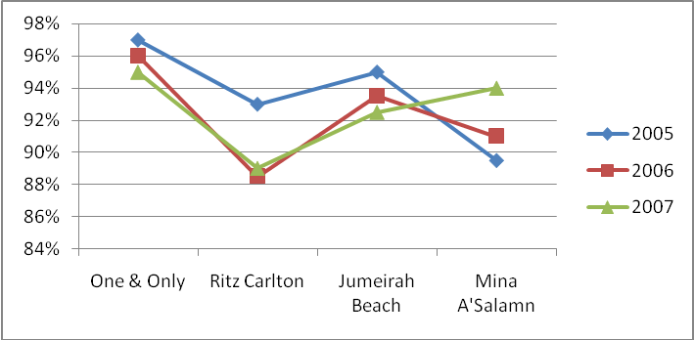
Source: Independent Research

With the exception of Mina A’Salam, occupancies at hotels within the competitive set peaked during 2005. In fact, Mina A’Salam is the only hotel within the competitive set that has increased year on year occupancy growth.

It should be noted, however, that all hotels within the competitive set experienced very high occupancies over 2005-2007 with the lowest occupancy being 88% realized by Ritz Carlton in 2006.

Figure 2-2
Competitive Set – Average Room Rate Evolution 2005-2007

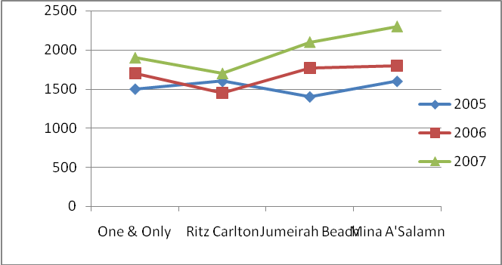
Source: Independent Research

Average room rates within the competitive set have shown year on year growth with the exception of Ritz Carlton whose 2006 ARR declined marginally from 2005 levels.

3.5 Competitive Set Seasonality Indicators (2006)

Figure 2-3 provides occupancies by month for year 2006 for competitive hotels. Hotels within the competitive set achieve high occupancies during November to April of a calendar year with occupancies declining through the summer. Notwithstanding, occupancies typically make a recovery in August before declining again in September. (Note: Ramadan took place on Sept 23rd up till the end of October in 2006).

Figure 2-3
Competitive Set – Seasonality 2006

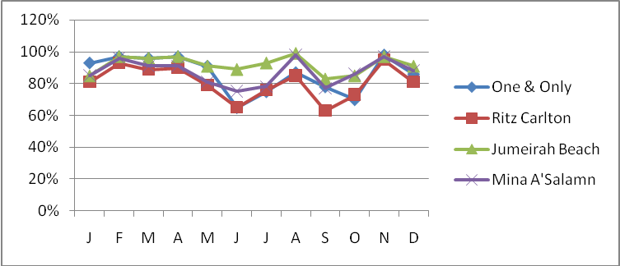
Sources: Independent Research

3.6 Competitive Set Rate Comparison

This section provides a high level overview of best available rates (BAR) for rooms and suites within competitive set properties. Best available are provided for deluxe room, standard suite, and luxury suite products (or equivalent).

Please note: best available rates provided are internet rates for bookings through October-November 2007. The rates are listed in UAE Dirham (AED).

Table 2-6
Competitive Set BAR Comparison
Competitive Set | Low BAR Deluxe | Middle BAR Suite | Higher BAR Suite
Burj Al Arab | 7,400 | 5,750 | 14,800
Ritz Carlton | 1,600 | 3,100 | 6,700
One & Only Royal Mirage | 1,900 | 4,520 | 13,010
Jumeirah Beach Hotel | 2,100 | 5,050 | 8,300
Mina’ A Salam | 1,950 | 2,550 | 5,900
Source: Independent Research; Hotel Websites

The average BAR rate for the deluxe room in AED 2c990, the average BAR rate for the 1st suite is AED 4,194, and the average BAR rate for the superior suite is AED 9,742.

Table 2-7
Competitive Set BAR Variance Analysis
Competitive Set | From Deluxe to the 1st Suite | From the 1st standard to the Superior Suite
Burj Al Arab | 10% | 45%
Ritz Carlton | 90% | 55%
One & Only Royal Mirage | 127% | 188%
Jumeirah Beach Hotel | 74% | 80%
Mina’ A Salam | 30% | 80%
Source: Independent Research; Hotel Websites

The average variation between the deluxe room and the 1st suite is 66%, the average difference between the 1st suite and the superior suite is 90%.

The following table provides RAC, BAR and BB rates for Burj Al Arab.

Table 2-8 Burj Al Arab Rack Rate and
Best Available Rates Sept-Nov 2007
Burj Al Arab | RAC (AED) | BAR (AED) | BB (AED)
Deluxe | 7,500 | 5,000 | 7,400
Panoramic View Suite | 8,250 | 5,750 | 8,150
Deluxe Suite | 15,000 | 10,000 | 14,800
Source: Independent Research; Hotel Websites

At the Burj Al Arab, the difference between the RAC and BAR rates is minimum of AED 2,000. The difference between RAC and BAR rates are relatively consistent with RAC rates being 140-150% BAR rates. This could be attributed to the fact that Burj Al Arab is an all suite hotel.

Table 2-9 Mina Al Salam Rack Rate and
Best Available Rates Sept-Nov 2007
Mina Al Salam | RAC (AED) | BAR (AED)
Deluxe | 3,000 | 1,950
Executive | 3,900 | 2,550
Arabian Gulf Suite | 7,000 | 5,900
Source: Independent Research; Hotel Websites

For Mina A’Salam, the difference in RAC and BAR rates vary between AED 1,000 – AED 1,500.

Table 2-10 Ritz Carlton Rack Rate and
Best Available Rates Sept-Nov 2007
Burj Al Arab | RAC (AED) | BAR (AED) | BB (AED)
Deluxe | 7,500 | 5,000 | 7,400
Panoramic View Suite | 8,250 | 5,750 | 8,150
Deluxe Suite | 15,000 | 10,000 | 14,800
Source: Independent Research; Hotel Websites

The Ritz Carlton offers a price variation from AED 1,800 to AED 4,835 between RAC and BAR rates with the luxury suites exhibiting larger differences than rooms.

The Ritz Carlton does not have many suites to offer; therefore the hotel generally avoids upgrading guests to ensure uniformity of treatment.

Table 2-11 Jumeirah Beach Hotel Rack Rate and
Best Available Rates Sept-Nov 2007
Jumeirah Beach Hotel | RAC (AED) | BAR (AED)
Deluxe | 2,900 | 2,100
Club Executive | 3,800 | 3,000
Ocean Suite | 5,050 | N.A.
Beachcomber | 6,640 | N.A.
Villa | 9,100 | 8,300
Source: Independent Research; Hotel Websites

Jumeirah Beach Hotel maintains a steady AED 800 differences between RAC and BAR rates regardless of room type. This in effect represents a set discount.

Table 2-12 One & Only Rack Rate and
Best Available Rates Sept-Nov 2007
Jumeirah Beach Hotel | RAC (AED) | BAR (AED)
Deluxe | 2,210 | 1,900
Gold Club | 2,630 | 2,370
Gold Suite | 5,020 | 4,520
Royal Suite | 14,460 | 13,010
Source: Independent Research; Hotel Websites

Difference in pricing between RAC and BAR at the One & Only, varies from AED 310 to AED 1,450. Notwithstanding, in percentage terms BAR rates are at a 10% discount to RAC rates.

4.0 SUITE PERFORMANCE

Table 3-1
Competitive Set Suite Performance Summary (2007)
Property Name |  | Total No. of Suites / Villa Rooms | ARR | OCC
Burj Al Arab |  | 202 | 3,643 | 72%
Madinat Jumeirah | Mina A’Salam Hotel & Al Qasr | 44 | 3,000 | 70%
Madinat Jumeirah | Dar Al Masyaf | 283 | 3,303 | 80%
One & Only Royal Mirage Dubai | The Palace & Arabian Court | 30 | 2,400 | 75%
One & Only Royal Mirage Dubai | Residence & Spa | 17 | 3,200 | 75%
Ritz-Carlton Dubai Hotel |  | 13 | 2,500 | 75%
Source: Independent Research (through Interview with Hotel Senior Management) *The single 2 bedroom villa at the One & Only Royal Mirage ‘Residence Spa’ achieves an average room rate of approximately AED 12,000 – 13,000.

Suites throughout the competitive set realized occupancies in the 70% - 80% range, performing approximately 15% points below the respective overall hotel occupancies. ARRs at suites ranged from AED 2,400 at the One & Only Royal Mirage ‘The Palace’ to AED 3,643 at the Burj Al Arab.

Additional information about demand trends for suites within the competitive set are provided below:

Suites at Ritz Carlton

- Though the Ritz Carlton caters to more of a business clientele than other hotels within the competitive set (estimated 40% business segment) suites at the hotel tend to be more popular among leisure guests due to its location on the beach.
- It is estimated that 90% of the suites are occupied by leisure guests who look for space, exclusivity, low noise level and privacy provided by Ritz-Carlton’s Suites.
- Due to moderately high occupancy all year round (75%), the Ritz Carlton does not typically upgrade room guests to suites.
- Leisure guests at the Ritz-Carlton spend the majority of their time in the hotel using the resort beach, pool, recreation area, gym and spa.
- The spa and beach are the most popular facilities in the hotel; the spa has a popular pool and children are not allowed in it.
- Golf is a very popular activity with almost every suite guest requesting the concierge to book a round of golf at least once during there stay.
- Room service is mostly used for breakfast as suite guests like to enjoy their breakfast on the balcony or terrace of their suites.
- Suite guests at the Ritz-Carlton tend to stay for 4 to 5 nights per visit.

Suites at Madinat Jumeirah: Mina Salam and Al Qasr

- During the high season (October-May), Eastern Europe is an important source market for suite guests. Additionally, suites are demanded by wealth Russian leisure travelers during the October – November which is Russian holiday season.
- In the low season, the important source markets are Western European (UK and Germany in particular) and GCC visitors.
- Furthermore, domestic tourism (e.g. visitors from Abu Dhabi) is an important source of revenue for the hotel during the low season. The hotel will also upgrade MICE and business visitors to suites during the low season in order to generate repeat business.
- Travel agents book approximately 70% of the bookings.
- The average length of stay in suites is about 3 to 4 days, increasing to 7-10 days over Christmas and the New Year.
- Suites guests tent to spend significant time in the hotel, and even when they do leave, they end up going to other Jumeirah Properties.
- Location acts as a main catalyst for demand since the resort is located in the nicest beach and one of the most prestigious areas in Dubai.
- Some of the key activities undertaken by suite guests include golfing, dessert safari’s and hot air ballooning.
- Room service tend to be popular mostly with guests from Kingdom of Saudi Arabia, otherwise many guests frequent the Souq at Madinat Jumeirah as there is a large number of restaurants to choose from.
- The Spa is very popular to both in-house and local guests.
- For kids, there are many parks and amenities which make the property a family friendly resort.

Suites at Madinat Jumeirah: Dar Al Masyaf

- The USP of Dar al Masyaf is the ultimate privacy provided by the resort; each villa gets 2 to 3 butlers who offer a comprehensive service from event bookings to serving dinner.
- The Spa facilities are extensively used by both in-house and local guests. The occupancy at the spa is about 85%.

Suites at One & Only Royal Mirage

- Majority of suite guests are from the UK and Germany.
- Suites guests normally book through a travel agent.
- Upgrades are normally offered to repeat guests, walk in guests on full rates, and on special occasions (wedding and anniversary celebrations). One & Only Royal Mirage do not have a loyalty program.
- 80% of suites guests are leisure guests.
- The percentage of repeat guests in the hotel varies from 45% in the low season to 60% in the high season.
- Suite guests tent to spend a lot of time in the hotel using its facilities with the beach being most popular.
- The spa and the hamman at the One & Only are very popular with the in-house guests.
- Generally suite guests at One & Only look for the unit size, privacy, availability of balcony, bathroom set up, and a well equipped living room.
- Due to most bookings being made through a travel agent, guest tend to dine in the hotel as it is included in the package.
- Room service is not the most popular service and is used mainly for breakfast meals.
- Golf and shopping are the most popular favourite activities of the guests staying at suites. The hotel arranges a shuttle bus Mall of the Emirates and Burjuman Centre.
- Due to the large gardens, the hotel isolates itself from the construction activity surrounding it.

APPENDICES

- APPENDIX: DUBAI HOTEL HISTORIC SUPPLY INDICATORS (2000-2006)

The following section provides a historical perspective (years 2000-2006) of Dubai hotel supply indicators. Preliminary supply indicators for year 2007 (Q1 and Q2) are presented in the main body of the report in Section 1.

Please note: For the purposed of this report. Luxury hotels are defined as five star properties as classified by the Dubai Department of Tourism and Commerce Marketing (DTCM). Similarly, other hotels comprise four, three, two, one star and listed hotels by DTCM classification.

The following table presents summary supply and demand indicators for Dubai hotels in 2006:

Table 4-1
Dubai Hotels Supply and Demand Summary (2006)
Category | 5-Star | 4-Star | Overall Al DXB Hotels
Supply Indicators
Operating Hotels | 40 | 40 | 302
Total Available Rooms | 11,806 | 5,990 | 30,850
Total Available Beds | 17,979 | 8,388 | 50,099
Demand Indicators
Room Occupancy Rate | 89.2% | 84.5% | 82%
Bed Occupancy Rate | 88.6% | 84.2% | 77.3%
ARR (AED) | 1,136 | 467 | 654
ARR(USD) | 311 | 128 | 179
RevPAR (AED) | 1,013 | 394 | 537
RevPAR (USD) | 278 | 108 | 147
Source: DTCM Statistics, 2006

In 2006 luxury hotels comprised 13% of Dubai hotel supply (40 hotels). At 17,796 available rooms, luxury hotel rooms comprised 58% of total available room’s inventory at all hotel in Dubai.

Similarly in 2006, luxury hotels provided 53% of all available beds in Dubai hotels at an average of 1.48 beds per room. Four star hotels provided marginally less beds per room than five star hotels (1.40 beds per room for four star hotels compared to 1.52 beds per room for 5 star hotels.

Average room rates (ARRs) at five star hotels in 2006 stood at AED 1,136 (USD 311) per room compared to AED 467 (USD 128) per room for four star hotels and AED 654 (USD 179) per room for the overall market. Five star hotels also enjoyed the highest occupancies (89.2%) out of all categories of hotels (market average 82% occupancy for all hotels). As such, RevPARs at five star properties averaged AED 1,013 (USD 278) per available room compared to AED 537 (USD 147) per available room for the market.

5.1 Luxury Hotel Supply Indicators (2000-2006)

The figure below represents the evolution of luxury hotel supply in Dubai between 2000-2006:

Figure 4-1 Luxury Hotel supply (2000-2006)

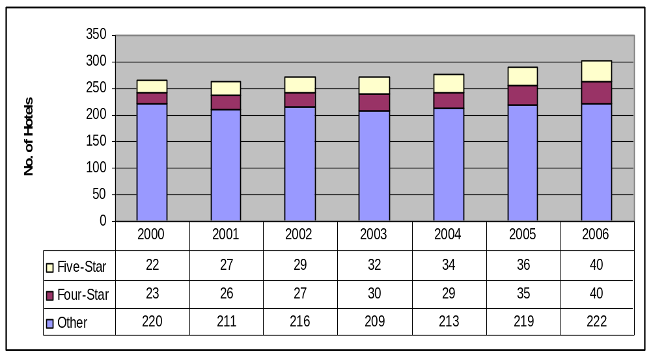
Source: DTCM Statistics, 2006

Overall hotel growth in Dubai from 265 hotels in year 2000 to 302 hotels in 2006 (14% growth was driven primarily by growth in luxury hotels. Luxury hotels grew 81.8% from 22 hotels in 2000 to 40 hotels in 2006 at a CAGR of 10.5% marginally out pacing four star hotel supply growth (73.9% growth at a CAGR of 9.7%).

5.2 Luxury Hotel Room Supply Indicators (2000-2006)

While luxury hotels comprised 13% of overall hotel supply in Dubai in year 2006, luxury hotels provided 38.3% of hotel room supply in the same year. Figure 4-2 presents the development of luxury hotel room supply in Dubai over the period 2000 – 2006.

Figure 4-2 Luxury Hotel Room Supply (2000-2006)

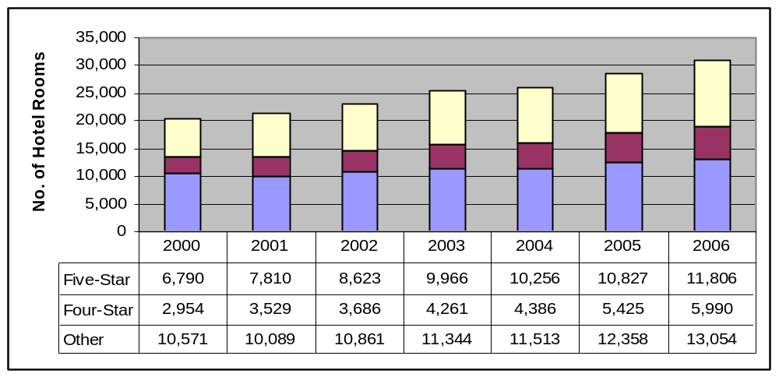
Source: DTCM Statistics, 2006

Overall, hotel room supply grew 51.9% from 20,315 rooms in 2000 to 30,850 rooms in 2006. Luxury hotel rooms grew 73.9% from 6,790 rooms in 2000 to 11,806 rooms in 2006. While four star hotel room grew faster than five star hotel rooms over the same period (CAGR of 12.5% for four star hotel rooms compared to CAGR of 9.7% for five star hotel rooms) five star hotel room supply at 11,806 rooms in year 2006 remains approximately double four star room supply.

5.3 Luxury Hotel Bed Supply Indicators (2000 – 2006)

The figure below present’s luxury presents luxury hotel bed supply in Dubai over the period 2000 – 2006:

Figure 4-3 Luxury Hotel Bed Supply 2000-2006

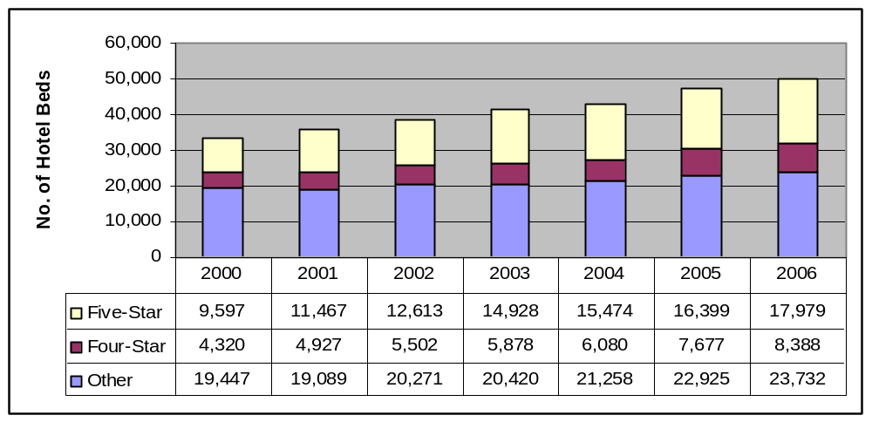
Source: DTCM Statistics, 2006
Overall, hotel bed supply grew 50.2% from 33,364 beds in 2000 to 50,099 beds in 2006. Luxury hotel beds grew87.3% over the same period with luxury hotel beds increasing from 9,597 beds in 2000 to 17,979 beds in 2006. Four star hotel bed growth marginally outpaced five star hotel bed growth, increasing 94.2% from 4,320 beds in 2000 to 8,388 beds in 2006.

On average, there were 1.52 beds per five star hotel room in year 2006 compared to 1.40 beds per four star hotel room.

6.0 APPENDIX: COMPETITIVE SET PERFORMANCE
INDICATORS (2005)

The following graphs compare competitive set hotel performance in terms of occupancy and average room rate in the year 2005.

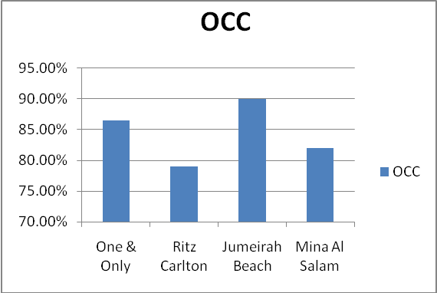
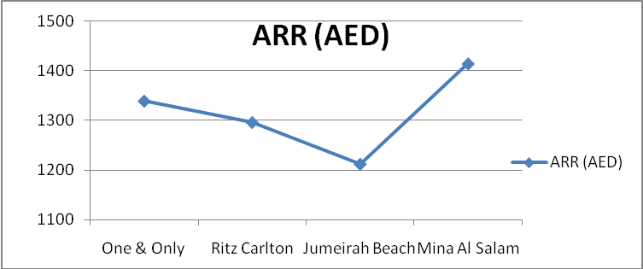
Source: Independent Research

Figure 5-2
Competitive Set-Select-Seasonality 2005

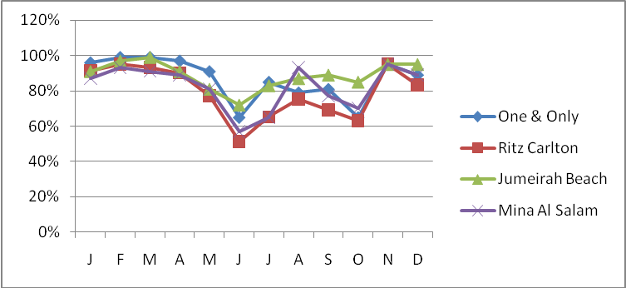
Sources: Independent Research

7.0 APPENDIX: ROOM FEATURES

7.1 Burj Al Arab
The all suite hotel offers the following categories of suites, starting from:

Deluxe Suite (1 Bedroom)
- Area 170 sqm
- Lower level: living room, large lounge, dining table for 4, private bar and guest washroom.
- Upper level: Dressing room, Bedroom with King or Twin size bed, luxury bathroom with Jacuzzi.
- Transport: Chauffeur driven Rolls Royce BMW available at a charge or helicopter transfers.

Panoramic Suites
- Floor to Glass windows
- Area 225 sqm
- Lower level: living room with large lounge, dining table for 4, private bar counter, guest washroom, storage closer.
- Upper Level: Bedroom with king size bed, luxury bathroom and dressing room.
- Chauffeur driven Rolls Royce BMW available at a charge or helicopter transfers.

Club suite (1 Bedroom)
- Spectacular view of both the sea and dessert.
- Area 330 sqm
- Lower lever: Living room with large lounge, full size snooker table, dining table for 6, cocktail bar, guest washroom, storage closet.
- Upper Level: Bedroom with king size bed, luxury bathroom and dressing room.
- Chauffeur driven Rolls Royce BMW available at a charge or helicopter transfers.

Two Bedroom Suite
- Large dining room with separate kitchen and two lounges
- Area 335 sqft
- Lower level: Living room with large lounge area, dining table for 6, kitchen and separate butler entrance, small lounge, guest washroom, office with chess table.
- Upper level: Master bedroom with king size bed and adjoining luxury.
- Bathroom and dressing room, second bedroom with twin beds and luxury bathroom.
- Chauffeur driven Rolls Royce BMW at a charge or helicopter transfers.

Three Bedroom Suite
- Area 670 sqm
- Lower level: 3 living areas, dining area with table for 8, kitchen and separate butler entrance, study area and library, private bar counter with seating for 4. Bedroom with twin beds and attached luxury bathroom.
- Upper level: 2 master bedrooms, each with king size bed and adjoining luxury bathroom.
- Chauffeur driven Rolls Royce BMW available at a charge or helicopter transfers.

Presidential Suite
- Area 667 SQM
- 24th floor
- Lower level: Spacious living area with private bar, large dining area with kitchen and separate butler entrance, study area and library, Majlis reception style lounge.
- Upper level: Master bedroom and second bedroom, each with adjoining marble bathrooms with spa bath, walk in shower fine porcelain fittings and full sized Hermes fragrances and body products.
- Chauffeur driven Rolls Royce BMW available at a charge or helicopter transfers.

For all suites at the Burj Al Arab:

Business Facilities
- Complimentary high speed internet access, office area, laptop, private telephone and facsimile, photocopier and data port within each suite.
- Access to a host of meeting, conference and event facilities
- Variety of restaurants and bars-ideal for lunch, entertainment, and private functions.

Entertainment Facilities
- Multimedia system – 42inch plasma screen, video on demand, 93 cable channels and DVD system.
- Range of DVDs and books to choose from
- Daily newspaper list with over 300 international newspapers to choose from
- Interactive online communication and hotel guide
- Complimentary access to Wild Wadi Water Park

7.2 Jumeirah Beach Hotel

Jumeirah Beach Hotel offers the following rooms and suites.

Ocean Deluxe Room:
- SQM area – approximately 50 square meters (538 square feet) for added comfort
- Special features – Choice of twin or king size beds, walk-in shower with separate bath and Gulf ocean views
- Occupancy – maximum 2 Adults and 2 Children below the age of 12, or 3 Adults. (Below the age of 12, 2 children free of charge. 12 year old children and above are considered as adults and will be subject to a supplement).

Ocean Club Executive Room:
- Area – approximately 50 square meters (538 square feet) for added comfort
- Special features – priority check in/out in the comfort of the Club Executive Lounge, luxurious amenities

Ocean Junior Suite:
- Average room area is approximately 105 square meters (1,130 square feet) for added comfort
- Special features – separate bedroom and living room.

One Bedroom Ocean Suite:
- Average room area is approximately 105 square meters (1,130 square feet) for added comfort
- Special features – combined bedroom with living room and sofa bed, dining table

Two Bedroom Ocean Suite:
- Average room area is approximately 162 square meters (1,744 square feet) for added comfort
- Special features – 2 bedrooms, one with en-suite bathroom, other with twin beds, living room, some with kitchen

Beachcomber Suite:
- Area – approximately 148 square meters (1,593 square feet) for added comfort
- Special features – 2 bedrooms, kitchenette, 2 sun beds

Presidential Suite:
- Special features – large bedroom on the upper floor with bathroom and whirlpool. Lower level living room with bar counter and terrace

Royal Ocean Suite:
- Area – approximately 216 square meters (2,325 square feet) for added comfort
- Special features – 1 bedroom with en-suite bathroom, large living room and dining table for 4 people, 2 mini bars, bar counter

Complimentary services for the above types of suites include the following:
- Guests have access to the Club Executive Lounge and breakfast is served in either La Parrilla, Latitude or in the comfort of your room.
- Guests with children have access to the Premium Leisure Club and breakfast is served in either the Premium Leisure Club, Latitude or in the comfort of your room.
- All day tea, coffee and soft drinks are served at the Club Executive and Premium Leisure lounges.
- Privilege access to the Club Executive Pool and Club Eight
- Pre-dinner canapés and cocktails
- Daily happy hour
- Complimentary internet access
- Selection of international newspapers and magazines
- Occupancy – maximum 2 Adults and 2 Children below the age of 12, or 3 adults. (Below the age of 12, 2 children free of charge. 12 year old children and above are considered as adults and will be subject to a supplement)
- Transport – complimentary & private transfers to and from Dubai International Airport (please provide 24 hours notice with flight details)

Bait Al Bahar:
- Special features – living room with high wood beamed roofs, King Bed with decorative canopies and bolstered cushions, luxurious bathroom with Jacuzzi, private bar counter

Complimentary Services
- Breakfast at Villa Beach restaurant
- Access to the Club Executive Lounge or Premium Leisure Lounge; Privilege access to the Club Executive Pool with exclusive use of private Majilis tents
- Privilege access to Club Eight
- Afternoon Tea or Coffee
- Pre-dinner canapés and cocktails
- Selection of international newspapers and magazines
- Complimentary internet access
- Daily happy hour
- Occupancy for One Bedroom Villa – maximum 2 Adults and 2 children below the age of 12, or 3 Adults (Below the age of 12, 2 children free of charge. 12 year old children and above are considered as adults and will be subject to a supplement)
- Occupancy for Two Bedroom Villa – maximum 4 Adults and 2 Children below the age of 12, or 5 Adults. (Below the age of 12, 2 children free of charge. 12 year old children and above are considered as adults and will be subject to a supplement)
- Transport – complimentary & private transfers to and from Dubai International Airport (please provide 24 hours notice with flight details).

For all suites within Jumeirah Beach Hotel:

Business Facilities
- High speed internet access, data port, private fax / printer, copier, voicemail

Entertainment Facilities
- Wide choice of satellite channels
- Unlimited access to Wild Wadi
- Sinbad’s kinds Club and Adventure playground.

7.3 Madinat Jumeirah: Mina’ A Salam

Mina A’Salam provides the following rooms and suites:

Deluxe Balcony Room:
- Area – 50 square meters (538 square foot)
- Special features – choice of twin or double size king beds, separate walk-in rainfall shower, bath and toilet, dressing area for added privacy, generous lounge area, floor to ceiling windows. Natural dark wood finishes with antique furnishings. All rooms are interconnecting.
- Occupancy – maximum 2 adults and 2 children below the age of 12, or 3 adults (Below the age of 12, 2 children are free of charge with existing bedding. Children 12 years old and above are considered as adult and will be subject to a supplement).
- Transport – private transfers to and from Dubai International Airport are available at a charge. 24 hours notice is required.
- Please note that supplement charge of AED 250 per room per night is applicable for ocean view rooms.

Club Executive / Premium Leisure Club Room
- Area – 50 square meters (538 square foot)
- Special features – Choice of twin or double king size beds, lavish bathrooms with separate walk-in rainfall shower, bath and toilet. High quality linens and fabrics, separate dressing area for added privacy, generous lounge area, floor to ceiling windows opening on to a private balcony. Interconnecting rooms are subject to availability.

Ocean Suite
- Area – 115 square meters (1,237 square foot)
- Special features – separate bedroom and dressing area, marble clad bathroom. Large bath with separate WC and walk-in rainfall shower. Spacious lounge and dining table.
- Generous balcony with gulf views

Arabian Gulf Suite:
- Area – 122 square meters (1,313 square foot)
- Special features – separate bedroom and dressing area, marble clad bathroom. Large bath with separate WC and walk-in rainfall shower. Spacious lounge and dining area with dining table. Magnificent private balcony with Gulf views.

Royal Suite:
- Area – 268 square meters (2,884 square foot)
- Special features – large intimate private lounge and dining area with table, separate office / study, 2 very large bedrooms, separate dressing areas, 2 capacious marble clad bathrooms, large circular Jacuzzi bath, walk-in rainfall showers, magnificent private balcony with Gulf views.

Complimentary services include the following:
- Unlimited access to the exclusive lounge area
- Transfer (BMW, Chrysler, Mercedes or Limousine) to and from
- Dubai International Airport
- Breakfast within the dedicated lounge
- All day beverages served in the lounge
- Afternoon tea served from 3.00pm to 4.30pm
- Pre-dinner canapés from 6.00pm to 8.00pm
- Private boardroom for meetings of up to 6 people
- Dedicated activities and facilities for children
- Priority check-in/out in the comfort of the Premium Leisure Lounge or Club Executive lounge
- Free pressing service (two items per stay)
- Dedicated guest relation team
- Occupancy – maximum 2 adults and 2 children below the age of 12 or 3 adults. (Below the age of 12, 2 children are free of charge with existing bedding. Children 12 years old and above are considered as adults and will be subject to a supplement)

For all suites within Mina A’Salam

Business Facilities
- Data Port
- Private Fax / Printer / Copier
- Voicemail

Entertainment Facilities
- Wild choice of Satellite Channels
- Television and radio
- Sinbad’s kids Club & Adventure Playground
- Access to Wild Wadi Water Park at a concessionary rate

7.4 Madinat Jumeirah: Al Qasr

Al Qasr offers the following and suite types:

Arabian Deluxe Room
- Area – 55 square meters (592 square foot)
- Special features – Private balconies with views of the Resort, a choice of twin or double king size beds, private dressing area, luxurious bathrooms with a large bath and walk in rain shower, antique furnishings and lounge seating area.
- Occupancy – maximum 2 adults and 2 children below the age of 12, or 3 adults. Below the age of 12, 2 children are free of charge with existing bedding. Children 12 years old and above are considered as adults and will be subject to a supplement)
- Transport – Private transfers to and from Dubai International Airport are available at a charge. 24 hours notice is required.

Ocean Deluxe Room:
- Area -55 square meters (592 square foot)
- Special Features – Private balconies with sea-facing aspects, choice of twin or double king size beds, private dressing area, luxurious bathrooms with a large bath and walk-in rain shower, antique furnishings and lounge seating area
- Occupancy – maximum 2 adults and 2 children below the age of 12, or 3 adults. Below the age of 12, 2 children are free of charge with existing bedding. Children 12 years old and above are considered as adults and will be subject to a supplement)
- Transport – Private transfers to and from Dubai International Airport are available at a charge. 24 hours notice is required.

Club Executive / Premium Leisure Club Room:
- Area – 55 square meters (892 square foot)
- Special Features – Private balconies with excellent views, king size beds, private dressing area, luxurious bathroom with large bath and walk-in rain shower, antique furnishings and lounge seating area.

Arabian Suite:
- Area – 105 square meters (1,130 square foot)
- Special Features – Large bedroom with separate lounge area, beautifully furnished in antique Arabian style, separate dining area, large balconies, terrace, large marble bathroom, luxurious in room amenities.
Junior Arabian Suite
- Area – 80 square meters (861 square foot)
- Special Features – Large bedroom with spacious lounge area, beautifully furnished in antique Arabian style, dining area, large private balconies, exquisite bathroom, luxurious in room amenities

Ocean Suite:
- Area – 105 square meters (1,130 square foot)
- Special Features – Large bedroom with spacious lounge area, beautifully furnished in antique Arabian style, dining area, large private balconies, exquisite bathroom, luxurious in room amenities

Junior Ocean Suite:
- Area – 80 square meters (861 square foot)
- Special Features – Large bedroom with spacious lounge, beautifully furnished in antique Arabian style, commanding ocean views, terrace and an individual balcony, large bathrooms and luxurious in room amenities.

Presidential Suite:
- Area – 180 square meters (1,937 square foot)
- Special Features – 2 large bedrooms, a separate lounge area, discreetly individual lift, en-suite bathrooms, separate bath and walk-in rain shower, luxurious fittings, large terrace and balcony

Royal Suite:
- Area – 550 square meters (5,920 square foot)
- Special Features – Majlis, large private terrace, 3 large bedrooms each with private dressing areas, en-suite bathrooms, large lounge area, separate dining area , 3 separate and private lifts.

Complimentary services:
- Unlimited access to the dedicated private lounge areas
- Transfer (BMW, Chrysler, Mercedes, or Limousine) to and from Dubai International Airport
- Breakfast within the dedicated lounge
- All day beverages served in the lounge
- Afternoon tea served from 3.00pm to 4.30pm
- Pre-dinner canapés from 6.00pm to 8.00pm
- Private boardroom for meetings of up to 6 people
- Dedicated activities and facilities for children
- Priority check in/out in the comfort of the Premium Leisure lounge
- Dedicated guest relations team
- Occupancy – maximum 2 adults and 2 children below the age of 12, or 3 adults. Below the age of 12, 2 children are free of charge with existing bedding. Children 12 years old and above are considered as adults and will be subject to a supplement)

For all Suites within Al Qasr:

Business Facilities Within Suite
- Data Port
- Private Fax / Printer / Copier
- Voicemail
- Secretarial Service

Entertainment Facilities
- Wide Choice of satellite channels
- Television and radio
- Sinbad’s Kids Club & Adventure Playground

7.5 Madinat Jumeirah: Dar Al Masyaf

Arabian Summer Houses, Approached through an enchanting, gardened central courtyard, the Arabian summer houses are entered through a large Arabic style door to reveal a space of sumptuous quality and stylish decorative themes. Arabian heritage is omnipresent in these exquisite properties, furnished in the warm tones and ochre hues redolent of times past.

Arabian Deluxe:
- Area – 60 square meters (645 square foot)
- Special Features – A large bedroom with lounge seating area, authentic Arabian furnishings, intricate detailing, luxurious room amenities, marble bathroom with walk-in rain shower and roll-topped bathtub, wide terrace and private butler service
- Occupancy – maximum 2 adults and 2 children below the age of 12, or 3 adults. (Below the age of 12, 2 children are free of charge with existing bedding. Children 12 years old and above are considered as adults and will be subject to a supplement).
- Transport – private transfers to and from Dubai International Airport are available at a charge. 24 hour notice is required.

Arabian Suite:
- Area – 130 square meters (1,453 square foot)
- Special Features – large rooms comprising of lounge, dining area, a superb bedroom and spacious marble bathroom, two private terraces, luxurious in-room amenities, exclusive shared pools, private butler service.

Arabian Deluxe:
- Area – 60 square meters (645 square foot)
- Special Features – Large bedroom with lounge seating area, very large bathroom, private and secluded terrace with views of the magnificent landscaped gardens, private butler service.
- Occupancy – maximum 2 adults and 2 children below the age of 12, or 3 adults. (Below the age of 12, 2 children are free of charge with existing bedding. Children 12 years old and above are considered as adults and will be subject to a supplement).
- Transport – private transfers to and from Dubai International Airport are available at a charge. 24 hour notice is required.

Arabian Suite:
- Area – 120 square meters (1,291 square foot)
- Special Features – The suite comprises a large bedroom, separate ‘majlis’ and sumptuous lounge area, 2 large terraces with views of the adjacent waterways and the passing abra, peacefully secluded, spacious bathrooms, walk-in showers, luxurious in room amenities, 24 hours private butler service, accessed by waterways.

Ocean Deluxe:
- Area – 60 square meters (645 square foot)
- Special Features – A large bedroom with lounge seating area, beautifully furnished in antique Arabian Style, luxurious room amenities, intricately detailed bathroom with free-standing bath and walk-in rain shower, private butler service
- Occupancy – maximum 2 adults and 2 children below the age of 12, or 3 adults. (Below the age of 12, 2 children are free of charge with existing bedding. Children 12 years old and above are considered as adults and will be subject to a supplement).
- Transport – private transfers to and from Dubai International Airport are available at a charge. 24 hour notice is required.

Ocean Suite:
- Area – 120 square meters (1,291 square foot)
- Special Features – The suite comprises a large bedroom, separate ‘majlis’ lounge, sumptuous bathroom, walk-in rain shower, luxurious in room amenities, authentic Arabian furnishings and private butler service. Two wide balconies offer superb beachside aspects with easy access to the beach
- Occupancy – maximum 2 adults and 2 children below the age of 12, or 3 adults. (Below the age of 12, 2 children are free of charge with existing bedding. Children 12 years old and above are considered as adults and will be subject to a supplement)

Complimentary Services:
- Transfer (BMW, Chrysler, Mercedes or Limousine) to and from Dubai international Airport
- Pre-dinner drinks in the Majlis of each individual summerhouse from 6.00pm to 8.00pm
- Breakfast at Khaymat Al Bahar of Arboretum inclusive

All suites within Dar Al Masyaf:

Business Facilities
- Data Port
- Private Fax / Printer / Copier
- Voicemail

Entertainment Facilities
- Wide Choice of satellite channels
- Television and ratio
- Sinbad’s Kids Club & Adventure Playground

7.6 The One and Only Royal Mirage

Rooms and suites within the ‘Palace’:

Deluxe Room:
- Area – 45 square meters
- Sea Facing
- Private Balcony
- Custom made furniture

Executive Suite:
- Area – 100 square meters
- King size bed
- Contemporary artwork

Gold Club Room:
- Access to the Gold Club.
- Area – 45 square meters

Gold Club Suite:
- Area – 100 square meters
- Access to the Gold Club

Royal Suite:
- Area – 325 square meters
- Two bedrooms
- Separate living room
- Large Balcony
- Walk-in Wardrobe
- Private Kitchenette

Rooms and suites within the ‘Arabian Court’:

Deluxe Room:
- Bathroom are adorned with wood, marble and slate
- Area – 50 square meters

Executive Suite:
- Area – 125 square meters
- Arabian Foyer
- Dining Area
- Guest Toilet
- Spacious Balcony

Prince Suite:
- 145 square meters
- Outdoor Terrace
- Majlis style seating
- Entrance Foyer
- Dining Area
- Guest Toilet
- Separate bedroom

7.7 Ritz Calton

Deluxe Room:
- One bedroom with seating area
- Choice of one King or two Queen beds
- Bathrooms include separate WC and bidet, two hand basins, bath and shower
- Private balcony or patio
- Pool and garden views

Club Room:
- Located on the 5th and 6th floors
- One bedroom with seating area
- Choice of one King or two Queen beds
- Bathrooms include separate WC and bidet, two hand basins, bath and shower
- Private balcony or patio
- Sea views
- DVD player
- Ritz-Calton Club Lounge privilege from 6:00am – 2.00am daily

Emirates Suites:
- Deluxe bedroom with spacious lounge/dining room
- Private outdoor terrace leading from the lounge
- Sea views
- DVD player

Executive Suite:
- Deluxe double room with King size bed
- Sitting room separated by French doors
- Bathrooms include separate WC and bidet, two hand basins, bath and shower
- Private balcony or patio
- Pool and garden views

The Ritz Carlton Suite:
- Deluxe bedroom with four-poster bed
- Separate dressing area and built-in wardrobes
- Adjoining guestroom can create two – bedroom suites
- Beautifully furnished lounge and dining area
- Kitchen
- Marble bathroom with sauna, steam room, shower, bath and Jacuzzi
- DVD player

- Bibliography

Aleesie, L. (October 2007). Things Get Personnel in Dubai. HVS International, London.

Clarke, C. (May 2007). Middle East Hotel Industry Leads the World in Performance. Article 4Hoteliers.

Colliers International. Dubai Real Estate Overview. Market Research, Fourth Quarter. Economic Highlights (2007)

Department of Tourism & Commerce Marketing – various reports and press releases, 2006 – 2007

Goddard, P (2006). Ready for 30 Million Room Nights? TRI Hospitality Consulting.

HVS International (2007). Middle East Hotel Survey – Outlook, Market Trends and Opportunities, London.

Industry Experts Expect Blue Skies Ahead for Regional and Global Hospitality Sectors, Arabian Hotel Investment Conference (AHIC, May 2007), ‘Global Aspirations’ Madinat Jumeirah Conference Centre. Dubai UAE.

Leeman, S. & Younes, E. (November 2005). HVS International, The Dubai Hotel Market – Hot or Soon To Overheat?

Hotelier Middle East, June 2007 – June 2008

Hotel Investment Sector is Soaring But Still Room for Growth, Arabian Hotel Investment Conference (AHIC, May 2008), ‘Global Aspirations’ Madinat Jumeirah Conference Centre. Dubai UAE.

Middle East Review – Comprehensive Real Estate & Investment Management Expertise. Strong Market Forces for UAE Hotels. Jones Lang LaSalle. Volume 7, 2007

Real Estate & Investment Middle East. 31 July 2007.

Steinmetz, T (21 May 2008). Dubai Bubble: About to Burst. Global Travel Industry News.

The Future of Travel and Tourism in the Middle East – a Vision to 2020 – Global Futures and Foresight Pathfinder Report May 1st 2007

Towering Vision Becomes Concrete Reality – The Hotel Show 2007 Catalogue and Industry Yearbook

Web Links

Red Sea Projects to Attract SR150 Billion – KSA http://www.menafn.com/qn_news_story_s.asp?StoryId=1093153388

Bawadi to double investment
http://archive.gulfnews.com/ar t icles/07/05/13/10124872.html

7-star hotel to be opened in Iran http://www.presstv.ir/detail.aspx?id=10759&sectionid=351020108

Emaar to Construct 2 New Projects in Egypt
http://www.menafn.com/qn_news_story_s.asp?StoryId=1093150428

Movenpick to be part of a major tourism project in Oman
http://www.traveldailynews.com/new.asp?newid=37422&subcategory_id=59

Abu Dhabi unveils big eco-tourism project
http://archive.gulfnews.com/articles/07/04/30/10121879.html

www.greenglobe.org

www.tripadvisor.com

Construction waste recycling plant set up
http://archive.gulfnews.com/ar t icles/07/05/23/10127168.html

Najwa finalises agreement ASEZA to develop Wadi Rum project. http://www.menafn.com/qn_news_story_s.asp?StoryId=1093151715

Fairmont goes green
http://www.arabianbusiness.com/index.php?option=com_content&view=article&id=12993

Masdar launches first zero-carbon city
http://www.tradearabia.com/news/newsdetails.asp?Sn=ENV&artid=123262

UNEP to monitor water usage in Arab cities
http://archive.gulfnews.com/ar t icles/07/05/24/10127404.html

Dubai hotels wasteful http://www.ameinfo.com/120642.html

Kuwait must spend $27bn on power
http://www.arabianbusiness.com/index.php?option=com_content&view=article&id=13386:Kuwait-must-spend-27bn-on-power&Itemid=1

Arabs need $345bn for energy http://www.ameinfo.com/121694.html

