EDUCATION DOCTORATE
AREA

HUMAN DEVELOMENT

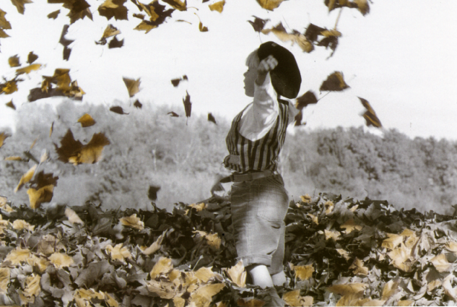

Literary Production:

“Genuine Human Stories” (With your permission, humanity, now it is our turn
to live).

By:
Martha Elena Valdés Lizárraga
ID: UD2079HHD6134
Email: marthika65@aol.com

July, 2006.

Table of Contents

Page

Introduction……………………………………………………………… 3

Poems

Waking Up……………………………………………………………………….. 6
The Miniscule Stature of Humanity…………………………………………... 9
A Hidden Treasure…………………………………………………….............. 11
I Am Not Alone…………………………………………………………............. 12
Ink of Light………………………………………………………………………. 13

Stories

Hope in Life……………………………………………..………………………… 17
A Comet Seen Through Dark Lenses……….………..………………………… 20
A Lasting Smile………………………………………..………………………….. 22

Monologue

An image, a mirror. Perhaps This Is “I”? ................................................. 26
A New Song………………………………………………………………………. 28

I n t r o d u c t i o n

Because my existence proceeds
from the fountain inexhaustible joy,
I offer my dreams to the divine light,
the spring of the inspiration from “the holy one”.

The softness and delicacy of the spirit has its subtle manifestation through the written word, verse or prose, harmoniously, covered up with free thoughts woven in open mind. This mind is without bonds; the spirit invites the mind to travel and, leads the creative imagination on a trip with no destination point. The trip is dizzying and penetrates the most intimate fibers of the body that sprout, like sparkling lights and with the permission of the conscience, use words as mediators.

The words approximately take a photograph like the effect of the ray that penetrates the heart and the mind as a literary dreamer.

As the thoughts silently announce that they are resting an allegorical manifestation is generated in the feelings. The serotonin show their conformity and loyalty to the heart; that in turn knocks on the door of the spirit, which without delay, pushing the energetic flow, removes its garments to let out the spontaneity and profundity of the human being.

Thus, the evolution of the conscious in perceived rapidly through any type or genre of writing that occasionally remains like an explosion of repressed feelings. In the projection of the “I”, the shadow, and the centaur follow. And in others it is the vivid presence of the spirit that covers these cloaks of fictitious mental creation and flourishes brightly, accompanied by the chant of the cosmic universe.

In this moment there is no time, no space; these remain in nothingness. There is only a profound perception of peace, harmony, and conciliation with humanity. From a compassionate and empathetic state, human beings fight on imperceptible scales, between turbulent demons and melodious angels. That fight resides in one’s own intimacy where triumph is negated by sublime sentiments. Cybernetic humanity awards a trophy to the human passions that give a hand to suffering, rancor, anger, jealously, and avarice. Human beings are sunk in a black hole, as they confusingly nap in the shade of negation of life, smothering the most sublime right of existence.

The tendency to flee from the goodness of life qualifies this stage as dehumanizing and antipoetic.

Literary expression has been limited, as our conscious is limited to the point where it is similar to a balsam, where we human beings write when there is suffering in our hearts.

Nevertheless, this period of literary creation emerges as a necessity of my spirit, of my commitment of existence. Or perhaps, it rises from my ego; I don’t know. The journey through poetry, stories and monologues will give you permission, my friends, the readers, to enjoy with me the trip I wish to undertake.

Thank you for being here and now let us accompany each other on that truly solitary experience. Do not quit being a restorer, so that my spirit and yours that wish to wake up from this nightmare of millenniums would resoundingly beg to wake up in one universal conscious.

Thank you, humanity of centuries, for being part of me. To you I dedicate this literary compendium, titled: “Genuine Human Stories” (With your permission, humanity, now it is our turn to live).

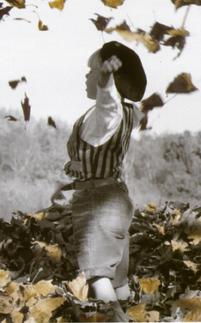

Waking Up

A bitter song of prayer
engulfs the gale of human inspiration.
from all sides the clamor
of pain rings out.

Oh, human race? What do you harbor?
Resentments, wrath, and rancor,
crushing the tenderness inherent
in the beat of each heart

The discovery of new paths
sanctifies the justice;
and in the dark room infinite
anguish and worry hide.

Human beings, brothers,
if what occurs does not disturb our intellect
or our magnificent invention,
why aren’t we content with such opulent radiance?

And Mother Earth is teaching
with patience and understanding
that there are no borders that divide
the infinite creative cosmos.

Unity, integrity, and connection
are the lessons modern selves must learn
before our stubborn determination
destroys our home.

I am sure that wisdom
is not an intellectual invention,
but is the compass that steadies
the horizon of the integrated man.

Wisdom is the orchestrated love
of mankind, nature, and celestial universe
that synchronizes silently
and echoes with sonorous silence.

Still, we acknowledge the marvels of technology,
scientific advances, the orbiting of the planets.
Meanwhile, the imbalance of humanity grows
Like a noxious weed devouring the harvest.

We call in unison
for a compassionate dialogue
that sows
transcendent change.

Bringing out the beauty
of a curative universe,
embracing the multi-ethnic bloom
and feeding the destitute.

The richness of spirit
will emerge to admire its mission,
lacing its ties
in one heart.

Decisive dreams cry out
in my ardent intimacy,
upon seeing this humanity
relishing such close joy.

Here you are happy, vibrating
like the birth of a sun;
the face of a mother leans over you,
cloaking you with caresses.

Winds and chills fall from the West
tidal waves from the East,
we go to the peak of the mountain
to contemplate our disdain.

If our group consciousness emerges
there would be new roads,
that are not decayed discourses,
rather spirit with a child’s innocent laughter.

Rivers, prairies and lakes,
mountains, deserts and pines,
comets, stars and moons
dance like witnesses.

Come on! Move consciousness!
Awaken from your millennium-year old sleepwalk!
Realize that the solution for your invented conflict
Is near, very near.

Without dogmas, tortures, or myths
divest the known effortlessly from your heart,
as you realize that your only answer lies
in the intimacy of your nest.

A nest with the scent of flowers,
with the taste of honey,
and the sound of warbling
frolicking with pleasure.

Thank you life, thank you death,
for this present, unitarily perceived,
without rules, or borders, or differences,
secluded silence, so alone, dissolved in total emptiness.

The Miniscule Stature of Humanity

The miniscule stature of humanity
spurts up in each divided brain.
While the eternal prescience of the mobile universe
awaits patiently the dim but redemptive light.

A golden infinity, magnificent,
grows even in the twilight of a painful life,
from obscurity, from agitated whirling;
every instant shapes a linked whole.

Every movement, every silence, every tear
forms a cosmic dance,
sketches destinies in song,
composes rhythms of vibrant fantasy.

Our life is an unfinished melody
that with sweet notes and lost tunes
stirs a sole song in wandering life,
and bitter sweetly contrasts joy with wounds.

The most intimate essence of mankind
awaits the mythical introspection.
While individuals masking their routines
Trust the obstinacy of evasive deeds.

There is no echo that thunders in the silence
there is no movement that doesn’t shake the cosmic harmony
and no individual who with strength satisfies his infinite interior
and reconciles with life giving love to his own self.

Brotherhood is only lived from the profound.
Looking tenderly to the Olympic, we see
our face reflected, transformed,
like birds with intuitive wings.

Worries are alleviated.
Rebellion increases
and from the union between universe and self
an authentic act of love takes flight.

Like a drop of water that joins in the sea
we merge together in the endless ocean of our lives
and with varied hues we paint our encounters,
deciding, approving or renouncing our union with the eternal.
Not conforming with what we have or are,
unconscious of the lived moment
we ramble with debris
that freezes our repressed potential.

Look, falsehood blocks you.
With a gust of truth you erode.
However, the trained mind corrals you and contradicts
any intent of a conscious state.

Our quivering union is impossible to imagine.
To conquer human yearning,
authentic love must move in balance.
The confidence to exist reaches out a hand to us.

A Hidden Treasure

I hiked fatigued into the mountains
and at the peak exhaustion detained me on a rock.
I contemplated the union of sky and earth
behind a sunset that illuminated the atmosphere.

I realized the scarcity of time we dedicate
to meeting with Nature’s offerings.
Each day we scorn her celestial displays.
Still they give us ineffable tonalities, a grand esteem for life.

For an instant I felt like a leaf fallen from a tree in autumn.
Living without respite, amid crushing noises and intense fear
of reflection, of discovery of myself -- behind the silence --
the treasure that lies hidden and asphyxiated inside.

Still, the fallen leaves, yellowing and lifeless,
reminded me that in the tree from which they grew there is a lesson:
“Return fearlessly to green life, bravely, in a pastoral cycle.
Open your arms to the loving birds and give breath to all else.”

I recognized the futile distance between myself and nature,
that I must shed the heavy life of routine
and face the stubbornness that alienates me,
leaves me without delight in hues and essences.

Then, I could gaze upon the sky, the earth, the ground, the sea,
with gladness, and a great vitality and energy.
I realized the marvels granted us by the planet
that shares, without laws, theories, or racial divide.

Behold the teachings granted us by nature.
Men walk without seeing the footprints they leave on the path;
Thinking only of control, force, power,
determined to travel the road that will dominate all else.

Fallacy that clouds human vision,
when will we see with clarity?
When we embrace nature’s hidden treasure.
We must not lose an instant of its marvels.

I Am Not Alone

Walking, with nostalgia,
I wanted to cover my face.
Was solitude this black cloud
that shrouded me at whim?

I cried, I screamed, distressed.
Beseechingly, I asked the cosmos
for a moment of peace.
I knew something was about to happen.

I could not resist; I felt it approach
and overwhelm me with shrieking,
crippling my soul time after time.
I confronted my irate, depressed shadow.

My soul leaned away.
I didn’t want to hear more
of this furious self
that incited me to quarrel.

For a moment, my ego seized power.
At the mercy of that bitter outburst,
I lamented my impure existence,
my life of challenge, my love of singularity.

But my inner voice relieved me
and succored me in that emptiness.
“You are not alone. You are not alone.”
It sprang up, insistent, like the dew.

When I heard this tiny voice, stirring
between my temples, I burst into tears,
and with joy I welcomed the unnamable
nestled in the folds of my mind.

Sobbing, I stayed in silence,
delighting in this sweet company,
fulfilled by an encounter
without bonds, without guilt, without melancholy.

I ask only that this light illuminate me forever.
I am ready to follow the path it lights
as a spirit at peace
with the truth of the universe.

Ink of Light

With the fragrance of a cold morning,
I nestled, grateful
for this life, this breath
that gently wakes my cells.

For a moment, my stubborn desires rested.
My adventures were tired.
Ink, like a tender light,
clearly illuminated the path.

Behind my earthly vision, blurry and flat,
a compassionate melancholy lay
dormant in my internal fibers,
calling for a new awareness.

I imagined myself in such solitude that life flourished,
joyful, bitterness fading into memory.
The magic of that galactic consciousness
broke the false bonds of my purgatory.

I sketched a planet in tune,
where we humans beamed.
We met ourselves, emerging from obscurity,
to the universe’s cosmic rhythms.

On the planet, an infinite light
enveloped both night and day, both hemispheres.
It sheltered us all without distrust,
without differences. The tranquil silence thrummed.

Harmony transcended words;
we lived in peace, without religious bias.
With “mitzvah” we translated comfort, compassion.
With heartfelt “shalom” we ourselves transcended.

We walked without shadow, without hindrance,
with wisdom, with humility, with the joyous cries
of having found, in an instant,
a new universe beyond centuries.

The group mind beat in tune;
it traveled with sure steps,
without imagined worries,
with the torch’s light spread to all corners.

And millions of people appeared.
Elbow to elbow they trembled at the encounter:
Mother Theresa of Calcutta, Gandhi, Parahamanda
fenced along the drawn-out path.

Krishnamurti, Ramayana:
they too smiled with visible ease.
We awoke to the eternal
with our consciousness timelessly united.

Our minds, in ecstatic vibration,
Found what was lost
from the parts of ourselves impeded by ego.
They expanded and shone on the truth. .

Mother Nature stayed still,
contemplative, content, waiting
for bewildered humans
to see certainty with the three eyes of knowledge..

At once, the trees extended their arms,
forgiving humanity for its neglect.
With a prayer of earthly resurrection,
we embraced, resting in a place of mercy. .

Though I had only dreamed, and translated that dream
to paper, I know it is the throbbing vision of all humans
aware of the destruction of beauty.
We pray that more enlightened ink shines.

In cosmic resonance, small lights burned,
and centuries of humanity connected,
achieving the just, the true, and the beautiful,
breathing in immensity, without dogmas.

Humanity, only a blink of an eye and you cease
to carry regret with you. You awaken heartily
and give up your armor. You are rebuilt.
Lean on a foundation of peace and felicity for the whole world.

Bless all humanity.
Oh that the strength of collective prayer
would transform vanity to wisdom
and the material mirage would yield to joy.



Hope in Life

Confronting a mountain of papers of the day, correspondence and notes, “Hope” overworked by the humor, the agony and the sweat of the ordinary, toiled at the same time as trying to achieve a childhood dream that intensified like a whirlwind every instant of her life. It was an internal voice that told her “come on write, let out your spirit that knows the essence of awakening an inspiration, timeless, without space… eternal.”

As she worked “I” observed her carefully. She felt something pushed her; something in her transcended.

“Well, what are you doing?”, “The Boss” surprised her in a pensive state.

Hope jumped and responded “I’ perceive, living my existence. No! Excuse me, organizing, yes, of course, organizing the mail.

“The Boss”, impatiently and with an authoritative tone states: Hurry up, as your sighs cut the little activity in your brain and make people less productive. Let’s go! Let’s go! Hurry up! Minutes are dollars and hours are…” -pausing with an astute gesture and continuing as she savored that philosophy that will bring her the future-. “… mmmm, more dollars, a fortune.”

“Ma’am, ma’am, wait”, with a warm smile and with the coolness of a transparent heart, Hope inquired “What flavor and aroma does your life have?”

“What?. What?, What flavor does my life have? Ha! Forget about that question. One can see that you continue in the same way, imagining possible worlds that don’t exist. Questions that take away time. Let’s see, tell me who would be interested these days, where…modernism reigns and technology shakes our brains. That’s only for those who behind comic glasses and a pen and paper believe they are saviors of the world. These are the ones called, mmmm, yes philosophers, authors, and they are no more than screwed up vagrants lost in the dimension of time and ones that say that life should believed in harmony and criticize any type of business deals. Thus, they consider PROO-GRESS like the extermination of reality. Tremendous fools. What pains in the neck they are, ingrates. So, how do they survive? Where does their substance come from?

Hope, with a sweet and insistent smile, repeated the question: “ma’am, what flavor and aroma does your life have?”

“Ha!, Ha!, Ha! She halted and turned with an offensive look, turning her head negatively and said: “It’s as if, you foolish girl, that thinking of this useless way of life would give the planet change of direction and… the human mind would miraculously change.

“The Boss” gave a half-turn and walked towards her office, Somewhat perplexed she stopped, altered her mocking face, at the same time turning and realizing that the relaxing of her face was clear. The uncertainty of the complexity already occurred by then. Walking with slow steps, she stopped at the door and simulate her wisdom, her face transformed from malice and manipulation and said energetically. “Don’t you see that entertaining yourself with this is pure utopia, fantasy, craziness, Chinese stories. Go, put your feet on “The Earth” and move your fingers with great speed on the keyboard for which we hired you. We pay you pretty well, so don’t rob time immersed in this nonsense.”

Hope was my companion my whole life. “I” felt an intense affection for her. And although I didn’t tell her, I thought her perception of life was something strange, so strange that…

I repeated to her insistently: “Friend, friend, I like your simplicity and this…how…how can I explain it; I don’t know. This naivete of yours, this unexpected harmony. See, I don’t know but it is something that is felt deep inside, way down, yes, yes in the spirit. It’s like a lovely indescribable energy that sooths and calms the demons that lie in the entrails of this body. And its creases become more pronounced over the years. But I can’t lie to you. You are so close to me. And you know that I feel tremendously and inexplicably confused. There is a distance between good and bad, between love and hate there is another; and between…well, let’s see, why do I talk of distances? Also, what is between me and my soul?... I don’t want to reply. Although I want to hide it with spoken words, well-spun empty talk surely, there is dread, fear, emptiness, vast emptiness. And after, after I ask my self what there is beyond this mind that lives in fantasy about that imagined future full of illusions, dreams that God knows will happen.

My self, “If I exist contemplating the past and discerning the future, when do I live?” What flavor does my fugitive life have in his moment, this eternal moment. Already, already, enough, I don’t want to think any more “The Boss” is?? The sort of successful woman, who secured by “blue blood” doesn’t connect with those matters that could appear and debilitate her iron heart. She is afraid to let go of mask after mask, since to do so, brings dread and of course destroys the fascination, the sweetness, or as Stop! Stop! But why such complication. Look what I am creating in y head. Really, after all, “The Boss” is rich ostentatious. Her demeanor is high class with enormous jewels, no less this choker of 18 karat gold that rests on her neck. Yes, yes, a neck of an elephant. I can’t imagine the sum of money she spent. Ay, mother! I know I’ve let my tongue out and offended this funny mammal. Although she is rough and massive, she is so tender that she lures ones fascination, similar to a magnet, attracting those who have a child like spirit.

Although Hope and I conversed profoundly our values of life were opposite. While “I” “the mind” analyzed and scrutinized everything, my faithful friend, Hope, took a few minutes of peace for herself and experienced a pleasant affection for life. Therefore the constant observations of the boss didn’t worry me at all as the practical intelligence of Hope was up to all tests, demonstrating a great ability and excellence in all of her tasks. These were impeccable, end with a touch of creativity that wouldn’t have even occurred to “The Boss”.

Her tasks were submitted timely. And although “The Boss” would never tell her, she always learned from Hope. The boss signed the reports, and because of their qualify they appeared in the newspapers of the community. And of course “The Boss” photograph appear, the jewels always will displayed, whose size could be confused with the soundness of her face. It was just a reflection of the abundant spicy food, the pleasures of tequila, the nocturnal sleeplessness in the plaza that were in favor of planetary life.”

Strangely it was the presence of Hope that softened me. Sometimes we chatted, and sometimes I didn’t find her, perhaps because I spent too much time on the business of the day. Nevertheless, I was in the habit of writing, and this allowed me to be closer to her.

In Hope’s diary entry that day there was a note that conveyed:

Today I feel in harmony, thinking about the unity of my being that gently trebles at the contact with this energy. This intersection is knocked over with contentment an orchestral music by the stars of the cosmos, witnesses to this transformation and connection with my molecular particles and the great infinite immortality.

An aroma is perceived, hummmm, and smells of peace, justice and equality. I listen; I see; I turn over in the space without space, in the timelessness. In the… si-len-ce, si-len-ce, I go; I go. I flow to the vacuity where my spirit is flooded with profound, nameable joy. I feel one with the world, one with the universe, one with “The holy one”. This is indescribable. It is more than a sensation. It is …LOVE, farther away than time and space, in the implicit order of the marvelous cosmic creation, without limits, without borders and in complete creative freedom.

September 6, 2012.

I only know that Hope is in a cosmic dimension. And although it is difficult to understand, it is the internal light, burning and vibrant. We cannot perceive it because of our eclipsing and bewildering routine.

Here am I; Here are you; and where is Hope? Tell me. What flavor and aroma does your life at this moment, our lives?

A comet through dark lenses

On the eve of a comet, the crowds were entrenched, eagerly waiting to witness of the most surprising phenomenon of the Universe.

The hours passed more slowly. The shouts were heard; and there were pushing and panting. No doubt, the phenomenon turned into a carnival. The vendors did not miss the event, offering large 3-D glasses that insured the best view of the spectacle. On each corner, in aloud commercial voice, they announced: “These are the best! A reasonable price, try them. Don’t let yourself be deceived by those: these are glare-proof.”

Nevertheless, there was some truth to the propaganda. The spectators should have protected themselves from any type of alteration of light provoked by the crossing of this announced event and the chaotic state of weakness of the earth.

As the squeezing was getting more and more intense, the sky silently cleared its corpulent clouds to open the curtains of the immense infinity, without charging a price, with emblematic dance, to reveal the apparition of one of the most captivating marvels.

Besides the fever of the promoters of the glasses, there were hundreds of creatures consuming corn cobs, peanuts and all sorts of junk food, contaminated by the impure air of the environment, capable of causing tremendous digestive explosions. The streets filled up with beer and liquor. And the young girls paraded in their tailored clothes intentionally provoking the hormonal fluttering of the boys and also the malicious old men, who looked out of the corners of their eyes in front of their wives!, vigilance and their impish kids.

Mandito asked, “When is the sky going to paint itself?”

“Don’t be impatient, child. The comet will come at it’s determined time. Hey, hey! Don’t be foolish. Don’t remain without a seat Run; look; there’s someone with his eye to the sky. And surely at the first distraction, you’ll remain speechless.

As evening approached, the forecast of the astronomers seemed to lose the exactness of the event. The updates jolted the people, waiting impatiently. Suddenly, the stars were more visible in the twilight.

“Mad, mad, is the sky sleeping?”

“No, Mandito, evening is coming and night is filling the sky.”

“But, where is the tail, that you told me would be large and colored with diamonds?”

“Now you will see it and will confirm what we read in that story. Come on; eat your French fries and drink your soda. Stop your questions for a moment.”

Suddenly, unexpectedly a great smoke filled the sky. A missile had exploded in the vicinity of the town.

The terrorized people left in a flash. The celestial spectacle was covered up, and the little boy was prevented from admiring that which he had longed to view.

“Mad, you told me that it was a long bright tail that covered the sky. I think you made a mistake. Instead of giving me clear glasses, you bought me dark ones, and I saw he universe as black.”

Mandito kept the illusion of experiencing the comet and in his diary he drew a black spot. At the bottom of the paper he wrote in large letters: “IF I HADN’T WORN DARK LENSES I would have fulfilled what mad told me in my dreams about that beautiful comet that happily invaded our sky with light”.

A Lasting Smile

I was enticed by the idea of my professor of Psychology who insisted on the value of the smile. Using anatomical explanations, she showed us that our jaw was strengthened each time we smiled. It was a fantastic exercise to reduce the crevices that clung to our face, with the passing of time to denote the accentuation of old age.

“Do I look old?” queried my professor, “look at me well, for the age that I am. The scar of the years only stayed in those that didn’t know how to move their dentures and they are for from appreciating that beautiful gift they could get by smiling. A sincere smile, with love and comfort gives strength to the soul to energetically propel its flight.

Look around you; marvel for a minute at the street. Observe the huddle faces that travel, like plastic objects of wax, hard, tense. Others walk, nodding their heads, bearing the exhaustion. But it seems they don’t recognize; they don’t feel human. With a lost gaze they count the minutes, prolonged minutes without strength to continue with…

The usual.

Yes, with the routine.

I asked my teacher if I could share an incident that had impacted my life. It had to do with my grandmother who smiled all the time.

Your grandmother, well also mine.

And mine.

And mine.

Shhhh! Well, tell us what you have learned from life.

I remember with joy, the days that I spent with my grandmother; she always possessed a smile. She was a beautiful woman. I thought she would live forever, and her body would not wrinkle. I assure you that I never saw her as old; she was always full of life. She shared her coffee; milk and rolls with anyone who had the kindness to greet her and declare, “what a beautiful day this is”!

Look what devotion you had for her. These are fantasies of yours. Foolishness!

Let her finish; you always interrupt when the stories have a rich taste of melancholy, it seems everything bothers your that doesn’t agree with your bad temper and sophisticated life of superficial magazines, luxury cars and your impoverished soul.

Well, I continued with my crystalline eyes, remembering the image of my grand mother, who in the mornings greeted her neighbors. She took her basket and brought food from the nearby store to hand out. She watered her garden and pet the birds and dogs that turned up to meet her. The little gifts were not lacking for the line of grandchildren. And we were there on each of grandchildren. And we were there on each birthday to receive her affection. The music played while she regaled us with soda, beans and grand repertoire of stories.

Time passed; and while I grew up, in all of the situations of my life, the image of my grandmother remained fresh in my mind on weekends I ran to see her and enjoy her smile. This smile, full of charm offered me a look that was different from books, professors, he university, scientists, theories, social modals and so much babbling that invites combat, envy and hides beauty.

With her I felt alive and eternally young. I felt that it was potential nourishment for my spirit to return to comprehending the structural roles of divisions through culture, music and attire.

I comprehended then that life can’t be studied through a microscope, or on printed papers. We needed to feel it, live it each moment, without delay, without dogmas like that . We spontaneously fearlessly open the door that leads us to the gibberish of the verbally inexplicable of the inner soul.

My grandmother offered so much teaching, that even on her deathbed this smile remained eternally pleasing, like an angel of light, gratefully she concluded one or phase on Earth with wisdom.

With moist eyes, but yet satisfied, I concluded my story grateful for life for giving me an opportunity to have a grandmother for whom time lacked value, coming after her mission of life to share her riches and internal integrity.

From then on, professor and friends, I haven’t renounced the smile, and I tell you with conviction that it’s one of the gifts that life gives us freely, to accept that we are a shared essence. Important ideas don’t have a price. Life in this eternal moment teaches us that a smile is the communication of love.

My teacher, with happy intonation said: “Take the eternal youth and invigorate our spirit every day by practicing a smile that lasts further away than the boundaries of life and enter in contact with beauty.

My friends, shaken with memories, raised their hands to continue the episodes lived with the eternal value of a smile that comes from within.

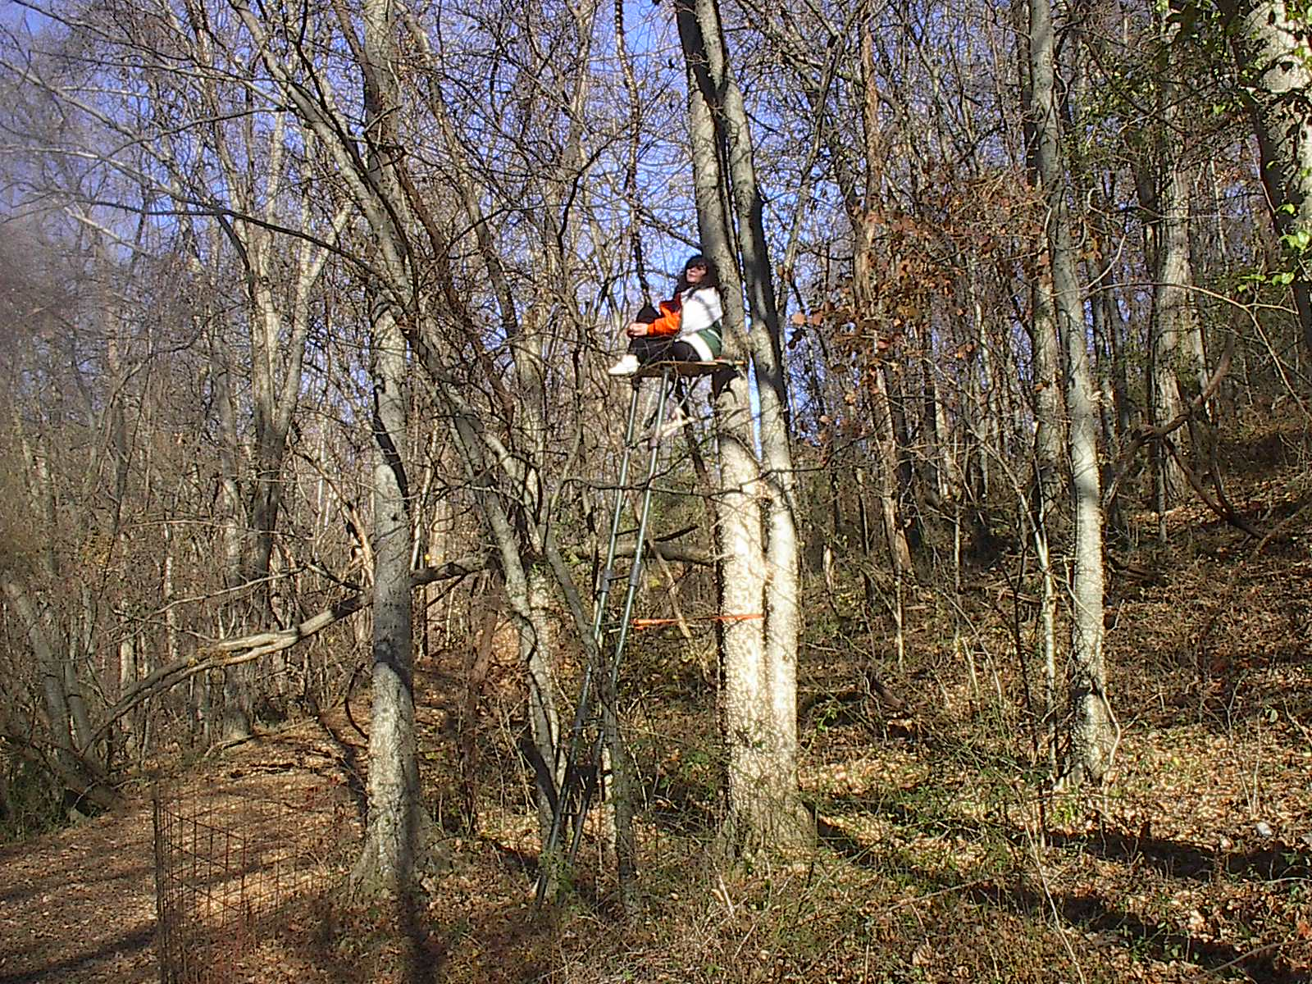

An Image; a mirror; perhaps this is “I”

My image is formed in the mirror.
Is that me? The one who carries a first name, a last name, a profession.
I’d be too insignificant to imagine I’m merely a name tag stuck on, and I strive in the corner of silence to recognize that I am part of everything.

The test is like a scientific approach that reveals its frequent discoveries. However, my intuition confirms, without parameters at hand that I am not this floating body, or these fake masks that only satisfy human desires.

I perfect my goals with the ink of pseudo intellectualism, on paper they remain inscribed.

A flutter of obstinacy, whims, presumptions, vanity like the glass of a goblet, they disintegrate.

Among the yeses and nos, my thoughts dart about a culture installed in my brain about an ego perched on a throne on the familiar byway and about and internal voice, bursting into the emptiness.

I resist a change,
Yes, of the theatrical role of life, I tell myself at he same time, without hesitation, perhaps, is our existence so poor that it has defined notes.

These are the absurd thoughts, of my intellect stressed with concepts that similar to the hum of notes are repeated in my academic discourses: Creativity! Ingenuity! These are armed with snags.

However, I peer at my image again in the mirror and I pause a long my eyes, I admire the rarity of nature that has given me two doors connected to the external, and even one more to the eternal.

I can’t resign my self to the absurd material world where the parade of fashion ins deceptively consecrated or the comedy of dancers with tattoos that search for peace, taking advantage of the dark side of commercial barbarism.

My yearning returns to my iris, to my hand, to my mind,
To energy, to movement, to everything,
where de body is unfolded in the cosmos penetrating,
receiving the totality from the minimum substance of who we are.

My face is happy being the mirror,
Displaying a hop for life
The road replies without turning back,
Before the majestic light of this my third eye.

A New Song

I repeated over and over, for many years, the melody of Julio Iglesias that penetrated my bones and I wanted to be part of the tune, when I heard it, I confused my misery, my sadness, my exhaustion, my rebelliousness. But well, I believed it gave emotion to my life. I couldn’t find the way to shake off the memory. I felt as if the song was sculpting my mortal confinement.

How can I continue with the torture of a miserable song and create dark resonance from my life? How can so many years elapse and I am nothing more than a fly, without wings, waiting for the fictions image of this memory to appear. And I would tell my self, “Come on when are we going to share the laughter?”

The ego is a terrible mystery, and with disguises I am converted into a marionette of thought, bogged down in the comic books of my opulent mixed heritage, my color, and my cowardice to leave my own burial.

I am hidden behind the glasses of fame. I hurriedly reject my I latent intimacy; I review my labels of fashion, consulting cosmetologists, to tug my hanging skin. I expose my body, my skin, my wrinkles to subjects who don’t even share even a speck of universal love.

I visualize my arrival to these bizarre places. When I enter, immediately the utilitarian symbol that unites the hemispheres is stamped on their faces: Yes, $$$. Maybe you don’t recall, but even in your dreams, you idolize it. But, let’s continue with the consolation. The eyes of these crows shine with avarice, contemplating how much money they will take, persuading me with sweet phrases. With hollow resonance, they shake my esteem, my value, my self confidence and …my money.

How could my mind not notice the indomitable fraudulent world? This frenetic world of exotic make-up lines and, transformations of wrinkles, stretching tugs of skin that transfigure our childhood smiles that always accompany us.

We have constructed an unhinged world I humbly ask pardon for those who can survive this chaotic creation of unbalance. Give permission to the eternal light of wisdom to shine without return, with profound vibration on the state of true consciousness.

Vibrate; pray; define yourself like a complete being in harmony. Shake off the cobwebs of your memory, of your songs, of the world that we have grotesquely sketched with divisive lines, with strong biases, with stigmas, with songs that circle the globe, offering bitterness, uncertainty and hopelessness. Revenge the fragile, hardened minds that seize ingenuity and negate without scruples, ridiculing all that is related to beauty.

Surely the world would be different if we took small pauses that connected us to our existence, pauses, pauses, pauses that transport us to the serenity of our existence.

Act already, well, yes, it’s alright; repeat the melody, Now, Linger; listen to it with a benevolent heart, with your transcendent spirit, with your generous love.

Have you found a trace of it? No! I know. Because in the inevitable flowing of your intelligence, you will realize that the magic of your life is placed in that underplayed immensity. Life, once conquered, will bring new songs that will illuminate your consciousness. It will fortify the unity of hearts, in the immeasurable harmonious balance of this life, and all lives, recreating the existence and all lives, recreating the existence and harmonizing in melodies like this one:

♫

I have sketched a road that leads to yours
Without stepping on your liberty
We touch, shoulder to shoulder
Without invading your dreams
We give each other strong energy
We feel each others’ emotions, we look at each other
And you see your lovely image through my eyes.

Your pupils are beautiful when seen through mine
Delicate hands soften my actions
Melodious songs harmonize our hearts
Your goodness radiates my presence in everything.

Your hands have touched my spine
And you have given tranquility to my delirium
You have accepted my random journey
And with a loving spirit your, have helped me
Sketching the road that leads to brotherhood
Without returning back.

I have painted my steps in life, firm and sure
With my hand resting on you shoulder,
With the benediction of your loving spirit
That circles in the dance of the cosmos.
♫

