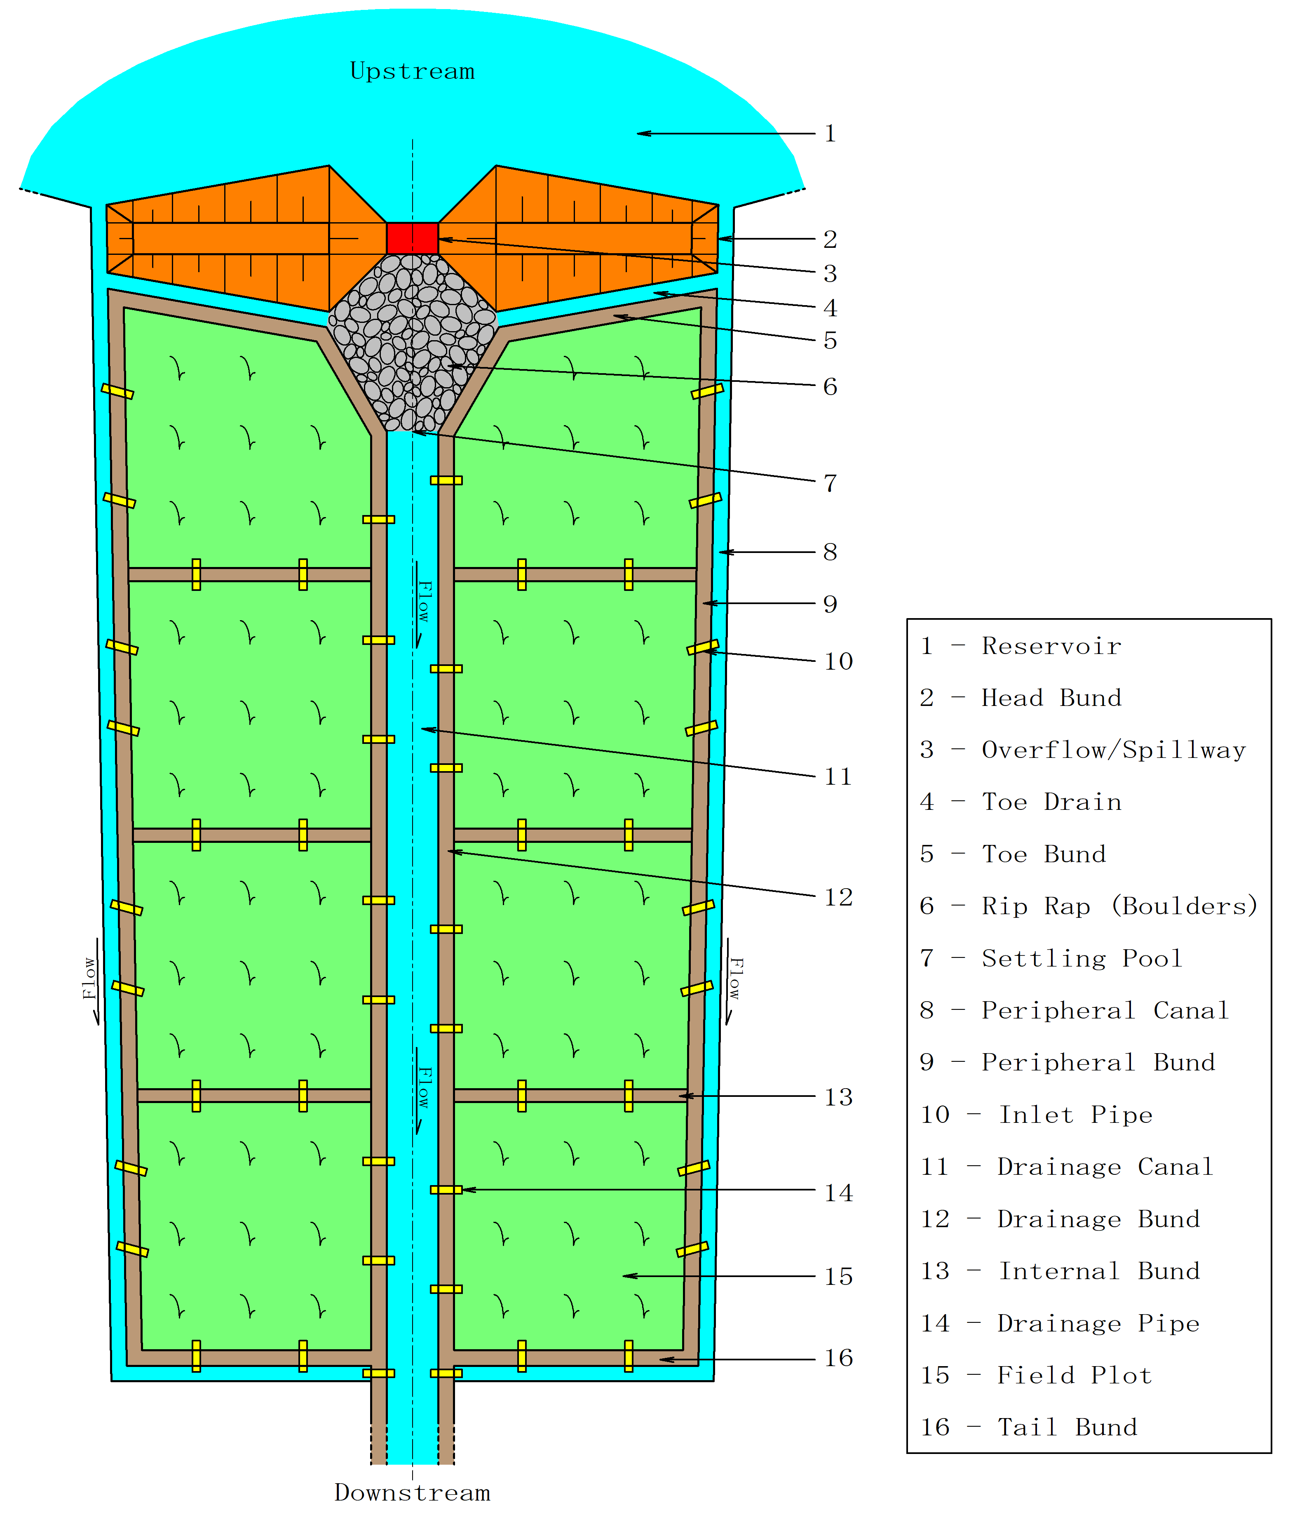
INLAND VALLEY SWAMP (IVS) DEVELOPMENT
A
TRAINING MANUAL
FOR IRRIGATION/LAND DEVELOPMENT PERSONNEL

2022

INLAND VALLEY SWAMP (IVS) DEVELOPMENT

A

TRAINING MANUAL

FOR IRRIGATION/ LAND DEVELOPMENT PERSONNEL

PREPARED BY

ABDUL RAHMAN KAMARA (DR.)
IRRIGATION/WATER RESOURCES ENGINEER

AGRICULTURAL ENGINEERING DIVISION

MINISTRY OF AGRICULTURE
SIERRA LEONE

2022

Table of Contents Page
i. About the manual …………………………………………………………………….. i
1. Introduction …………………………………………………………………………… 1
1.1. Definition of Inland Valley Swamp (IVS) ……………………………………..… 2
1.2. Classification of inland valley swamps ……………………………………...….. 3
1.3. Common features of a developed IVS ………………………………………….. 4
2.0. Criteria for swamp selection ……………………………………………………… 6
2.1. Water regime and hydrologic information ……………………..……………... 6
2.2. Size and production potential of the swamp …………………..…………….. 7
2.3. Labour availability …………………………………………………..…………...7
2.4. Enthusiasm and willingness for development by the selected community...8
2.5. Ease of development …………………………………………………………....8
2.6. Institutional capacity or level of organization of the farmers ……………......9
2.7. Access to land ……………………………………………………………………9
2.8. Accessibility ……………………………………………………………………...10
2.9. Nature of catchment ……………………………………………………….……10
3.0. Swamp implementation procedures …………………………………………….11
3.1. Criteria for identification of swamp fringes/edges........................................12
3.1.1. Slope …………………………………………………………………………12
3.1.2. Vegetation ……………………………………………………………,……. 12
3.1.3. Soil condition …………………………………………………………...….. 13
3.1.4. Soil moisture content ……………………………………………………….13
3.1.5. Spread of sand ……………………………………………………………...13
3.2. Felling and stump removal…...………………………………………………….13
3.3. Placement and construction of peripheral canals …………..…..……………14
3.3.1. Placement of peripheral canals …………………………..………………..14
3.3.2. Lay outing of peripheral canals …....……………. ………………………..18
3.3.3. Construction procedures of peripheral canals ……………………………19
3.4. Placement and construction of peripheral bunds……… ……….......………. 22
3.5. Location and construction of drainage canals……………………………...….25
3.6. Location and construction of drainage bunds ……………………………..….26
3.7. Construction of head bund/mini dam and overflow/spillway…………………28
3.7.1. Head bund construction …………………………………………………….28
3.7.2. Overflow/spillway construction ……………………………………………..31
3.8. Construction of internal bunds ………………………………………………….35
3.8.1. Contour bund …………………………………………………………………36
3.8.2. Rectangular bund …………………………………………………………….37
4.0. Complementary activities/processes ……………………………………………38
4.1. Levelling ………………………………………………………………………….38
4.2. Installation of irrigation and drainage pipes …………………………………..40
4.3. Catchment protection/conservation …………………………………………...44
5.0. References..………………………………………………………………………..46

ABOUT THE MANUAL
This Manual seeks to provide requisite information, skills and appropriate techniques needed in the development of inland valley swamps with a view to enhancing double/triple cropping of major food crops especially rice, this being the staple food for many countries as well as the production of vegetables on sustainable basis. Simple but technically robust and environmentally friendly swamp implementation methods and procedures which have been tested in the field and found to be technically acceptable, form part of this manual. This field guide contains clear illustrations of basic swamp development methods, procedures and practices that have been tested in the field and found to be ideal, appropriate and workable. It is an implementation instrument/guide which could be used by youths, technicians and engineers engaged in swamp development as procedures, methods and practice are very much simplified and can easily be understood, adopted and implemented by practicing Inland Valley Swamp (IVS) development personnel with little or no difficulty.
In Sierra Leone, different design options, procedures and implementation methods have been adopted by both national and internal organizations involved in IVS development resulting in vast variations or differences in the dimensions of water control and retention structures. Most of those approaches have however proved to be counterproductive as they have not achieved the objective of swamp development since little attention was given to use of basic engineering principles and methods as related to swamp development. The essence of this manual therefore, is to present a unified approach in swamp development for better performance of water control structures leading to the full utilization of developed/rehabilitated inland valley swamps, with a view to enhancing production and productivity of major food crops, especially rice. It is hoped that this manual will be of great assistance to swamp development staff as well as youths who wish to choose agricultural engineering as a career, with special interest in swamp development.
As a reference material, the Manual intends to make positive contributions to proven sustainable swamp development practice(s) with a view to maximizing crop production that will enhance the economic status of the farmers, and hence improving the standard of living of the rural communities (Farmers). It should however be borne in mind that this is not an IVS design manual with equations or formulae for determining hydraulic parameters of canals and the dimensions of the various IVS water control infrastructures.
It is expected that the design of the various water control infrastructures would have been carried out by a well-trained and qualified irrigation/rural infrastructure engineer. The role of the field staff/supervisor therefore is to implement the designs of the various water control infrastructures in the field in accordance with designs prepared by the engineer. The implementation methods and procedures in this training manual are well explained and illustrations contained herein further create room for better understanding and application of IVS procedures, methods and practice.
This manual which is a reflection of over thirty years of field experience of the author and is envisaged to essentially serve as a guiding tool or working document/reference material for the construction of the various water control infrastructures in inland valley swamps in order to enhance better water management in the paddy fields, so as to enhance production and productivity of various food crops, especially rice.

CHAPTER 1. INTRODUCTION
In Sierra Leone, there are 5 (Five) agro-ecologies suitable for the production of a variety of food crops. These agro-ecologies are classified into; upland and lowland. The lowlands constitute inland valley swamps, mangrove swamps, boliland and riverine grassland. Being part of the lowlands, the IVS agro-ecology provides the enabling environment for crop diversification, land intensification and expansion geared towards increased production and productivity of food crops on a sustainable basis, thus leading to the achievement of sustainable food security. Besides crop production, inland fish farming (aquaculture) could also be practiced in inland valley swamps, thus providing the required protein in the diet of the rural communities. Serious efforts have been made by the government to move the farmers away from the uplands since upland farming encourages felling of trees accompanied by some adverse effects, such as erosion, deforestation, diminished rainfall, etc. It is an open secret that climate change is here, therefore adequate and appropriate actions should be taken by governments to put it under control.
Deforestation and unwise use of land and water resources create negative consequences on countries that are working tremendously hard to produce enough food to feed their people. Having seriously considered this objective therefore, the government of Sierra Leone has laid serious emphases on the meaningful exploitation/utilization of inland valley swamps for sustainable food production, especially the staple food, rice. A lot of efforts have been made to move the farmers from the upland to the lowlands so as to reduce the negative effects of upland farming (deforestation) which normally contributes to decline in soil fertility, progressive erosion and steady decline in rainfall quantities.
Sierra Leone has a total surface area of about 690,000 hectares of Inland Valley Swamps of which not more than 5% have been completely developed and made functional and effective for the production of food crops, especially rice. The area under irrigation/swamp development is considered low, especially so when the achievement of food security is contingent on the implementation/development and maintenance of irrigation schemes/infrastructures on a sustainable basis. Sustainable and economically viable swamp development/rehabilitation must encompass the development/improvement of the entire swamp continuum/toposequence for higher economic benefits for farmers. The meaningful exploitation of the swamp continuum will lead to increase and continuous food production and steady cash flow for the farmers, since other food crops could be cultivated on the lower slopes, tree crops in the middle slopes and forest trees on the upper slopes.
The valley bottoms or inland valley swamps have the advantage of multiple crop production leading to an improvement in the economic status and the standard of living of the rural community farmers. That notwithstanding however, these swamps have to be technically investigated so as to determine the best design/engineering options as every swamp has its own peculiarity. The development of inland valley swamps falls under small-scale irrigation scheme. This category of irrigation can be defined as irrigation, usually on small plots in which stallholder farmers have the controlling influence, using a level of technology which can effectively be operated, maintained and managed by the farmers. Small-scale irrigation is now considered to be a more appropriate option as a result of the following;
- It costs less to construct
- Takes less time to complete
- Causes less disruption to the population and to the environment, provided they have been properly involved
- Is more likely to be supported by the local people

In spite of the very high potential for crop production in the IVS however, this agro-ecology is negatively affected by: (a) inadequate drainage; (b) irregular/uncontrolled flooding due to lack of water management; (c) Water-borne diseases; and (d) inadequate residual moisture and water supply during the dry season (Some of the swamps).
The performance of the various water control infrastructures is dependent on the appropriateness of the designs which should be done by a well-trained and qualified irrigation/rural infrastructure/hydraulic engineer or hydrologist. The engineer or hydrologist would have to make use of hydrologic/hydrometric information, topographic, contour and soils maps amongst other information in order to carry out the most appropriate designs for all the water control infrastructures. It therefore stands to reason that before a swamp is developed, hydrologic studies, topographic and soils surveys should be conducted so that technically robust, environmentally friendly and socially acceptable water control infrastructures that will stand the test of time would be designed and implemented for the benefit of the farmers.

  - DEFINITION OF AN INLAND VALLEY SWAMP (IVS)

Inland valley swamp (IVS) can be defined as the upper sections of a river drainage system, comprising valley bottoms, their hydromorphic fringes and flood plains. In its simplest form however, an Inland Valley Swamp, commonly called IVS in Sierra Leone, can be defined as a piece of wet land located between two uplands. They are usually concave in shape with varying slopes (from gentle to steep) depending on their location in the drainage system.
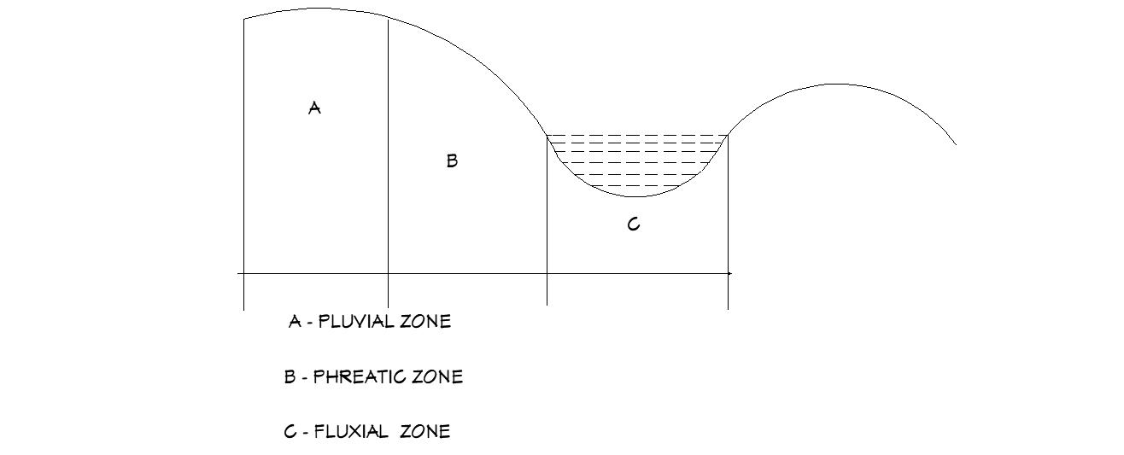
Figure 1. IVS toposequence
Source: - Inland Valleys in West Africa. An Agro-ecological characterization of rice growing environment, by Andriesse W. and P. N. Windmeijer

1.2. CLASSIFICATION OF INLAND VALLEY SWAMPS
In terms of water regime, Inland Valley Swamps (IVSs) can be classified into two main groups or categories; namely, perennial and seasonal. Perennial swamps are swamps, which can hold surface water throughout the year. Whereas seasonal swamps can hold surface water for some part of the year only.
Inland valley swamps (IVS) in Sierra Leone for example, using surface water can be classified, on the basis of their water regime, into three categories;
- Inland valley swamps with surface water all year round with potential for 2-3 crops per year (P1).

- Inland Valley Swamps with surface water until end of February with potential for 1-2 crops per year (P2)

- Inland Valley Swamps with surface water until mid-December, with potential for one crop per year (P3).
By virtue of the fact that swamp development is geared towards multiple cropping, it is advisable to always select swamps which fall under categories P1 and P2. In certain areas where there are more of (P2) and (P3) than (P1), (P3) could also be selected but the development of such swamps require serious technical measures that will lead to multiple cropping.

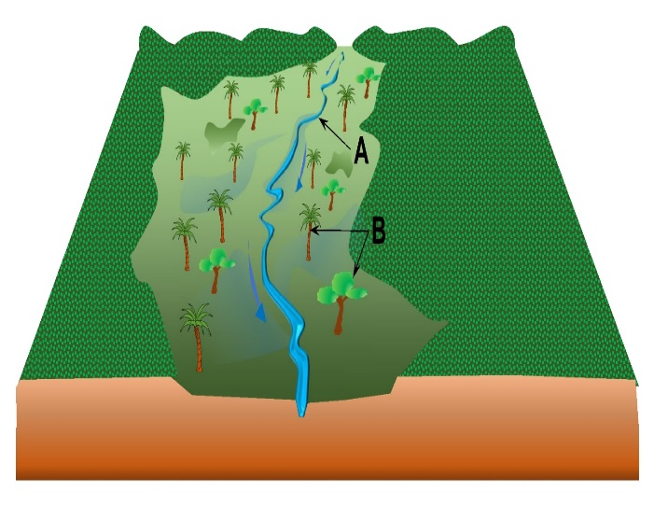
A – Natural stream
B – Natural vegetation

Figure 2. An undeveloped Inland Valley Swamp (IVS)

1.3. COMMON FEATURES OF A DEVELOPED SWAMP
Hydrologically and geomorphologically speaking, no two swamps are the same. After development however, that is, when all the water control infrastructures would have been constructed, all developed swamps must have all the features indicated in figure 3 below;
Figure 3. Diagram of a developed inland valley swamp
However, other design options suggest the use of gates to be installed at the canal intakes of the peripheral/irrigation canals in order to regulate flow as well as to conserve water in the reservoir to be used for crop production in the dry season.

CHAPTER 2. CRITERIA FOR SWAMP SELECTION
Swamp development is a tedious exercise and also highly technical. Therefore, this exercise should not be ventured into without obtaining the requisite information (bio-physical characteristics among others) of the selected sites for development or rehabilitation. In the process of selecting the most suitable swamps for development, it is strongly advised that due consideration be given to swamps that fulfill the under mentioned criteria. The process of selecting a swamp is very important because it will provide the necessary guidance that will lead to successful implementation, sustainability of the scheme and great performance of the water control infrastructures leading to increase in production and productivity of major food crops, especially rice.
In the process of conducting inland valley swamps identification, investigation/assessment and selection for development, due consideration must be given to the undermentioned criteria amongst others, if the most ideal/suitable swamps are to be selected.

2.1. Water regime and hydrological information
This is a very important criteria as it can determine whether a particular swamp could be used multiple times or not for the production of food crops, especially rice. This means that the source of water (River, stream, spring, underground, etc.) must be reliable and should therefore be ascertained before a swamp is finally selected. In order to obtain such information, hydrologic and hydrometric studies/stream flow measurements have to be conducted. The studies would lead to the development of hyetographs (Rainfall depth versus time) and hydrographs (flow versus time) leading to the determination of low, mean and peak discharges of the water source. it is advisable to obtain all climatic information or data from institutions This information would be very useful in the design of the various water control infrastructures. In the event that such information cannot be generated, responsible for conducting such studies, such as meteorological department.
Once requisite information or data is obtained from the relevant institution(s), it is then analyzed to determine return period, in the case of rainfall. This information is useful in the sizing of water control infrastructures. Another very important information is obtained from flow measurement to determine the reliability of the water source to support the proposed irrigation scheme. This information hereinafter referred to as peak discharge (Q_{p}) would be compared with design discharge (Q_{d}) which is determined using requisite formulae for sizing the water control infrastructures (Canals, head bunds, overflows, etc.). The most ideal swamps for development are perennial swamps, i.e. swamps with surface running water throughout the year. It should be borne in mind that in order to produce a second crop of rice using three months rice variety, this being the essence or object of swamp development, a swamp should have not less than 8 months of surface running water.
Another important information that must be obtained is rainfall intensity, this being an important input in the determination of peak discharge, using the CIA method/Rational Formula for sizing major water control structures, especially head bunds/dams and spillways/overflows. Rainfall intensity is the average rainfall rate in mm/h or mm/min for specific rainfall duration and a selected frequency. Information about rainfall could be obtained from the meteorological department, analyzed and used in relevant equations/formulae.

2.2. Size and production potential of the swamp
In the process of swamp identification and selection, very serious attention should be given to the size of the swamp as well as its production potentials. Inasmuch as the water control structures would be constructed using in-situ soil, narrow swamps should always be avoided as much as possible. This is because development would be counterproductive if a large portion of the swamp land is occupied by water control structures.
In such a situation, the farmers would end up destroying the bunds since they believe that their land area for crop production has been drastically reduced. In order to avoid such a situation therefore, it is advisable to select large swamps with great production potentials. As a rule of thumb, the production potential of a swamp could be ascertained by observing and examining a standing rice crop in the field. When the rice fields are growing very well, it is an indication of a swamp with high production potentials.

2.3. Labour availability within the community
It is important that every community be assessed in terms of the availability of able bodied men (Youths) as the success of the development greatly depends on the number of willing, strong, and development oriented youths. This is because swamp development is labour intensive and can only be carried out by young and enthusiastic people, especially youths who are willing to work and also highly interested in agriculture.
It is a fact that most of the youths have migrated to urban areas in search of greener pastures, leaving the elderly in the villages. In the event that a certain community is blessed with a swamp with high production potentials but lack the requisite labour force, such a community should be encouraged to work together with nearby villages that are willing to provide the labour required to develop the swamp. It will be the responsibility of the extension worker to sensitize and mobilize those communities so that such a swamp would not be knocked out. However, if that fails to happen, that swamp should not be selected.

2.4. Enthusiasm and willingness for development by the selected community.

An enthusiastic and interested community is one which constantly engages the field extension worker especially the land development officer and frequently visits the district agriculture office for assistance. Farmers in such communities do accept conditions of swamp development and are therefore willing to sign any deed or land agreement related to inland valley swamp development. In most cases, some members of such communities must have experienced the benefit of swamp development in other communities. In such a situation, these farmers would be very eager and enthusiastic in ensuring that their swamp is developed for the benefit of the community.
Experienced has shown that farmers are usually unenthusiastic if their swamps are selected without them making the first move. They will assume that their swamp is ideal and whether they provide the necessary support or not, their swamp would be developed. In such a situation, that particular swamp would be less utilized and eventually abandoned by the farmers.

2.5. Ease of development

Development interventions should critically look at the nature of the selected swamps with regards ease of development. This is because, some project interventions lay emphasis on rehabilitation and not development. Therefore, in the process of swamp selection, the objective of the project in relation to small-scale irrigation should be a priority or highly considered. In an event that the objective of the intervention is swamp rehabilitation, preference should be given to swamps with defunct water control infrastructures or under cultivation/utilization. This is because, in such swamps a greater part of the vegetation must have been removed by the farmers. Thus making the entire swamp implementation process easier.
However, if a swamp fulfils all the criteria for swamp selection but has thick vegetation, the farmers in such a community should be advised to engage in feeling of trees and carry out some stump removal activities before such a swamp is selected for development. However, if the community is considered to be highly committed and very enthusiastic to have their swamp developed, such a swamp should be given due consideration for development.

2.6. Institutional capacity or level of organization of the farmers

Some IVS communities do not have organized and well-structured groups or Farmer Based Organizations (FBOs). An IVS community with a well-organized group or farmer based organization should be considered for selection as against an organization or group that is not well organized. In the event that a swamp has been selected as ideal but does not have a well-organized association, the farmers in such a community should be brought together to form a viable legal entity through series of engagements with relevant institutions/organizations such as the extension services division, etc. Such engagements would eventually lead to the formation of laws (Constitution) governing the running of the organization.
Once this is done, the organization can then be registered with the relevant institutions (Ministry of Agriculture, District/city councils, etc.) for recognition and support as the case may be.

2.7. Access to land

This is a very crucial part of swamp development especially so when farm land in the provincial areas in Sierra Leone is mostly owned by families. The land owning families of a connected stretch of swamp must be willing to surrender their parcels of land for communal development and utilization by members of the group who are non-land owners. Experience has shown that when a swamp is not yet developed, there are little or no problems in relation to utilization by non-land owners. But as soon as the swamp is developed and becomes more productive, the land owning families will create problems for the farmers (Non-land owners) and would do anything to get back the parcel of land which collectively developed by all the members in the group.
In order to avoid conflict after the swamps have been developed, there must be a written agreement for the use of such a land by all members (Land owners and non-land owners) of the organization. This is normally achieved through a land agreement which is witnessed by ministry of agriculture staff, local authorities and other relevant government institutions representatives for legality. The number of years an organization can use the swamp should be determined through mutual consent. Usually, after development the land owning families should surrender their swamp to members of the organization/association for utilization for a period of between 5 – 10 years. Within this period, the non-land owners would have been compensated for the labour expended during swamp development exercise.

2.8. Accessibility

Swamp accessibility should be considered in the process of swamp identification, especially if the project intervention does not have a feeder road component. Swamps selected for development should therefore not be located far away from their communities. This is because, farmers would spend a lot of time to arrive at the swamp for work in the morning hours and they would also find it difficult to return to the village after a tedious day’s work. Such a situation will encourage the farmers to have less interest in the work and this will lead to dispute among farmers leading to abandonment of the swamp.
Ideally, the distance from the community to the village should not be more than one mile or 15 minutes’ walk. However, if a certain swamp is considered to have very high potentials but very remote and have accessibility challenges, such an issue should be brought to the attention of the local government/council for their intervention. This is because remote communities also need development and it is the responsibility of the government to support them in their endeavours.

2.9. Nature of catchment area

The nature of the catchment area of a swamp determines how water (surface and sub-surface) flows into a swamp. A swamp which has been depleted of its vegetation will generate very high runoff as against a catchment that is highly vegetated. It is therefore ideal to select swamps with high vegetal cover on the catchments. This is because the vegetation on the catchments would protect the soil against erosion as well as enhance infiltration that will lead to the formation of springs which will eventually support multiple crop production in the inland valley swamp.

CHAPTER 3. SWAMP IMPLEMENTATION PROCEDURES
The successful implementation of inland valley swamps requires better understanding of and correct use of requisite procedures related to swamp development. This means that in order to have a thorough understanding of a swamp after it has been selected for development, the field officer must first of all conduct a reconnaissance survey or field inspection visit of the entire swamp. This exercise will guide him/her on a variety of issues including but not limited to the following:
- Approximation of locations of the various water control infrastructures (canals, drains, head bunds/dams, etc.).
- Identification of areas to obtain laterite soils (borrow sites) for construction of head bunds/mini dams.
- Identification of area(s) to obtain clay material for overflow construction
- Identification and confirmation of swamp boundaries, including internal boundaries between farm families, etc.
- Possible obstructions along the periphery and other areas and how they could be surmounted, etc.
- Identification of sacred bushes and how such issues could be addressed or avoided.

It is a fact that swamp development is labour intensive and thus require considerable amount of money for proper implementation. Therefore, if the scheme is to be effective, the right procedures and methods must be identified and implemented with a high degree of sustainability measures. Generally, the elements for sustainability of irrigation development (small, medium or large scale) highlighted below must be given premium in the implementation of inland valley swamps;
- Technical appropriateness
- Economic feasibility
- Social reliability and acceptability
- Environmental friendliness
- Institutional reliability

Swamp development entails principally, the construction of water retention/diversion, conveyance and distribution structures in order for irrigation waters to be efficiently and efficiently applied to the paddy fields. The placement of structures such as peripheral/irrigation canals must be done with precision if irrigation water is to be delivered to the field plots by gravity or free flow. In order to ensure that water flows by gravity into the filed plots, peripheral canals must be placed at an elevation higher than the fields to be irrigated. In such a situation, irrigation canals could be viewed as having command over the irrigated land.
The development of inland valley swamp entails a variety of technical issues that need to be addressed if the scheme is to perform its functions effectively and efficiently. Amongst the technical issues is the placement of irrigation/peripheral canals and other water control infrastructures using some parameters.

3.1. PARAMETERS FOR IDENTIFICATION OF SWAMP FRINGES
An important aspect in the location or placement of peripheral/irrigation canals is the identification of the edges/fringes of the swamp. This is very important because the major function of these canals is to deliver water to the field plots by gravity. In order to achieve that therefore, these canals should be properly located so that they can have a command over the land area to be irrigated. In other words, the irrigation canal should be placed at a higher elevation in relation to the land to be irrigated. Proper identification of swamp edges/fringes could be achieved using the following parameters:

    - Slope

The IVS continuum is characterized by lower, middle and upper slopes. Working around the fringes of the swamp one would identify a marked difference in slope between the fluxial and phreatic zones (Figure 1). It is quite evident that the natural slope of the adjacent upland is steeper than that of the swamp. One should try to identify the break in slope between the edge of the swamp and the adjacent upland. The break in slope between the adjacent upland and the swamp will give you a rough indication of the fringes of the swamp and this point would therefore be an ideal location of the periphery/irrigation canal.

    - Vegetation

Vegetation in inland valley swamps is quite different from upland vegetation. Therefore, proper observation should be made to differentiate/observe the change in vegetation around the edge of the swamp so as to have an idea of the swamp fringes suitable for placement/location of peripheral canals. When one moves along the fringes one would observe that there is vegetation which is adaptable in swamps whilst there are others which can thrive only on the fringes of the swamp near to the adjacent upland. As soon as you observe a change in vegetation along the swamp edge, that point or area is a possible point for placement of irrigation/peripheral canal.

    - Soil condition

It is obvious that upland soils are quite different from lowland/swamp soils. It therefore follows that there are sharp differences in soil characteristics around the edge of the swamp. Therefore, one should critically examine soil conditions as you move from the valley bottom to the upland considering soil physical characteristics, such as texture, structure, consistency, colour, etc. Usually, the colour of the soil in the swamp is usually dark and non-gravelly compared to upland soils. The location or point wherein soil conditions begin to change from dark to dark brown and yellowish brown, appearance of gravels, that point is a rough indication of the fringe of the swamp.

    - Soil moisture content

Soil moisture changes as you move from the valley bottom towards the upland/catchment area. The point at which the moisture content begins to change from wet to dry soil conditions around the edge of the swamp, that point is a rough indication of the fringe of the swamp.

    - Spread of sand

Inland valley swamp continuum has varying slopes which could also be used to identify the fringes of swamps. Usually after rains, due to a change in slope between upland and swamp, a thin layer of sand is normally deposited at the boundary between the swamp and the upland. One has to be very observant for the point, herein referred to as “break in slope” because this is the point where sand/silt is usually deposited. That point once identified in the field could be an indication of the fringe of the swamp.

  - FELLING AND STUMP REMOVAL (LAND CLEARING)

An undeveloped inland valley swamp is usually infested with dense vegetal cover of grasses, shrubs and trees. The most predominant amongst the trees in inland valley swamp are lophira arata, commonly called cola tree and raphia vinifera, commonly called raffia palm. This vegetal cover greatly hinders the use of the swamp by farmers because of the high labour demand and cost of clearing. Therefore, the farmers usually clear a small portion of the total land area that they are able to cultivate, leaving the rest unutilized.
An important and difficult aspect of swamp development is the cutting down and removal of trees and shrubs followed by the removal of stumps from swamp. A variety of tools and equipment, ranging from cutlasses, axes, power/chain saws, mattocks and stump grinders, etc. are used to carry out this task. The cutting down and removal of trees as well as the removal of stumps from the swamp create room for more land area to be brought under cultivation (expansion of cultivable land area).
It should be borne in mind that cutting down of tress after the construction of water control infrastructures would led to destruction of these infrastructures. Therefore, it is advisable to always cut down the trees and remove them from the swamp prior to the construction of water control infrastructures.

3.3. PLACEMENT AND CONSTRUCTION OF PERIPHERAL CANALS
3.3.1. PLACEMENT OF PERIPHERAL CANALS
Generally, canals can be defined as open waterways of a regular shape constructed in a cut-and-fill manner, having various shapes/effective sections; trapezoidal, rectangular, polygonal, etc.
Irrigation/peripheral canals are always located on the fringes/edges of the swamp so that water can be supplied into the field plots by gravity. The functions of these structures include but not limited to; receiving and conveying water for irrigation, delivery of excess water from head and side catchments, etc. The exact location of the peripheral canal should be identified and demarcated using the parameters described in 3.1 above. Use is made of ranging poles or long bush pegs to align the canal track, a process known as “canal alignment”. Thereafter, short pegs are prepared (sharpened and labeled) as dictated by the length of the proposed canal to establish or demarcate the axis or centre line of canal.
For the establishment of each peripheral canal, a profile survey should be conducted along the aligned swamp edge from top/head to bottom/tail end of the swamp. The numbered pegs should be placed and maintained at regular intervals (10 m for example) and firmly driven into the soil along the proposed canal track (Figure 5). However, the minor bends or curves should be taken into consideration during alignment and noted as intermediate sights during surveying/levelling.
The farmers should be advised not to tamper with those pegs as they would be referenced in the determination of canal slope/gradient. They must not be removed at all until after the canal gradient has been established.

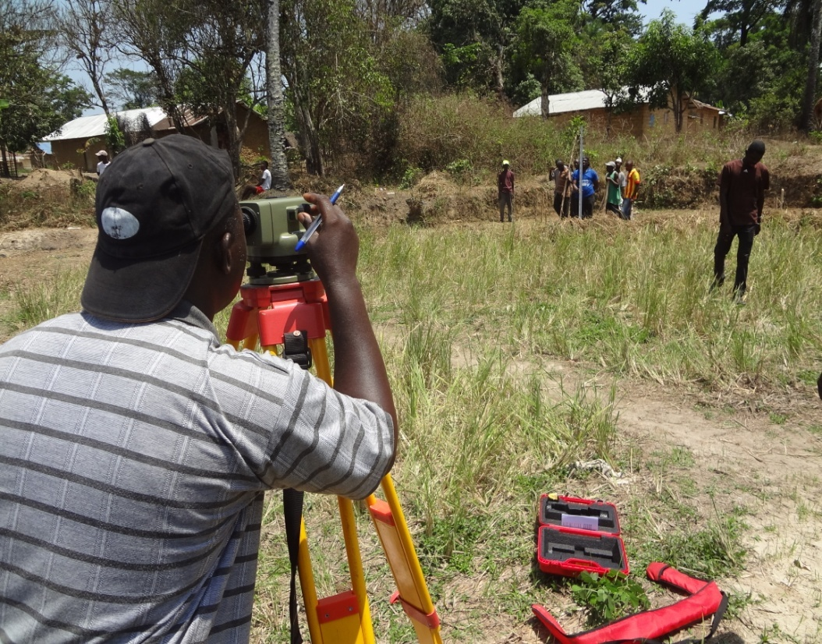
Figure 4. Profile survey for the establishment of peripheral canal

Conventionally, two peripheral canals (Left and right) are constructed along the edges of the swamp. They are usually placed at an elevation sufficient enough to allow water to be delivered into the field plots by gravity. In such a situation, the canals are described as having a command over the land to be irrigated.
The establishment of peripheral canals in inland valley swamps has to follow the undermentioned processes and procedures;

- Prepare short pegs between 0.70 – 1.00 m long and number them accordingly (P₁, P₂ ……..P_{n}).
- Using a mallet or flat stone, firmly drive down the pegs serially (P₁, P₂ ….P_{n}) along the proposed canal track/axis at a uniform distance of 10 m between pegs up to the end of the already established canal track/axis.
- With the aid of an engineer’s level or other suitable instruments (Figure 4), determine the relative heights/elevations of the top of the peg, the bottom of the peg (ground level) and swamp terrain in relation to a chosen bench mark or datum. This is because, those three readings play very significant roles in the determination of the required canal gradient.

The importance of the three readings are as follows;
- The top peg elevations will serve as a guide to determine the elevation of canal bed level relative to the height of the peg;
- The bottom peg elevation establishes the topography of the proposed canal track;
- The swamp terrain elevation serves as a guide against over excavation of canal.
- Plot the three elevations (Top of Peg (TP), Bottom of Peg (BP) and Terrain in Swamp (TS)) on a piece of graph paper (Figure 5).
- Determine the gradient(s) of the canal(s) that will accommodate a non-scoring and non-silting velocity (Figure 5).
- Prepare the earth work guide, which illustrates the depth of either cut or fill (Table 1). This action establishes the bed level of the canal. Please note that, if the established canal gradient/bed level is above the ground surface/topography, it is an indication of filling. But if it is below the ground level then it indicates cutting/earth removal.

Table 1. EARTH WORK GUIDE
Peg No. | Top Peg (T.P) Elevation | Bottom Peg  (B.P) Elevation | Terrain in Swamp (TS)  Elevation | Canal Elevation | Depth of Cut or Fill from T.P. | Remarks
1 | 100.21 | 99.66 | 99.28 | 99.45 | 0.76m | Cut
2 | 100.05 | 99.48 | 99.11 | 99.43 | 0.62m | Cut
3 | 99.98 | 99.75 | 99.18 | 99.40 | 0.58m | Cut
4 | 99.95 | 99.64 | 99.29 | 99.30 | 0.65m | Cut
5 | 99.79 | 99.41 | 99.15 | 99.35 | 0.44m | Cut
6 | 99.98 | 99.75 | 99.22 | 99.33 | 0.65m | Cut
7 | 100.21 | 99.67 | 99.21 | 99.30 | 0.91m | Cut
8 | 99.94 | 99.39 | 99.11 | 99.28 | 0.66m | Cut
9 | 99.65 | 99.32 | 99.10 | 99.25 | 0.40m | Cut
10 | 99.67 | 99.25 | 99.09 | 99.23 | 0.44m | Cut
11 | 99.89 | 99.30 | 99.04 | 99.20 | 0.69m | Cut
12 | 99.80 | 99.26 | 99.07 | 99.18 | 0.62m | Cut
13 | 99.89 | 99.60 | 99.05 | 99.16 | 0.73m | Cut
14 | 99.91 | 99.64 | 98.94 | 99.14 | 0.77m | Cut
15 | 99.79 | 99.38 | 98.90 | 99.12 | 067m | Cut
16 | 99.86 | 99.36 | 98.89 | 99.09 | 0.77m | Cut
17 | 99.58 | 99.48 | 98.98 | 99.06 | 0.52m | Cut
18 | 99.46 | 99.15 | 98.89 | 99.04 | 0.42m | Cut
19 | 99.74 | 99.16 | 98.92 | 99.02 | 0.72m | Cut
20 | 99.55 | 99.48 | 98.90 | 99.00 | 0.55m | Cut

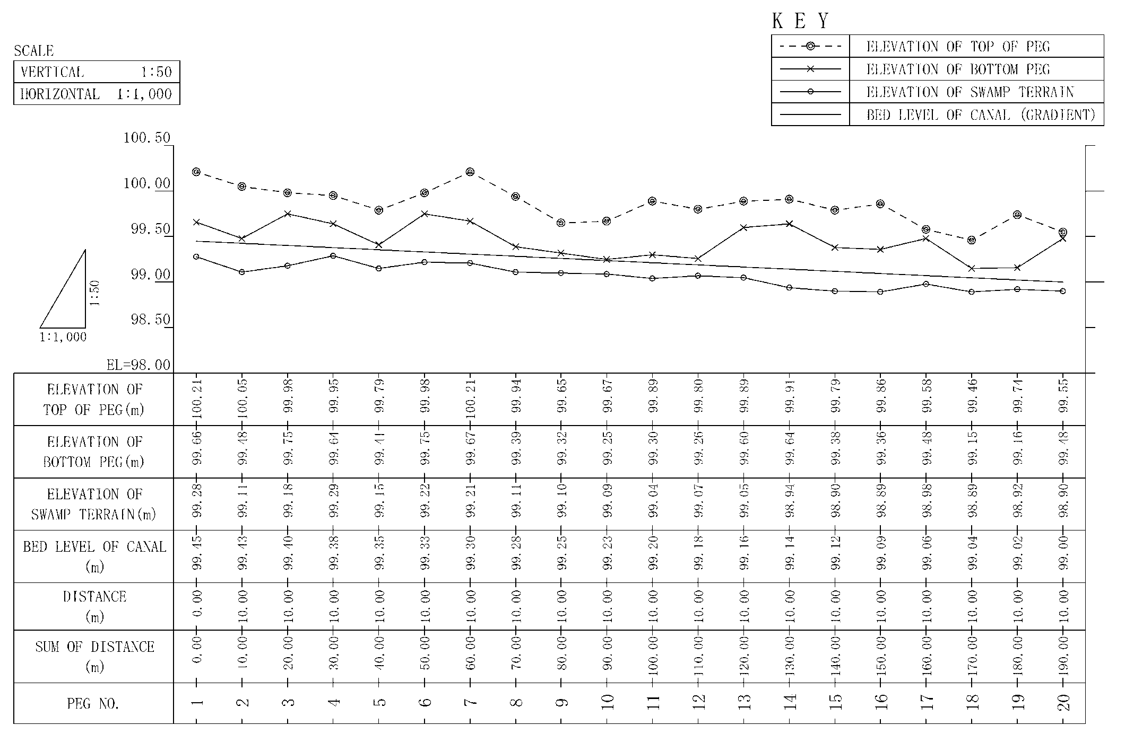

Longitudinal profile of a peripheral/irrigation canal

Figure 5. Longitudinal profile of an irrigation/peripheral canal

3.3.2. LAYOUTING OF PERIPHERAL CANALS
This activity is very critical and should be done with technical dexterity if these structures are to effectively and efficiently perform their desired functions. Therefore, it is advisable for this activity to be always supervised by individuals who have the requisite training, skills and experience in inland valley swamp development.
The ideal procedure is to use short and straight pegs up to 1.0 m in length or less to lay out the canals. Basically, these short pegs are firmly driving on either side of the centre pegs/canal axis (1, 2 …10) to indicate the bottom width of the canal on the ground as per design established (1’-1”, 2’ -2” ….10’-10”). This means that pegs 1’ – 1”, 2’ – 2”, 3’ – 3” … 10’ - 10” indicate the bottom width of the canal (Figure 6).
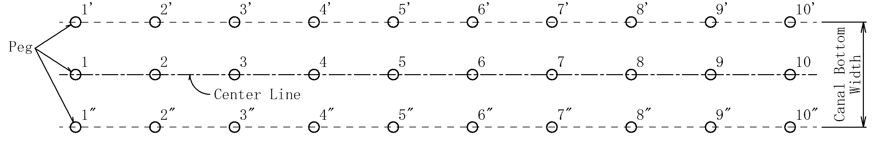
Figure 6. Lay outing of peripheral/irrigation canal

The size of the canal is usually dependent on the design discharge, which is the amount of water per unit of time which the canal must be able to carry. This aspect is usually dealt with by a well-trained and qualified irrigation/water resources engineer with a wealth of experience in swamp development.

3.3.3. CONSTRUCTION OF PERIPHERAL CANAL
In order to establish the bottom width of the canal as per design, the outer pegs are connected using a nylon/alignment rope/twine and demarcated with a spade. It should be borne in mind that the bottom width of the canal is determined using the right equation(s), and dimensions thus established must be supplied to the site supervisor for implementation.
Following the design dimensions, and the cut and fill procedure as determined by the profile survey and the subsequent earthwork guide, shovels are then used to remove all vegetal cover within the proposed canal area and the canal excavated to its right depth (Figures 7 i ). Thereafter, the side slopes are established with the aid of spades according to the prevailing soil type (Figure 7 ii - iii).
Channel/canal side slopes are determined principally by soil texture and stability. The relationship between side slopes and soil materials could be obtained from relevant tables (Table 2). After determination of the side slopes, a spade is then used to establish the final gradient of the canal.

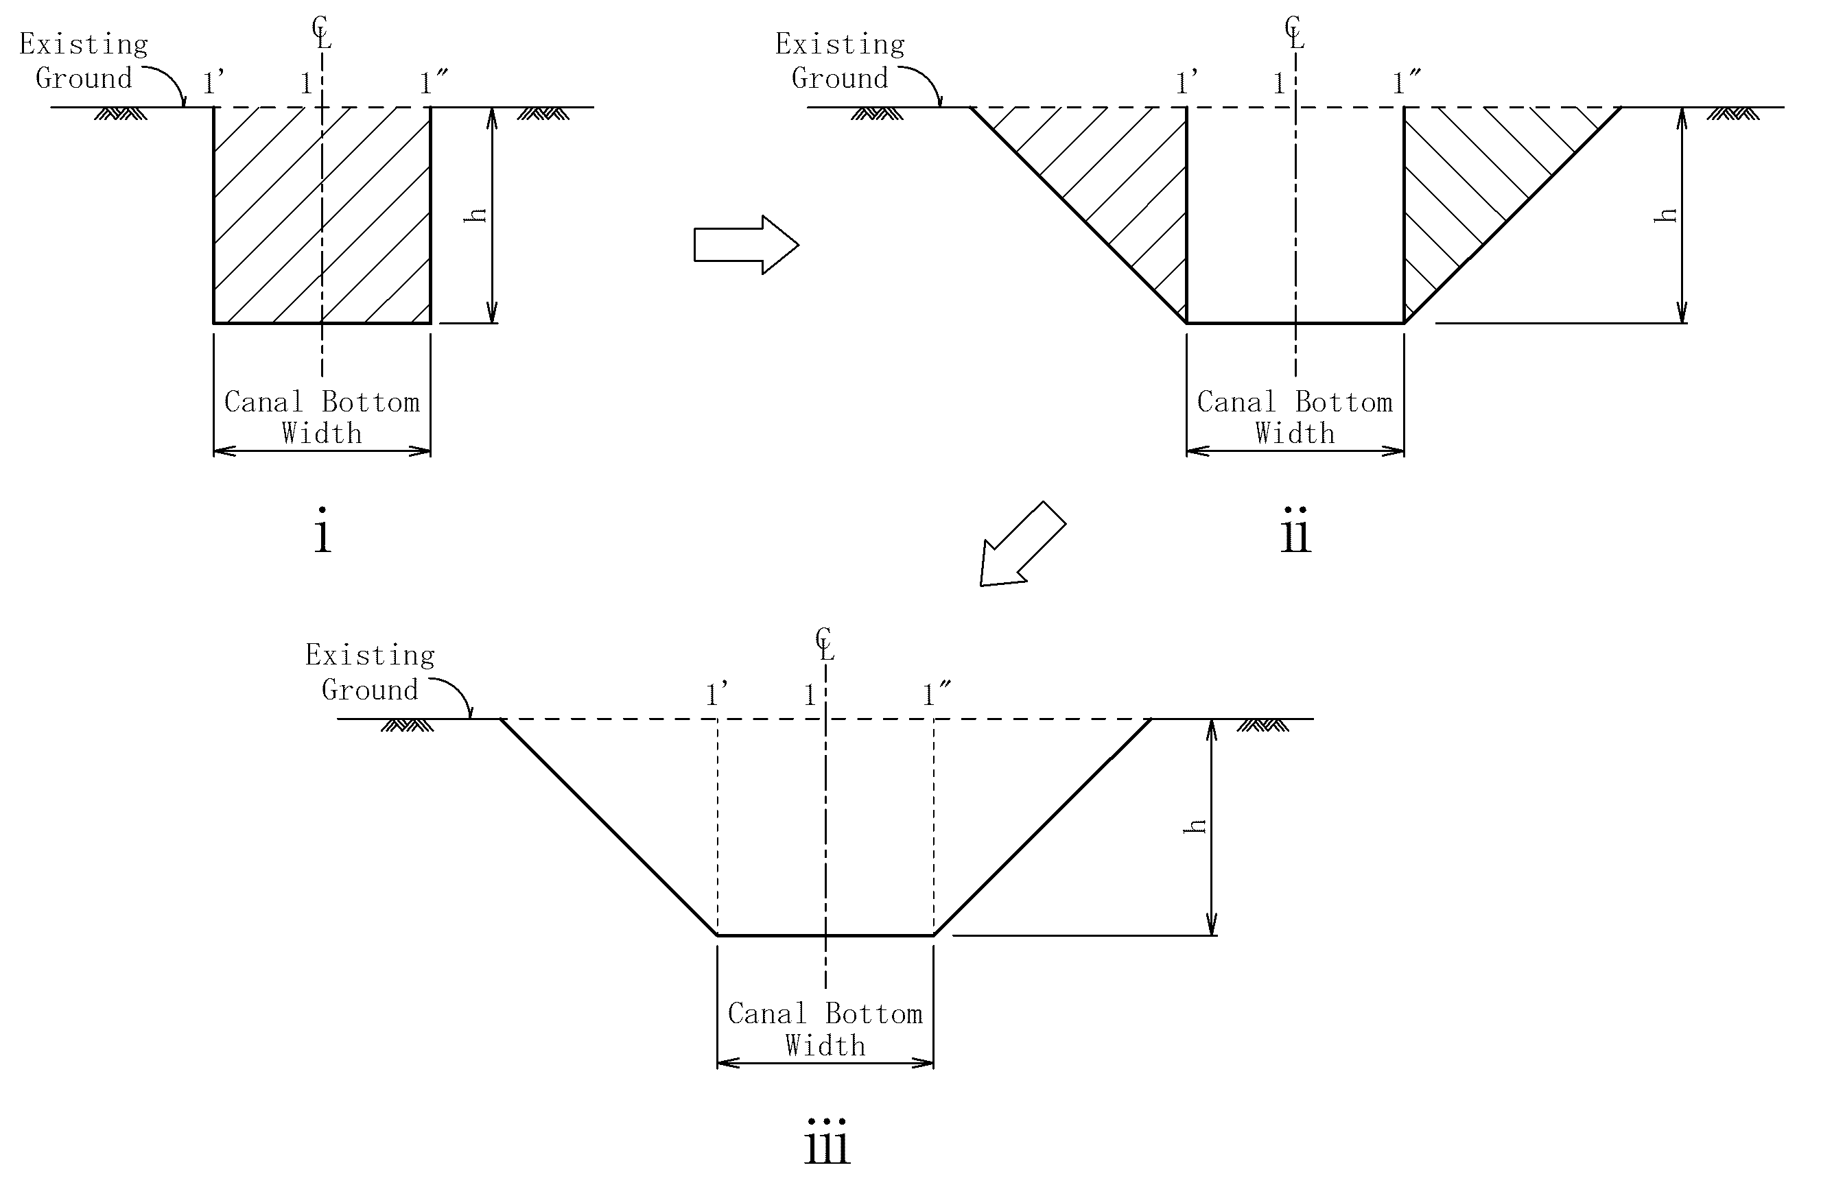
Figure 7. Construction of peripheral/irrigation canal
Determination of slope/gradient of canal is very critical and great care must be taken in a bid to obtain the correct gradient. One should realize that a steep slope in earth canals would cause serious erosion leading to deformation/destruction and poor performance of irrigation canals. Also, a flatter gradient will not allow free flow of water in the canal, thus leading to accumulation of unwanted materials (sand, silt and soil). This situation will lead to reduction in canal capacity (less water in the canal)
Generally for earth canals, it is advisable that the gradient/canal slope be kept within acceptable limits (0.5 – 1.0%). These being convenient gradient(s) that would accommodate a non-scouring and non-eroding velocity.

Table 2. Soil material and side slopes of canals
Material | Side slope
Rock | Nearly vertical
Stiff clay or earth with concrete lining | 1 / 2: 1 to 1: 1
Earth with stone lining or each for large channels | 1: 1
Firm clay or earth for small ditches | 1 1/2: 1
Loose, sandy earth | 2: 1
Sandy loam or porous clay | 3: 1

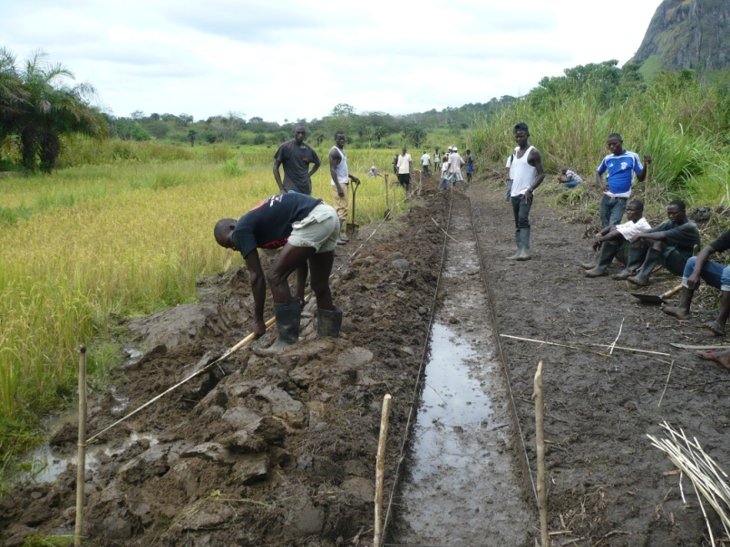
Figure 8. Construction of peripheral canal and bund

Excavation of the canal can be started anywhere along its length as long as the supervisor correctly uses the earthwork guide (Table 1). But it is best to start canal excavation from the beginning (head) so as to conveniently maintain a uniform slope/gradient. As a rule, canal excavation should be done following the gradient or the direction of flow. After canal excavation, the side slopes are then established to have the requisite dimensions (Figure 6 ii). For reasons of slope stability and operation, trapezoidal canal sections are usually preferred in swamp development.

3.4. PLACEMENT AND CONSTRUCTION OF PERIPHERAL BUNDS
As the name implies, peripheral bunds are water control/retention structures placed along the periphery/edge of the swamp and serve a number of functions including but not limited to the following;
- Prevention of uncontrolled flooding of swamp from the catchments
- Access to the paddy fields
- Direct flow in peripheral canals.
- Support water confinement in field plots

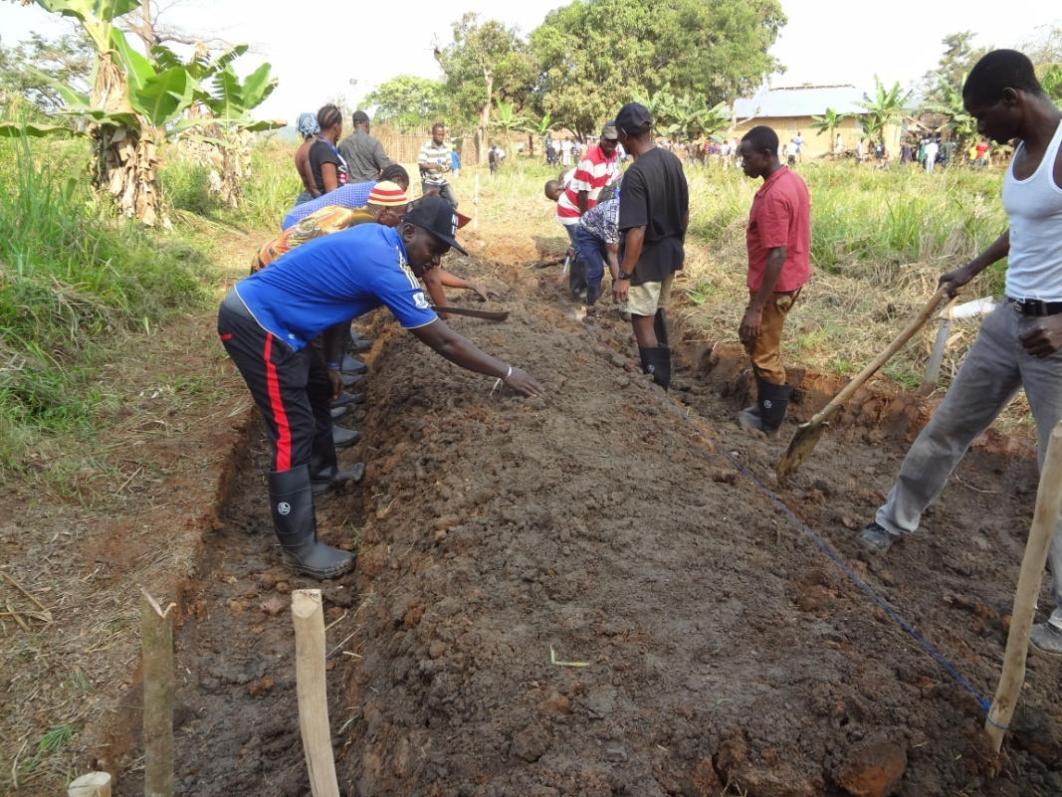

Figure 9. Construction of peripheral bund

The dimensions of peripheral bunds are dependent on soil type, runoff from the catchment (volume and velocity) and miscellaneous uses of the structure e.g. access amongst others.
Following the design dimensions particularly the base width, the peripheral bund is laid-out using garden line/alignment rope and bush poles, a process known as “lay outing”. The bush poles are connected using a nylon rope or garden line so as to establish the bottom width of the bund. Thereafter, shovels and spades are used to remove unwanted materials including vegetative/top soil. Once this is achieved, construction of peripheral bund is executed by using the soil, preferably sub-soil close to the area already demarcated for bund construction. In other words, top soil is removed and use is made of sub-soil from the area where soil is to be obtained for bund construction.
It should be borne in mind that the soil close to the bund should not be disturbed, otherwise the stability of the bund would be compromised. Therefore, always give an allowance of 0.1 - 0.15 m away from the bund to obtain sub-soil material for bund construction.
The procedure entails the removal of all vegetal cover and other unwanted materials from the area demarcated for the establishment of the peripheral bund. This is done in order to avoid weakening of bunds, seepage and eventual collapse of the bund. Thereafter, soil material is excavated from the adjacent area in the swamp and placed in the demarcated area for bund construction. This soil material should be placed in thin layers and compacted well until the height of the bund is established as per design. In the event that adequate soil material could not be obtained from the adjacent swamp area, soil could be obtained from the adjacent upland or catchment to construct the bund especially where depressions or unwanted soil materials are found.
Spades are used to give the bunds their right side slopes depending on the type of soil thereby establishing a trapezoidal section. The bund is built to the right size/dimension (height, top width, side slopes and base width), figure 10. During construction of the bunds, allowances that would account for settlement/stabilization and freeboard should form the final height of the bund. The side slope of the peripheral canal and that of the peripheral bund should be perfectly unified (Figure 11).

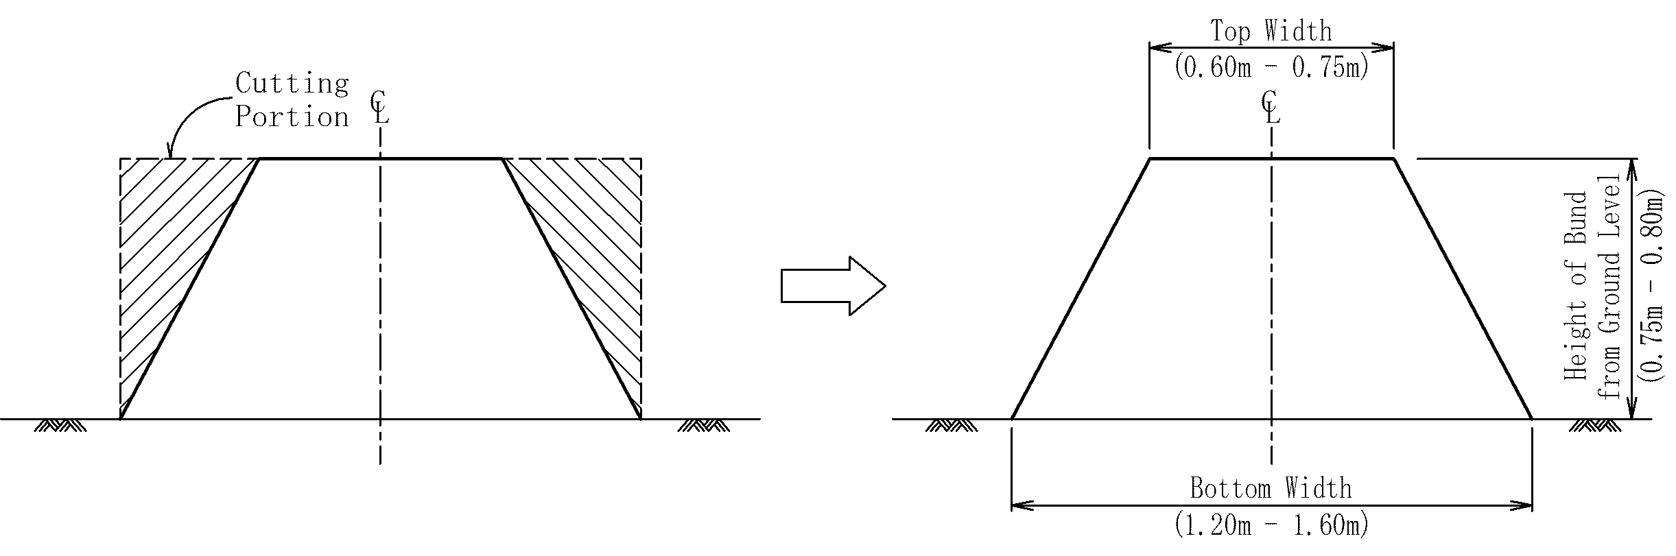
Figure 10. Establishment of side slopes of peripheral bunds

Although the dimensions of water control structures vary from swamp to swamp, experience has shown that the following dimensions could be very effective as they have stood the test of time. In the absence of engineering design therefore, these dimensions would be useful.
Height of bund (H) from ground level = 0.75 - 0.80m
Top width (T) = 0.60 - 0.75m
Bottom width (B) = 1.20 -1.60m

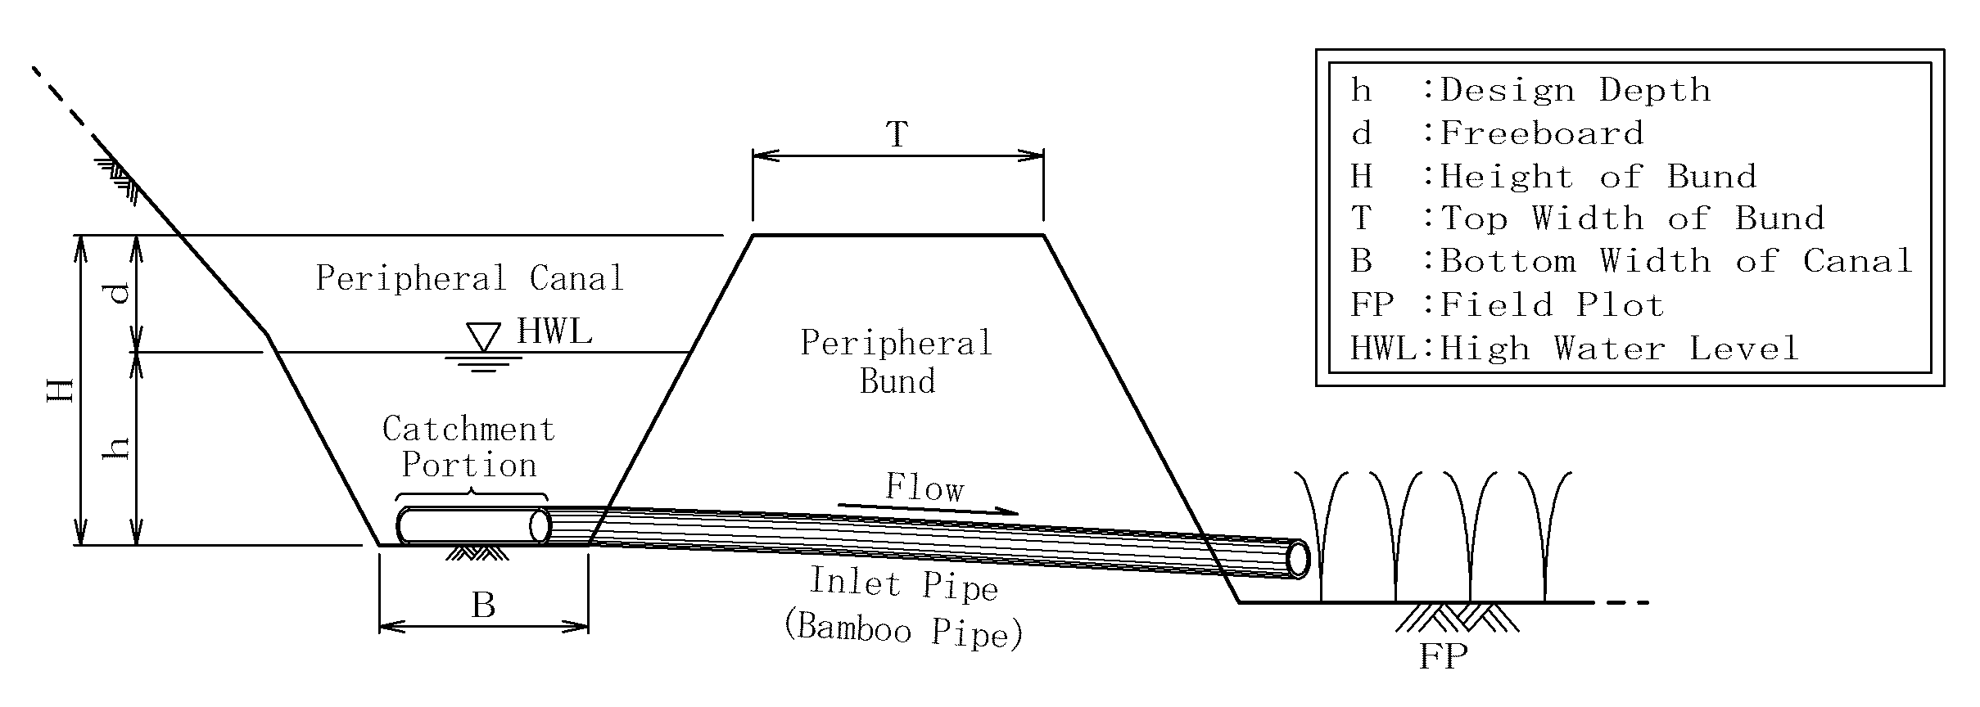
Figure 11. Peripheral canal and bund

3.5. LOCATION AND CONSTRUCTION OF DRAINAGE CANAL
Generally, drainage canals are located at the lowest part of the swamp, which in this case is the water course or stream/channel. Ideally, the main drain should follow the natural course of the stream except in a situation wherein the natural stream meanders extensively. In a situation where the stream has considerable meanders, it will be reasonable and technically ideal to straighten up the proposed canal course in order to obtain a fairly straight water course that will allow free flow of water.
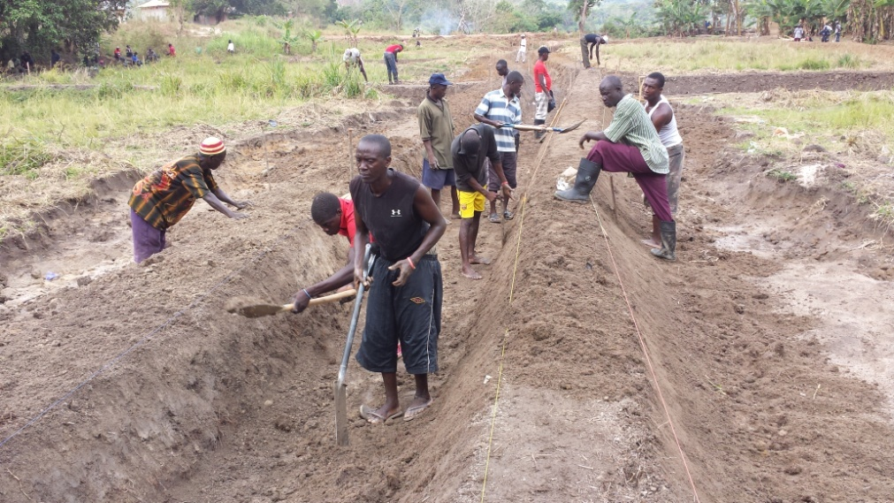

Figure 12. Construction of main drainage canal and bunds

The alignment and survey procedures for the establishment of drainage canal are similar to those of the peripheral canal, except that the readings/elevations to be determined are; top of peg, bottom of peg and depth of stream or water course rather than terrain in the swamp. The elevation of depth of stream or water course would guide against over-excavation of drainage canal. Care must be taken to avoid over-excavation/deepening of drainage canal as this will lead to over-draining of the swamp. Widening rather than deepening of the drainage course is advisable so as to maintain the natural status (water regime) of the swamp.
Dimension of drainage canals should be in accordance with design/hydraulic parameters of water control structures especially so when due consideration is given to accommodation and removal of excess water from the reservoir through the overflow/spillway as well as drainage water from the rice fields or plots. Excavation is done from upper to lower elevation so as to maintain suitable gradient. However, in the event that the stream of the swamp has a lot of water in it, it is better to start canal excavation from the lower part of the stream course in order to enhance drainage that will lead to proper construction of drainage canal as per design established.
The procedure for drainage canal construction are similar to that of the peripheral canal construction as explained earlier in 3.2.3. (Construction of peripheral canal).

3.6. LOCATION AND CONSTRUCTION OF DRAINAGE BUNDS
Drainage/flood bunds are earth structures located on either side of the drainage canal. These bunds confine the excess water from the spillway or overflow and also facilitate conveyance of excess water from the paddy/field plots throughout the length of the swamp, thereby controlling unwanted/excess flooding.

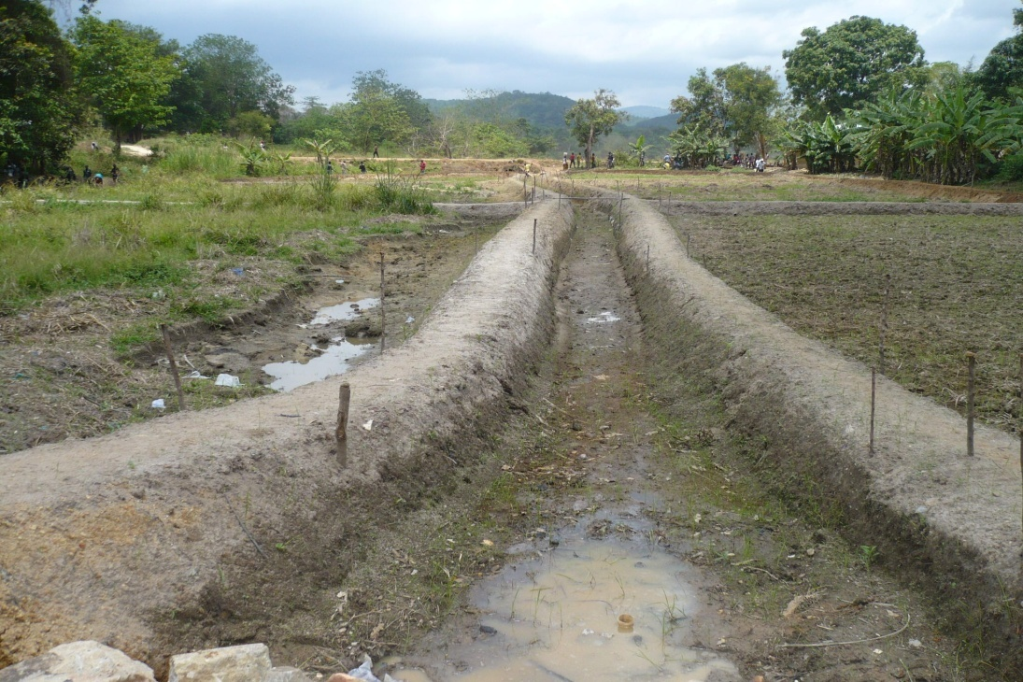
Figure 13. Main drainage bunds

Following the design dimensions, bush poles/sticks and alignment rope are used to establish the bottom width of the bunds (lay-outing). The size of the bunds will depend on type of soil, volume and velocity of water and other uses such as access. Construction of the bunds entails removal of all seepage causing materials (weak soil, dead leaves, sticks, stones, etc. and placement of the required soil material obtained from the sides of the demarcated area for the construction of bunds.
The soil material which in most cases is wet, is placed in layers in order to allow adequate drainage and for easy compaction. In some cases it is extremely difficult to obtain suitable soil from the adjacent areas of the location where drainage bunds are to be constructed due to marshy conditions. In such a situation, upland soils are used for the construction of bunds, especially periphery and main drainage bunds. But care must be taken to identify good laterite materials. Gravel and sandy soil must be avoided. The bunds are built to the right size (height, top width, side slope and bottom width) as per design. Thereafter, spades are used to give the bunds the right side slopes after the bunds have drained well, settled and stabilized. The side slopes of the drainage canal and those of the drainage bunds should be perfectly synchronized (Figure 14).
The design of drainage and all other bunds should reflect the use to which the structures would be put. Experience has shown that in Sierra Leone, depending on the prevailing bio-physical characteristics and in the absence of engineering designs, the following dimensions have proved to be very effective.
Height of bund (H) from ground surface) = 0.70 – 0.80m
To width (T) = 0.60 – 0.70m
Bottom width (B) = 1.0 -1.20m
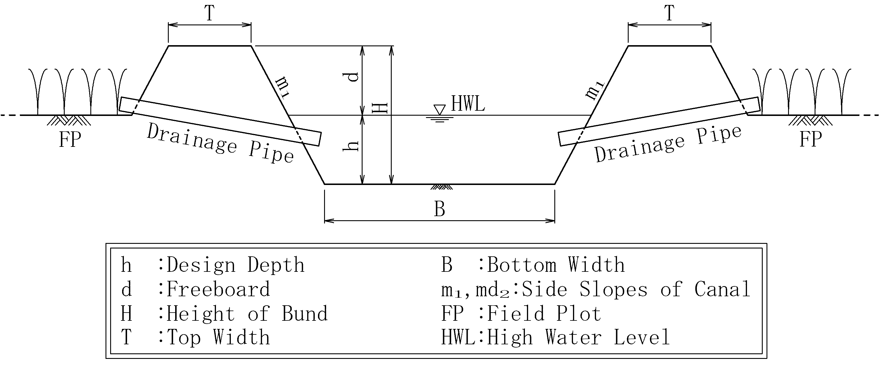
Figure 14. Main drainage canal and bunds

3.7. CONSTRUCTION OF HEAD BUNDS/DAMS AND OVERFLOWS/
SPILLWAYS
3.7.1. HEAD BUND/DAM
The head bund is a structure which is constructed across the narrowest point on the upper reaches of the swamp, using earth/soil material usually obtained from the side catchments. A head bund/dam can be referred to as a structure which effecting the closure of the stream, creates afflux (heading up). Location of the head bund is one of the most critical aspects of the construction process. In consideration of both technical and economic aspects, the head bund is normally located at the narrowest/ shortest cross-section of the swamp upstream. This is because, this area allows the construction of a smaller head structure that could effectively withstand water pressure as well as easy and effective distribution of water to peripheral canals. Constructing a smaller but technically robust head bund means that less money would be spent at such a location compared to wider/longer cross-sectional areas. Furthermore, at this point or location, the soils are usually stable and therefore capable of carrying the dead weight of the structure, and also, seepage can be minimized by using proper anchorage (Figure 19).

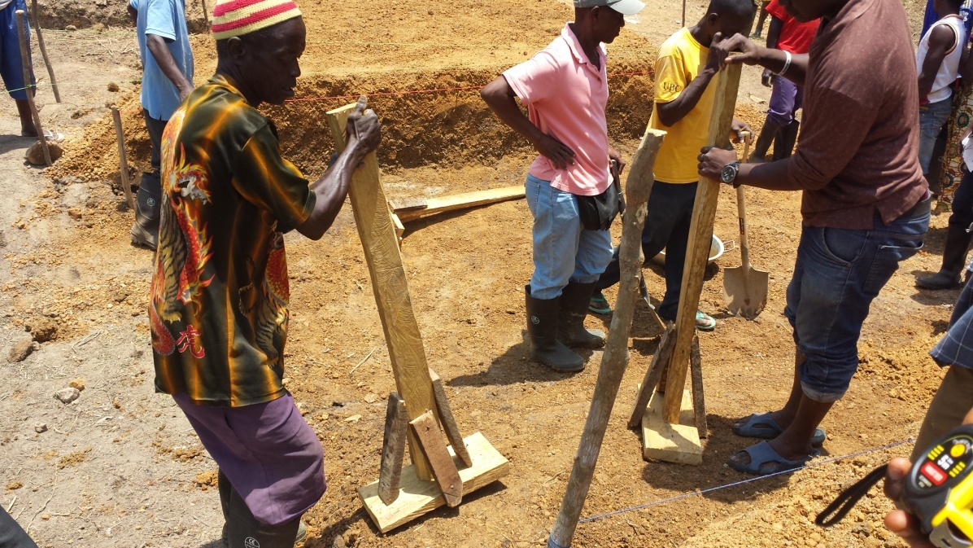

Figure 15. Compaction during head bund construction
Head bund construction is normally preceded by a proper design process that will lead to the establishment of suitable dimensions which is expected to stand up against or resist various forces acting upon it (toppling, sliding, etc.). The determination of the right dimensions is usually done by an experienced engineer and the information or data obtained thereof, is submitted to the field officer/supervisor for implementation.

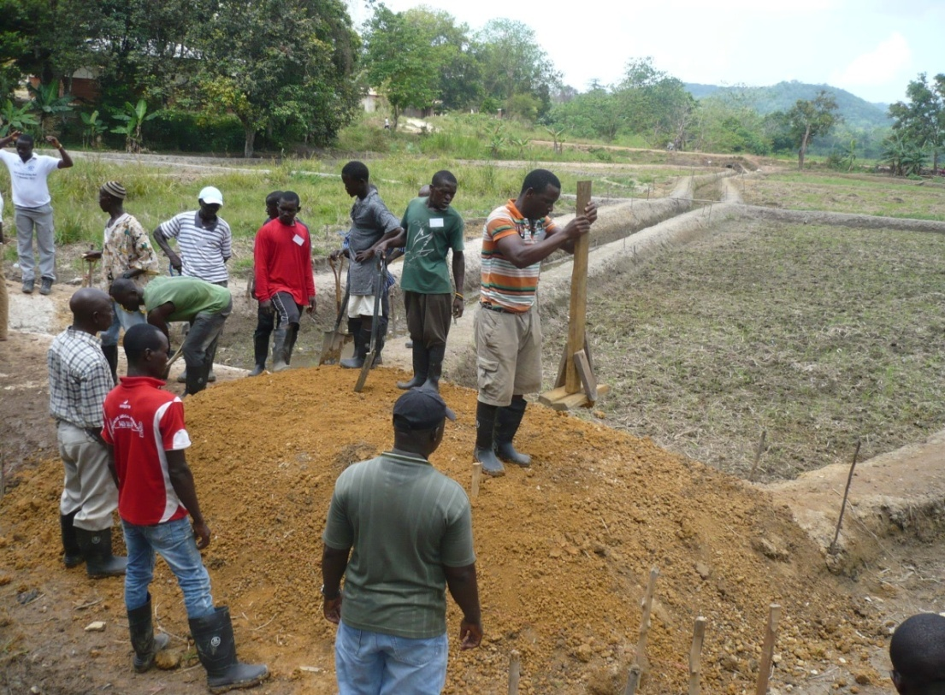
Figure 16. Final compaction of head bund

The head bund is a very important water control structure and serious attention should be paid in its construction. This structure is important for a variety of reasons including but not limited to; water retention and diversion, water regulation, etc.
The basic procedure for construction of head bund is as follows:-
- Identify head bund location upstream (Narrowest point), brush and clean well to ground level.
- Using bush range/poles, establish the axis or centre line of the head bund (Alignment).
- Using an engineer’s level or any available instrument, determine the height of the head bund.
- Mark the height of the head bund on the pegs using either string, paint/cutlass mark. The height of the head bund is a combination of depth of water in the canal, freeboard and settlement allowance.
- Layout the base width of the head bund with pegs on either side of the centre pegs.
- Connect the outside pegs with alignment rope or garden line to show the ground layout of the head bund.
- Remove vegetal cover and other unwanted materials from the proposed and demarcated site or area.
- Identify good subsoil (Laterite) from the adjacent upland/catchment areas.
- Dig, transport and place soil material (Laterite) on the demarcated head bund area at layers of 0.07 m – 0.10 m for easy compaction.
- Compact each layer thoroughly well with vibrators, rollers or rammers as the case may be.
- Moisten each layer to the right moisture content for proper compaction, If soil is dry.
- Repeat the layering and compaction process until the final height of the dike or head bund is established.
- Maintain the right side slopes (1:1.75 on the reservoir/upstream side and 1:1.5 on the other side) and shape with spade where necessary.
- Camber the crest of the dike/head bund to avoid ponding during rains.
- Place a layer of top soil on the sides of the dike/head bund to stimulate growth of grass as a means of protection against erosion.
- Grass may be planted on the slopes of the dike to protect the structure against erosion.

The head bund/dam must be stable if it is to perform its desired functions. In that regard, it is always advisable to anchor the head bund (Figure 17). The anchorage is that part of the head bund/dam which is built below the ground level for two reasons;
- It increases the weight of the dam and lessens the risk of toppling
- It fixes the construction in the ground, preventing it from sliding downstream due to the horizontal thrust of the water.

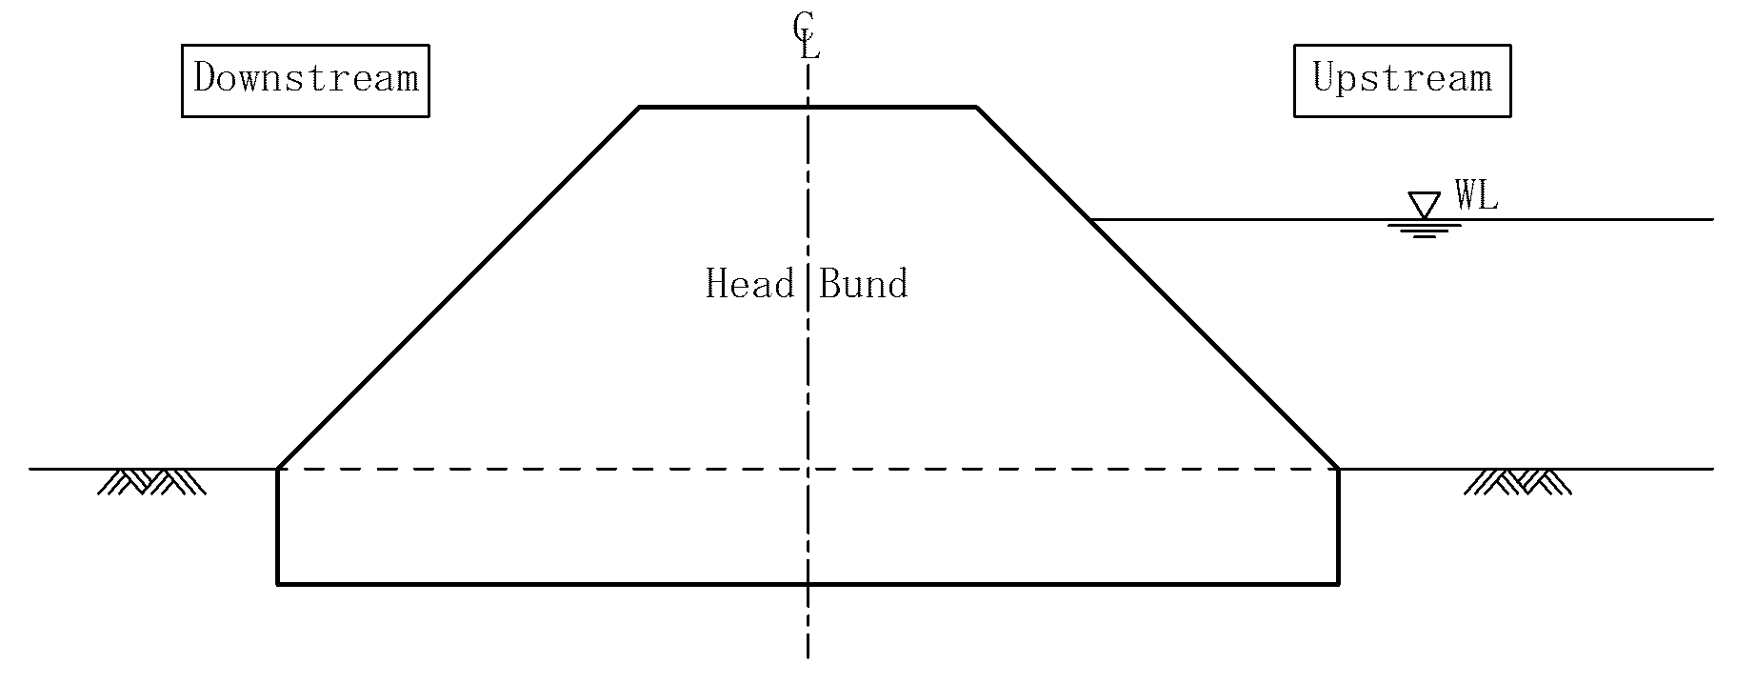
Figure 17. Head bund anchorage

3.7.2. OVERFLOW/SPILLWAY
An overflow/spillway is required to protect the dam from over-topping during high floods. It allows surplus or excess water to be conveyed downstream safely through the main drainage canal, thereby averting dam failure and damage downstream. In addition to the above, a spillway also facilitates the diversion of water to the peripheral/irrigation canals. By virtue of its functions therefore, a spillway should be properly sized (determination of length, width and thickness). The length, width and thickness should be determined or designed by a qualified and highly experienced engineer. However, there is a direct relationship between heights and crest widths of overflows/spillways (Table 3) as well as width and thickness of earth dams (Table 4).

Table 3. Relationship of heights and crest widths of earth dams
Heights (m) | Crest width (m)
1.0 – 2.0 | 2.5
2.1 – 3.0 | 2.8
3.1 – 4.0 | 3.0
4.1 – 5.0 | 3.3
5.1 – 6.0 | 3.5

Placement of the overflow generally depends on the location of the water course but this structure is usually located between the two halves of the head bund as indicated in figure 18.
Table 4. Relationship of width and thickness of earth overflows/spillways
Width (m) | Thickness (m)
3 - 4 | 1.5
4 - 6 | 2.0
6 - 8 | 2.5
8 - 10 | 3.0

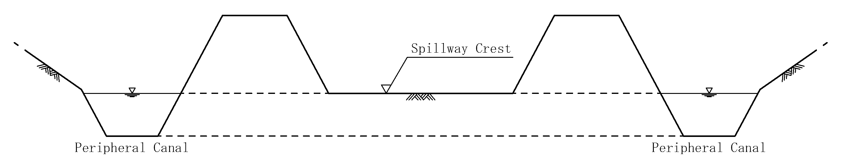
Figure 18. Spillway/overflow and peripheral canals

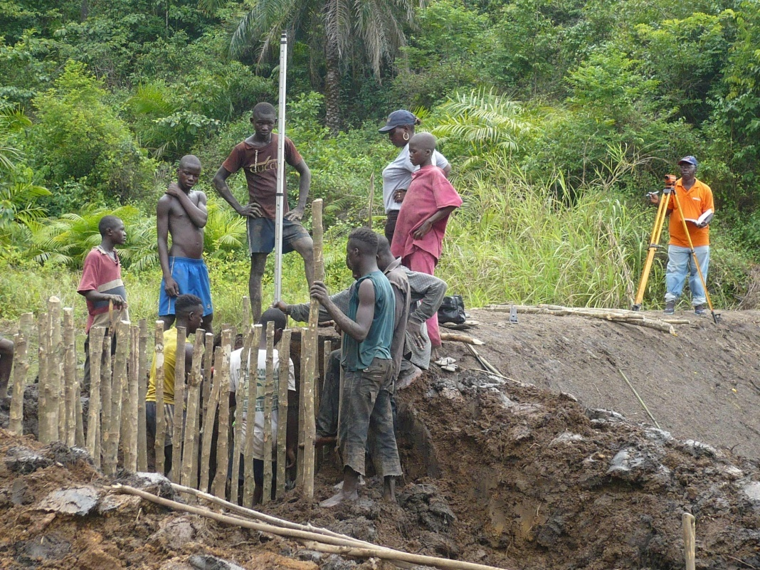
Figure 19. Establishing height of overflow
The size of the spillway depends on the rainfall intensity, the size and characteristics of the catchment area. Therefore, technical advice should be sought on local standards and practice prior to its construction.
The size of the overflow is also dependent on the peak discharge of the head catchment. For sustainability and less construction cost, earth overflows are usually constructed in inland valley swamps.
The construction of earth overflows is implemented as follows;
- Layout the area of the overflow using pegs and alignment rope/garden line like in the case of the head bund.
- Excavate and remove topsoil/vegetative layer (0.10– 0.2m) as the case may be until good/solid foundation is reached.
- Drive in bush poles/timber templates of 0.05 - 0.1m diameter firmly into the ground (Figure 19)
- Place timbers (5 cm thick) one over the other from the foundation of the overflow to the established height (Figure 20). Using either an engineer’s or spirit level, ensure that the timbers/board are of the same elevation from one corner of the overflow to the other.

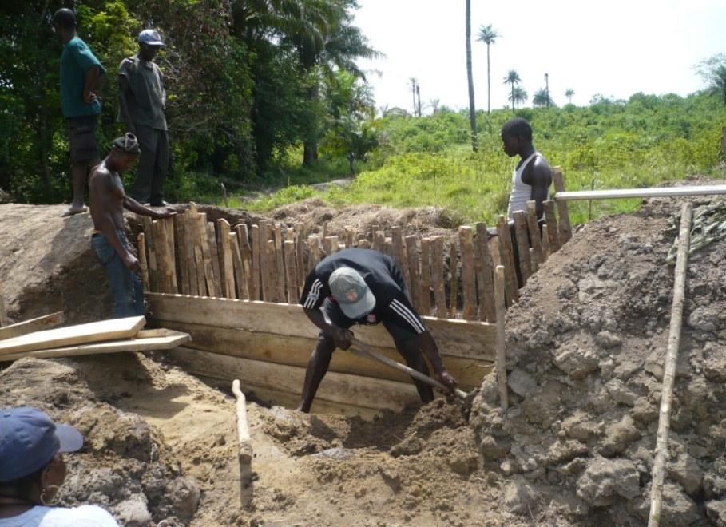
Figure 20. Construction of overflow (Placement of boards)

- Once this is established, nail the timbers using 3 and 4 inches nails
- Place the first plank/board at the bottom of the foundation and ensure that the elevation of the board at both ends are the same and mail firmly.
- Place one timber on top of the other and nail firmly until the required/designed height is reached (Figure 21).
- Use timber rammers to compact the clay onto the final height of the overflow.
- Verify the height using either an engineer’s level, water tube or spirit level.

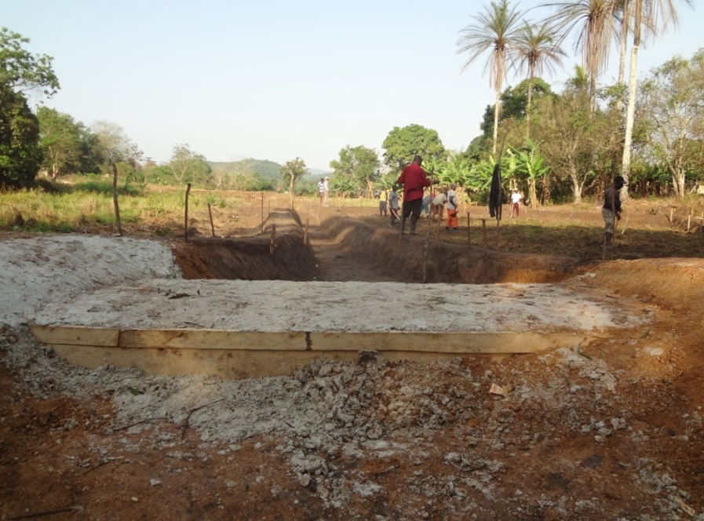
Figure 21. Completed overflow (Wooden box filled with clay)
- Level/cut off the bush poles to the level of the final board, which is the height of the overflow as per design.
- Lay flat boulders on top of the overflow to minimize/prevent erosion
- Place the excavated soil from the foundation on the upstream face of the overflow.

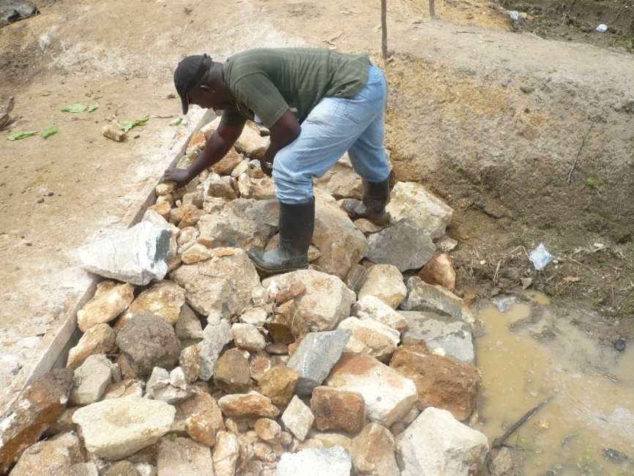
Figure 22. Correct placement of boulders behind the overflow

- Place stone boulders neatly so as to form a gentle slope on the downstream of the overflow (Figure 22).
- Shape the approaches of the overflow very well in order to enhance easy/smooth flow of water.
- Protect the side slopes of the overflow and the edges of stilling basin with flat boulders.

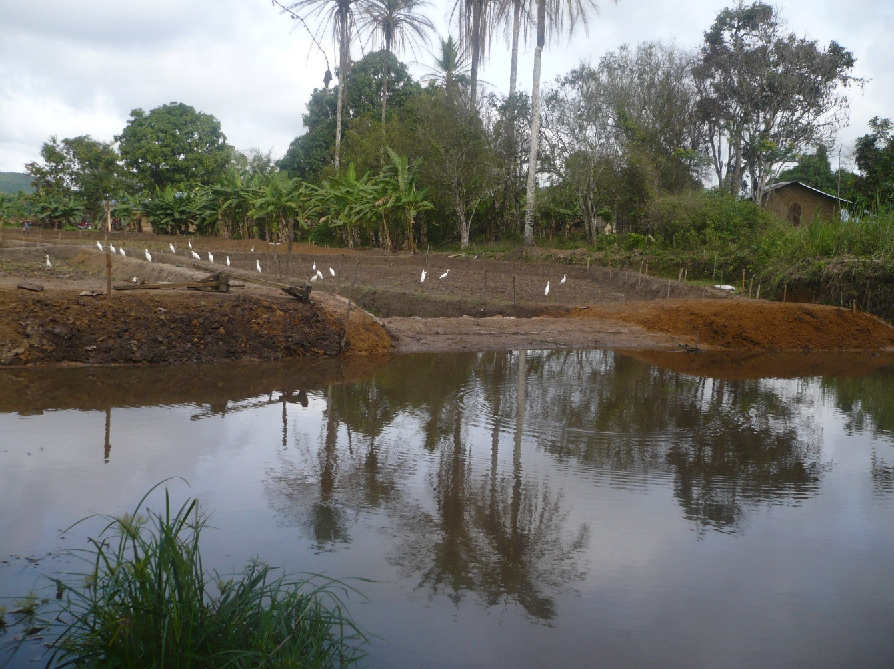
Figure 23. Reservoir for dry season cropping

3.8. CONSTRUCTION OF INTERNAL BUNDS
3.8.1. Contour bund
The system of internal bunding of plots may be either rectangular or contour/semi contour. The choice of bunding depends amongst other factors on the depth of the top soil and the longitudinal slopes of the swamp.
Contours are imaginary lines joining points of equal elevation. These points could be located in the swamp using any suitable surveying instrument, such as engineer’s level, dumpy level, leveling tubes, etc. In the field, the engineer’s level or any other suitable equipment and pegs should be used to establish the contour lines with an elevation difference of +- 0.15 - +₋ 0.20m between contours. Adjust the long pegs representing the contour lines carefully with the aim of avoiding serious bends. The adjusted long pegs establish the contour line. Short pegs and alignment rope are then used to establish the size of the contour bund as per design. Thereafter, the contour bund is constructed using in-situ soil from the lower end of the contour, thus reducing leveling.

3.8.2. Rectangular bund
Rectangular bund construction is quite common in Sierra Leone, using the following dimensions: 50m x 20m, 40m x 25m, 20m x 20m, etc. The dimensions are established with the aid of a measuring tape (30 or 50m), alignment rope, bush pegs and optical square if available. In the absence of an optical square, range/bush poles are used to align the bund whilst short pegs are used to layout the bund. Thereafter, the bunds are established or built using the soil from the lower part/elevation of the area where the bund is to be built. After the bunds have been built, the plots would look like bench terraces, establishing command from one plot to another, thus facilitating plot to plot irrigation.
In the absence of design data, the following dimensions could be used:
Height of bund (on the upper basin) = 0.45 - 0.50m
Top width = 0.35 - 0.40m
Bottom width = 0.55 - 0.65m

CHAPTER 4. COMPLIMENTARY ACTIVITIES/PROCESSES
4.1. LEVELING
Leveling is an essential operation in flood irrigation. It entails flattening and making horizontal the basin surface so that the sheet of irrigation water is the same depth throughout the basin. In a thoroughly leveled plot there will be even shooting, minimal discharge of irrigation water, uniform application of agro-chemicals, especially fertilizers and some degree of weed control. Leveling is one of the most difficult tasks as it requires digging/removal, and the movement of huge volume of soil from one area of the plot to another (Figures 24, 25 & 26).

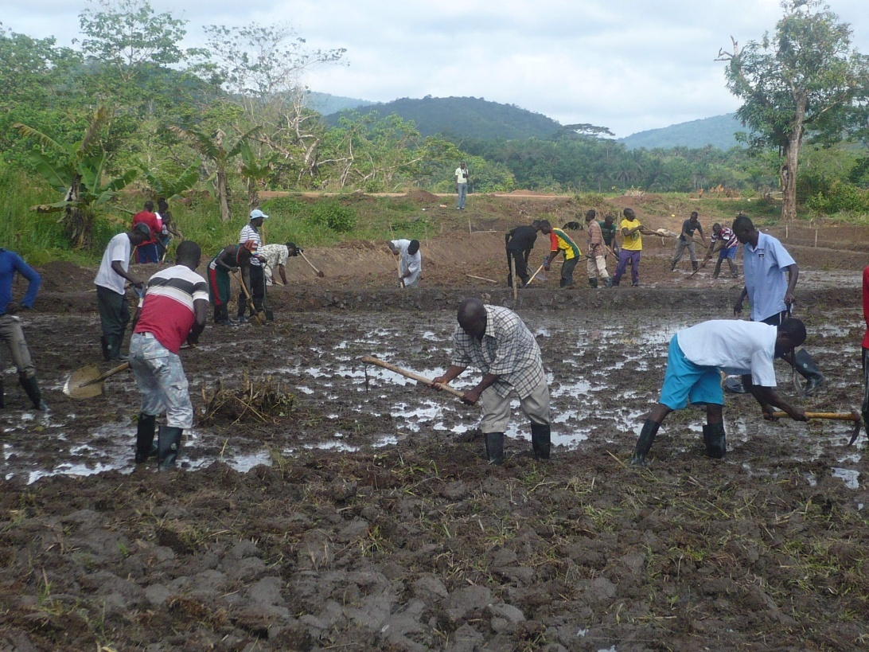
Figure 24. Leveling of plot
When preparing land for flood irrigation, especially on sloping ground, the degree of technical skill and hard work required grows with the size of the basin. It is fairly easy to level small plots without pegging. This is why smaller plots are in use in inland valley swamp development.
Different types of instruments could be used to level fields for even distribution of water. These include leveling triangle, water level tubes, theodolite, engineer’s level

etc. In order that these instruments are used effectively, the field staff needs to be properly trained (hands-on-experience) on the use and care of these instruments.

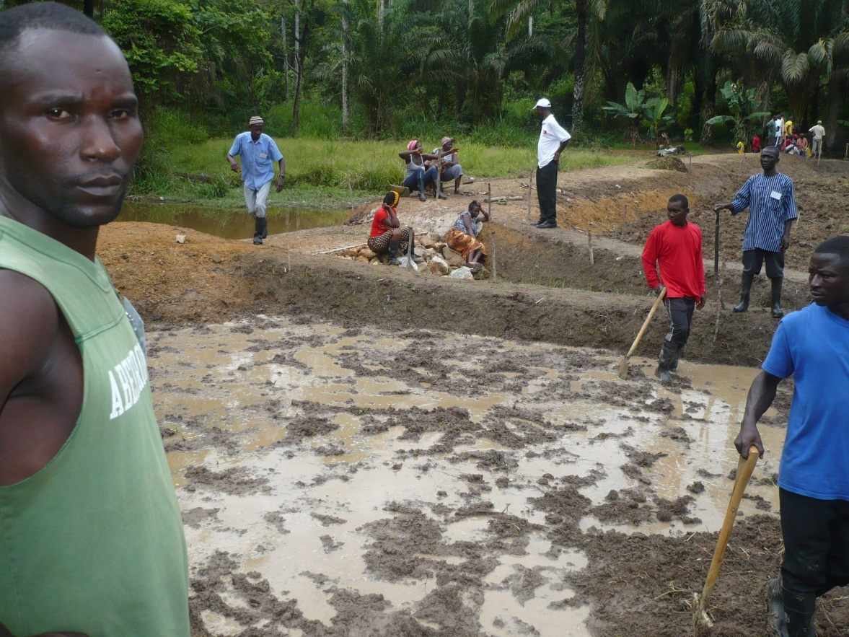
Figure 25. Establishing a level field by introducing water into the plot
In the field under local conditions, the soil in the higher areas (A) is scraped/moved to the lower level (B) until the surface of the soil is parallel with the surface of the water (Figure 26). On small plots, leveling is carried out with the help of a rake, hoe or scraper operated by manual, mechanical or animal power. A good level surface is hard to achieve during the first year of development. However, serious effort must be made to achieve a relatively level surface during the first year.
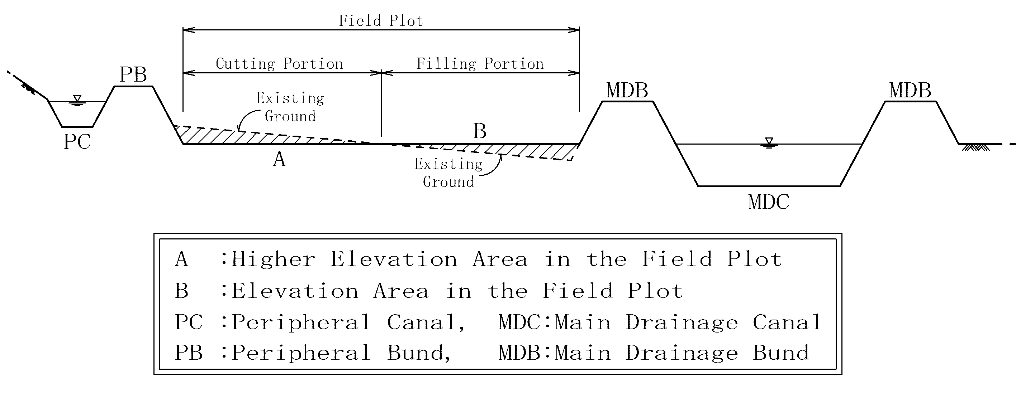
Figure 26. Levelling of field plots

After the first leveling, the farmer should let water into the basin and observe movement within the plot/basin areas where there is standing water and areas which are dry as a result of difference in elevation. Usually, water settles on the lower elevations whilst the upper elevations remain dry or without water.
The dipper/low elevation areas (B) are then filled first with vegetal remains as the case may be and then with earth taken from higher ground (A) (Figure 26) until a level surface is obtained. Use of vegetal remains is usually made when deep depressions or holes are found within the field plot/basin. It should be borne in mind that proper leveling is not an easy task under local conditions, therefore proper care must be taken in the movement of soil from points of higher to lower elevations, giving due consideration/attention to deep depressions within the plot.

4.2. Installation of Irrigation and Drainage Pipes (Bamboo tubes)
Irrigation and drainage pipes, in this case bamboo pipes are integral components of a fully developed and functional inland valley swamp. Bamboo canes are used because they are local materials which can be obtained within the communities at no cost. It is advisable to use local materials because they creates room for sustainability. Prepare bamboo pipes; cut the correct length, remove nodes and diaphragm from pipes of up to 0.10m in diameter for installation in the peripheral bunds, whilst pipes of 0.06-0.08m diameter are prepared for installation in internal bunds.
The lengths of the pipes for installation in peripheral bunds as irrigation pipes depend on the bottom width of the bunds and the angle of tilt (orientation of the pipes) relative to the direction of flow. Irrigation pipes are installed with double-tilt (vertical and horizontal inclination). Horizontal and vertical placement will facilitate easy catch and delivery of water respectively.
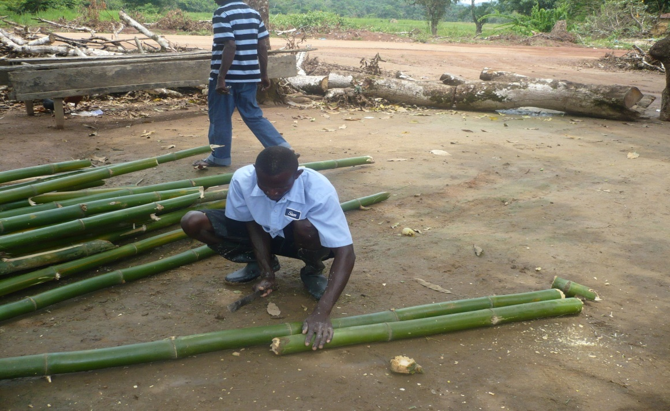
Figure 27. Cutting bamboo canes to the required length

Pipes are usually installed at appropriate intervals; say every 10m along peripheral and drainage bunds, ideally before bund construction and; 5 - 8m along internal bunds. This is because installation of bamboo canes or pipes after bund construction entails making a breach or opening after the bunds have been compacted. When proper compaction is not done, this situation will lead to seepage and eventual weakening and destruction of the bunds. However, when pipes are installed after bund construction, good soil material, preferably clay should be used to close the breach and compaction must be done layer by layer until the height of the bund is attained.
The installation of pipes along peripheral bunds starts with the determination of the full length of the pipe, which is the length of the diagonal of the bund plus 20% allowance on both ends. The figure obtained thereof, is the length of the pipe to be installed.
Bamboo canes have been used in IVS development/rehabilitation as inlet and outlet pipes for conveying water;
- From the peripheral canal onto the plots, through the peripheral bund
- From one plot to another through the internal bunds where plot-to-plot irrigation is practiced and
- From paddy fields/plots to the main drain through the drainage/flood bund/dikes

The supply of irrigation water from one plot to the other can sometimes have adverse effects on the paddy fields especially during the incidence of case worm infestation. In this situation therefore, it becomes optional to install pipes in internal bunds (Figure 28). However, when the pipes have already been installed, plot to plot irrigation could be halted by simply blocking the pipes with grass, thus facilitating movement of water from paddy fields to the drainage canal.
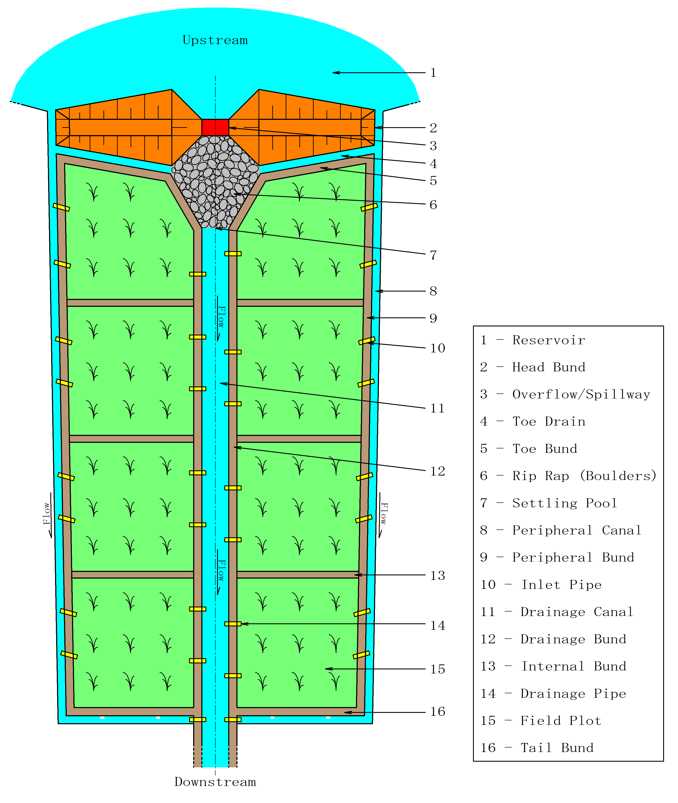
Figure 28. Developed Inland Valley Swamp without pipes in the internal bunds.
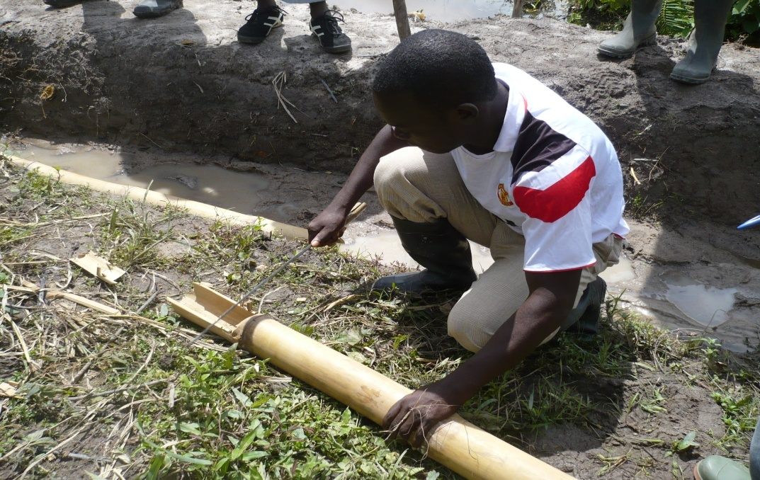
Figure 29. Preparation of bamboo cane for installation as irrigation pipe

Bamboo canes are used because they are cheap and abundant in the country. In the past, mistakes have been made in the placement of bamboo cane /pipes to the extent wherein they cease to perform their functions, thus leading to water deficit in the field plots, a situation which can adversely affect production and productivity. In that regard, it is imperative that bamboo canes/ pipes are properly prepared and installed accordingly for effectiveness and high degree of efficiency.

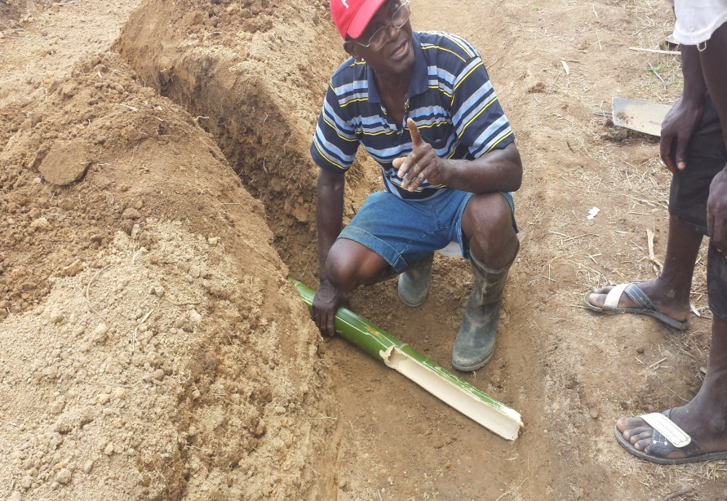
Figure 30. Placement of bamboo cane in the peripheral bund
The required length should be accurately determined and placed in the correct position and maintained regularly for better performance.

4.3. Catchment Protection/ Conservation
A swamp with good engineering design work and proper implementation but without adequate protection of the watershed/catchment area will have a very short life. Therefore, proper and sustainable swamp development requires adequate protection of the catchment area/ watershed by the provision or maintenance of sufficient vegetation cover on the catchment if the efficiency of the water control structures is to be maintained.
As a rule vegetation greatly decreases runoff, and the less the vegetation, the more abundant and rapid the runoff will be. A close plant cover, at least for a while

modifies the violent effects of heavy rains and mollifies the hydrologic effects of very light showers, thereby minimizing or preventing erosion of the catchment, siltation and protection of the conveyance/water control structures.
Furthermore, the following positive effects could be derived from good vegetal cover;
- Rain interception
- Storage by adsorption and subsequent evaporation
- Improves biological activity (soil organic matter, infiltration, structure and stability)
- Reduces runoff speed and splash
- Holds soil together through roots
- Depletes stored soil moisture so that next rain water can be stored.

The main aim of protecting the catchment with vegetal cover is to lessen surface runoff so as to avert excessive flooding and the ultimate destruction of the water control structure.
Silt-charged streams can become choked and cause flooding which damages structures like bridges, culverts or the silt may be deposited in storage reservoirs, irrigation channels and on farmland.
Planting of fruit trees on the lower slopes, tree crops on the middle slopes and forest trees on the upper slope provides income to the farmer and also protects the catchment.

5.0. References.
1. FAO, 1984, Report on the workshop on small-scale swamp development
2. FAO, TCP/SIL/2304 (T), Manual on swamp construction, grass root training for
Swamp rice development
3. Kamara A.R, 2000, An introduction to sustainable inland valley swamp
development; methods, procedure and practice
4. Kay Melvyn, 1986, Surface irrigation systems and practice
5. M.H. Ali, 2010, Fundamentals of irrigation and on-farm water management vol. 1, sprinter
6. P.N. Windmeijer W. Andriesse, 1993. Inland valleys in West Africa: An Agro-Ecological Characterization of Rice-Growing Environment.
7. R.N.Reddy, 2010, Irrigation Engineering
7. Santosh Kumar Garg, August 2005, Irrigation Engineering and Hydraulic Structures

